USA Swimming On-line Coaches Clinics
August 3, 2011

“D3 Swimming – One of the Best-Kept Secrets in the NCAA”
Greg Parini – Head Coach, Denison University Swim and Dive Team
Greg Parini has been involved in D3 swimming for 30 years, first as a swimmer at Kenyon and subsequently as a D3 coach.

One of the biggest advantages of D3 Swimming is that the student-athlete is able to attend and receive an education at a D3 school. Period. Why D3 is NOT chosen largely comes down to several misperceptions. Big IS NOT better nor is BIG best. Our strength actually lies in our size as smaller colleges. In fact, 14 out of the top 50 universities in the country are D3 and 40 out of the top 50 colleges in the country (US News and World Report 2011) are D3 schools. This ratio extends to the top 100 of both categories.

The advantages include a strong sense of school community, smaller class sizes, stronger relationships at all levels, plus a sense of belonging is fostered. Swimmers are known on campus as individuals and by the professors, students, alumni, trustees, president of the university, and coaches. The student-athlete is truly known as a person. D3 schools place a premium on academics and co-curricular successes/programs. Thus an athlete is able to effectively compete both athletically and academically (which is much less the case than at D1 schools).

There is a qualitative difference in the teaching methods (Parini has taught at both D1 and D3 schools). Essentially the material is the same as at D1 schools, but with smaller class sizes, the curriculum and discussions may be tailored to the specific dynamics of the classroom. Hence the context is different. There is way more discussion at D3. At D1, only the top 10% and the bottom 10% of the students in a class are known by the professor. In a class of 14, the course can be geared towards the strengths and weaknesses of the specific group. Professors get to know the students personally. The learning environment is great. It is not enough to just be one dimensional. The goal of the education is to set the student up for long term success (including their job). Hence, one of the biggest advantages is the environment which includes the types of people they encounter and the relationships they form.

At a big D1 school, it is very very difficult to be competitive in the pool and to also be able to compete in the classroom especially at schools where the athletic competition is at a high level and the competition is so great academically (Stanford, Cal, UCLA, Michigan as examples). Additionally, a D3 athlete is much more likely to be attend NCAAs.

Question from Coach: How to steer to D3 when you know D1 isn’t a fit for a swimmer? In this case, the swimmer wanted a “big time school”. Well, what exactly does that mean? What are the motivations for D1? Academics is one thing, the level of athletics is another and perhaps they view social as the third (boring?). Ask the questions of the swimmers. There may be ego involved.

Upper level D3 Swimming (Emory, Kenyon, Denison, Williams as examples) can effectively compete with almost all but the most competitive D1 schools. Most D3 teams can compete with midlevel D1 schools. However, status and ego get involved when picking schools. If a swimmer is not a bona fide world class level swimmer, it is very very hard to be competitive at top D1 schools. A swimmer must be world-class. There are not scholarships available at those top level schools unless you are top 50 in the world. These dollars will go overseas to find the athletes. One needs to stop and take a look as D3 swimming is super competitive. You will be pleasantly surprised as the highest level D3 swimmers have gone on to the Olympics, Olympic Trials, World Games, Pan Pacific, Nationals and certainly Jr Nationals. This is a testimony that good swimming is going on at the D3 level. Additionally, most swimmers actually get a chance to both participate on the team and to compete. For many D1 swimmers, they don’t actually get the chance to compete but instead just attend practices.

How do you measure the Success of an undergraduate education? There are two critical areas.
- Critical and creative thinking skills
- The ability to communicate effectively both in writing and in speech.

These two components will not change; they will transcend any changes in technology, etc. People need to be able to adapt. The world will change. The world will get smaller and smaller. No matter how it changes, people need to be able to adapt or they will go the way of the dinosaur. So, the hallmark of a great undergraduate education is teaching the students these skills. This is best done with smaller class sizes and at a smaller environment where there are more interaction/relationships at all levels. The same goes with swimming. The most adaptable swimmers, those that can make changes even without immediate results, are the ones that succeed.

Perception: What kind of swimming is going on at D3? Many think that it is the kids that couldn’t get scholarships at the D1 level. However, many of the D3 swimmers turned down scholarships elsewhere because they valued the education and the environment/culture that they find at D3 in terms of such things as classroom size, interaction with professors, internships and team culture.

Look at the D3 National records. These are very fast swims. Most of them have been set in the last 10 years (D3 is getting more and more competitive). They are quality swims that will stand up against mid-D1 teams. They have also been achieved without the aid of the technical suits of a few years ago. In many cases, you will find that D3 schools can be more affordable and will provide a better education. There is great quality of coaching, athletes and events. Very very few D1 schools would turn these D3 swims down as they would be attractive to all but D1 schools at the highest level. Therefore, the D3 product is good on all fronts: the coaches, the athletes, the programs and also the facilities. In the last 25 years, the facilities at D3 schools have vastly improved. The NCAA Invitational times are not super high but they are fast and they are appropriate. The quality of the meet keeps improving. The kids are now surpassing the blip of the technical suits.

Big Factor/Big Misperception. D3 schools often are disqualified immediately as being more expensive. There is “sticker shock” as many have a list price at over $50,000. This is a real question and it needs to be addressed. Most schools make it affordable. One would be really surprised to find out how much money is actually out there as most are equipped with aggressive financial aid packages. In many, many cases, a D3 education is the same if not less expensive than D1.

D3 Financial Aid comes in two ways:
- Need-Based – based on income, assets and debt (FAFSA form)
- Academic/Merit (leadership record) Based– this is usually reserved for the most “deserving” students. In D3, athletes are not allowed scholarships but the reality is that every school values certain aspects of their specific culture and for many D3 schools, swimming is part of the culture and they will help finance it. Leadership/sport is important. Athletes are considered “leaders” at many schools.

Forms of Financial Aid: loans, scholarships/grants, work-study.

Value of this type of aid (as opposed to athletic scholarships) is that: receiving the aid is NOT tied to swimming. The kids are participating in the sport because they love it and they want to be there. Secondly, the swimmers want to get better and not because they have to swim to finance their way through school and thirdly, the student-athletes are able to take a full load, graduate in 4 years without summer school. It may end up less expensive than many public schools.

D3 Swimming provides an integrated approach towards the student-athlete (academics and athletics).
- Kids are swimming for “love of the sport” which creates a much healthier team environment (not competing against each other for scholarships). The team is there because they want to be and not because they have to be.
- The whole team has the opportunity to compete. D1 travel squads are often fairly skeletal. This is not the case with most D3 programs. Most D1 swimmers never travel nor attend a Championship meet so there is actually little opportunity to compete
- Traveling with the team creates meaning to their swimming
- Swimming as a sport isn’t competing with revenue producing sports (football for instance) and in many cases the spotlight may actually be on the pool/them

In D3 swimming, there is something for virtually everyone at every level as there is a very wide range of abilities from the highly competitive to participation based. D3 offers 243 women’s programs and 204 men’s programs.

In conclusion, Greg Parini linked to a blog written by Ben Moses, a D1 photographer which Denison hired to capture the 2011 D3 NCAA Championships in Knoxville. Moses had never photographed any D3 sports nor ever been to a swimming competition. He was so taken by the event; he wrote an article (which follows) entitled “For the Love of the Sport”. The article captures the essence of D3 swimming.

Question?
Is the NCAA Clearinghouse used by D3?
No. He wasn’t even sure of its purpose

Question?
Best places to go to get information?
D3Swimming.com is the best site out there. In fact, it is award winning, literally, for its quality of information. Or, look at collegeswimming.com or talk to your local D3 coaches as coaches love to talk and may provide some great ideas/suggestions.

Net net…D3 swimming is really really fun!

For Love of Sport

Ben Moser: D1 Photographer.
- Posted on 04.14.11
- blog, photos, sports
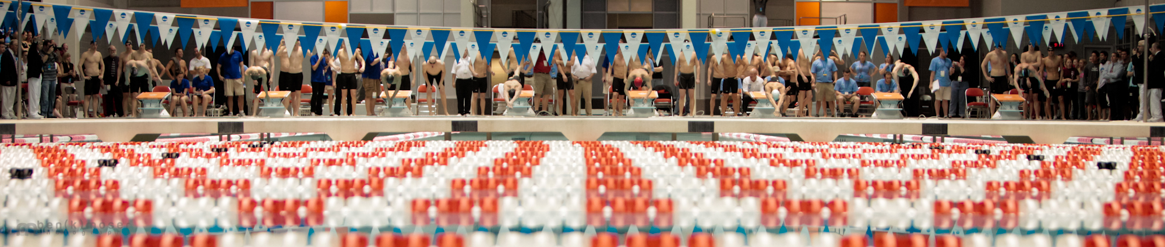
The final heat of the 2011 NCAA Division III Swimming and Diving Championships in Knoxville, Tenn. began with more drama than any men's heat in the last 31 years. Denison had to finish within two spots of Kenyon to retain its lead and unseat the only overall champion the sport had seen in 31 years.
The full slideshow of photos from the event is located at the end of the story.
I remember showing up at my first UT football game as a photographer. Not a fan, student or band member, but with my mind focused on my goals for the next few hours and working to learn and accomplish those goals. I was impressed with how nice the facilities were, but it didn’t come as a surprise to me–this is Tennessee, an FBS (Division I) SEC program with a top-10 all-time winning percentage.
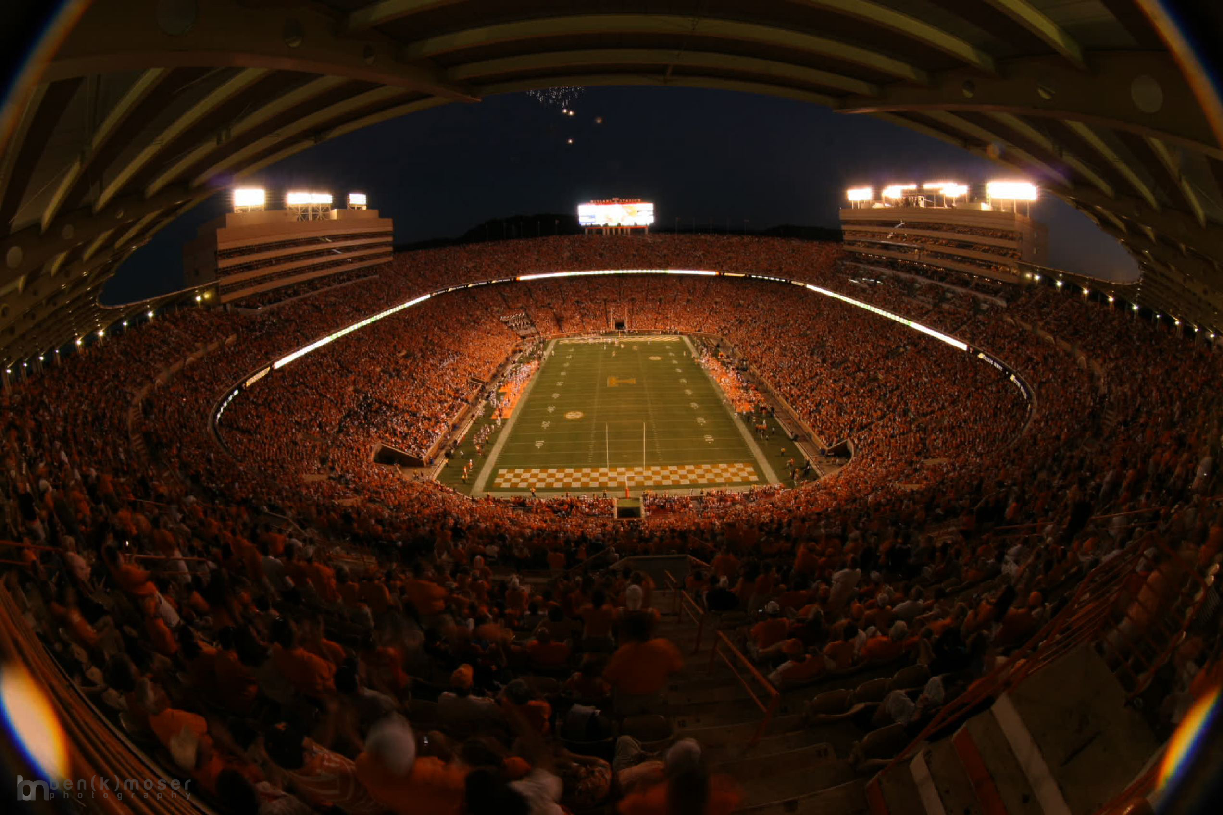
Neyland Stadium is known for being one of the largest stadiums in America--over 100,000 in capacity, but after the multimillion dollar renovations to its interior and exterior, it is one of the nation's most beautiful as well.
Money goes to what people care about most, and Volunteer football is a big-revenue operation. Neyland Stadium is one of the oldest, finest and largest stadiums in the country for a reason–people are fanatical about the cleated brethren that don the orange and white jerseys and hit the wooden sign that says “I will give my all for Tennessee today,” as they leave the locker room.
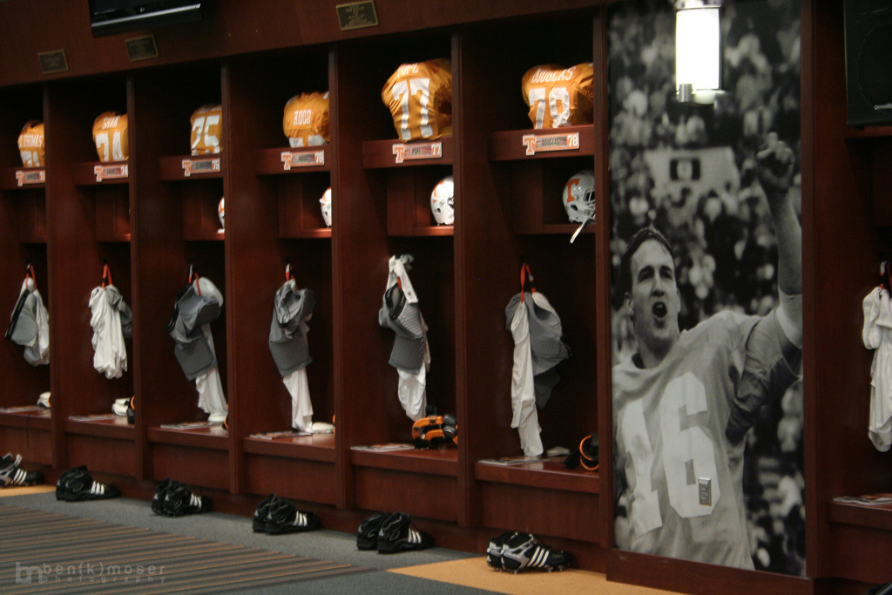
The Tennessee football locker room has been compared to the quality of NFL locker rooms.
That locker room, by the way, was recently renovated and named for Peyton Manning after he made a $1 million contribution to the Neyland Stadium renovation project. According to UT’s website, Phase II of this plan alone was an estimated $27.4 million.
The media rooms that I’ve worked in on field level and in the press box are beautiful and spacious areas. They serve a pre-game meal, halftime meal, and snacks and pizza after the game to working members of the press. A similar routine occurs at men’s and women’s basketball games in Thompson Boling Arena. In addition, all media get parking passes near the venue, a storage area for gear, work space for writing/editing/uploading and dedicated athletic department personnel to help them solve problems and accomplish (most of ) their needs.
None of that exists at the Division III (DIII) level.
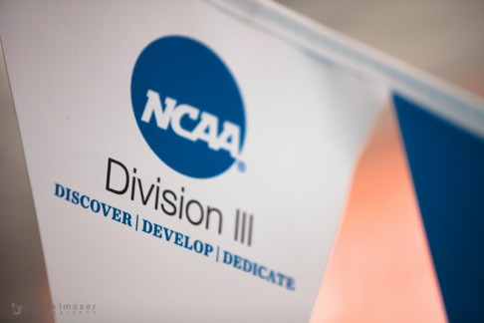
NCAA Division III athletics programs do not offer athletic scholarships to athletes.
What DIII does have that Division I (DI) sports do not, however, is pure and uncorrupted passion.
Don’t dismiss me as some sensationalist DIII homer either–I love DI sports and I think there is excitement in the droves of people who follow those sports. But with so much of the DI culture focused on getting national attention and going pro, as well as issues like paying players, lunatic fans vandalizing rival campuses and constant NCAA recruiting investigations, the DI culture kind of loses its innocent wonder.
There are no athletic scholarships in DIII. No revenue sports or funds to specifically benefit athletics. No athletes looking to go pro. No ulterior motives.
They compete for their love of the sport.
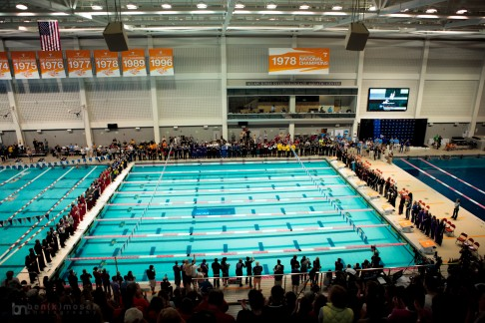
The facilities for the NCAA DIII Swimming and Diving Championships were excellent--held at Tennessee's Allan Jones Intercollegiate Aquatic Center. This was the only similarity to DI athletics, however.
I was hired by Denison University to shoot their men’s and women’s swimming and diving teams during the 2011 NCAA Swimming and Diving Championships held here in Knoxville at UT’s Allan Jones Intercollegiate Aquatic Center. They wanted a dedicated photographer to capture these special moments for their Ohio-based university.
When I showed up at the site, there was no reserved media parking next to the facility. I had to park on the street and walk to the aquatic center in the rain. When I arrived inside, I picked up my media pass and asked the nearest official-looking NCAA staffer where the media area was, and I was directed to a solitary and lonely table set up at the end of the concourse. When I asked where I could store my gear, he pointed at the table. Baffled, I began to search for a place to setup a workspace that wasn’t in a public area–there were none. In addition, there were no meals or drinks provided to working media at all. No parking, no press room, no storage, no workspace, no meals and no dedicated staff to solve problems for the media. I’ve seen high schools with more media-friendly policies and procedures.
I was stunned. This was, after all, the NCAA Championships–the pinnacle of competition for this sport and the biggest event of the year for these schools. Welcome to DIII, where the only thing that matters is the competition itself.
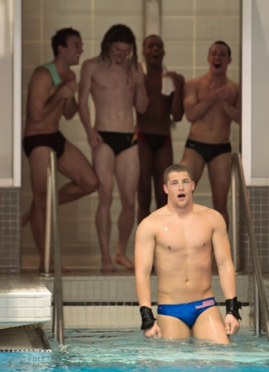
Several men's diving competitors smile in awe after fellow competitor Nick Halbach finished his final dive that led to his championship total of 591.65 points, which set a new NCAA record.
What seemed like a burden during the first of four nights of the competition turned into an inspiration and encouragement. Without the luxury-suites (and crowd associated with it), scholarship athletes (and the attitude that is inherently included with them) and the multitude of distractions that exist in professional and DI sports, I was able to see athletes that only cared about performing their best against other athletes with the same motivations.
Winning is the only goal here, not gaining notoriety or making money. And while winning is their focus, they don’t lose sight of good sportsmanship. During the entire competition, sworn enemies still genuinely encourage each other to perform at their best because everyone wants to beat the best. Men’s and women’s teams from the same schools equally cheer on the other–and celebrate the other’s victories as their own. Respect-filled handshakes on the podium during the trophy presentations are a common, if not expected occurrence. Acknowledging the athlete who bested you’s great performance, and you theirs, is a refreshing sight for someone who had been indoctrinated in big-stage athletics at a high-major university for years.
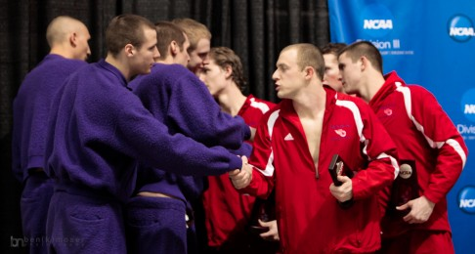
Swimmers from Kenyon, 31-time defending champion, shake hands with swimmers from Denison after taking first place in a heat.
And the best part of the entire experience was the story I had the opportunity to cover. Denison’s men’s team versus Kenyon’s men’s team.
Kenyon College began a streak of 31 consecutive NCAA DIII men’s overall swimming and diving championships in 1980 on the back of a young Gregg Parini, who became the school’s first individual sprint champion in 1981. His coach, Jim Steen, was successful on the women’s side as well, at one point winning 17 consecutive women’s titles. Steen has coached 54 championship teams, the most of any NCAA coach in history. That was the story year-in and year-out, including the 2011 Championships–the Kenyon men always win. They had established the longest championship streak in the NCAA in any sport at any level of competition (For perspective, the most consecutive swimming and diving championships at the DI level is five.)
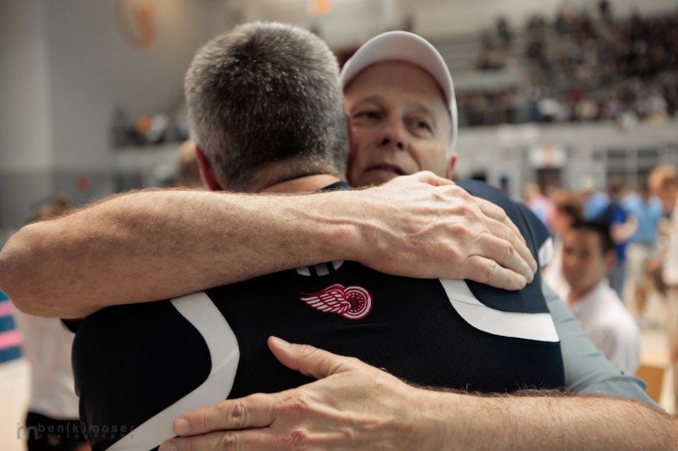
Head coaches for Kenyon (Jim Steen, mentor) and Denison (Gregg Parini, student) embrace after the conclusion of the 2011 NCAA DIII Swimming and Diving Championships.
A few years after graduating from Kenyon, Parini got a coaching gig at rival school Denison–only 28 miles away. 24 years later, he was still without a men’s title at the school. His women’s team, however, had previously broken the Kenyon women’s 17-year streak.
That brings us to the photo at the top of this story–the men’s 400 freestyle relay. The final heat of the four-day event. Denison had a nine-point lead heading into the heat, and the math said they had to finish within two spots of Kenyon to retain their hold on the top spot and complete the biggest upset in an NCAA sporting event. (Don’t balk at that statement–name another team that’s won 31 consecutive titles and wouldn’t be considered the “Goliaths”–and conversely all other competitors the “Davids”–of their sport.)
Sure, Denison had finished second the previous year, so moving up one tier on the podium shouldn’t be such a big deal. But it is. They finished second by 400 points the year before, and considering the final score in 2011 (in which the winning school posted just over 500 total points), that was about the same level of dominance as a winning an NCAA Final Four game by at least 30-40 points.
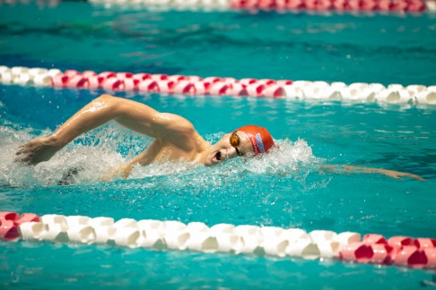
Alan Weik, freshman at Denison, shattered the NCAA record for the 1650-meter Freestyle heat, which contributed to Denison's 1-point victory over 31-year defending champion Kenyon.
As the heat entered its final leg, it looked as if Denison would write the cruelest of runner-up stories. They had fallen into fourth place and Kenyon had a commanding lead over the field. Denison’s anchor, freshman Spencer Fronk, would have to overtake the swimmer from Emory, just one lane over.
He did–finishing only thirty-two hundredths of a second ahead of Emory’s swimmer.
Those thirty-two hundredths of a second created a one point advantage that propelled Denison to a 500.5 to 499.5 win over Kenyon, the smallest margin of victory ever in an NCAA DIII Swimming and Diving Championship. More importantly, it gave them their first title and signified the end of the most impressive streak in collegiate athletics.
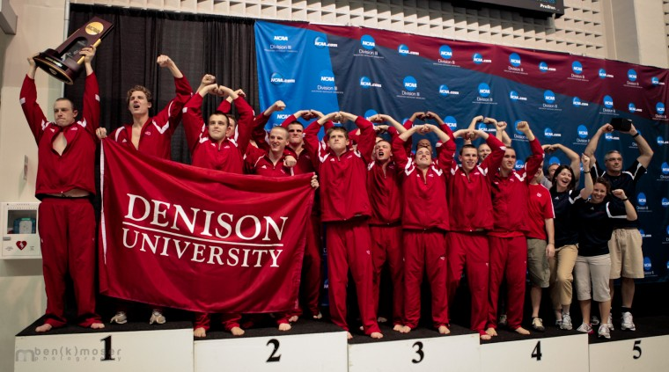
The Denison men's swimming and diving team celebrates on the trophy podium after winning its first championship.
Let’s recap all the story lines involved here:
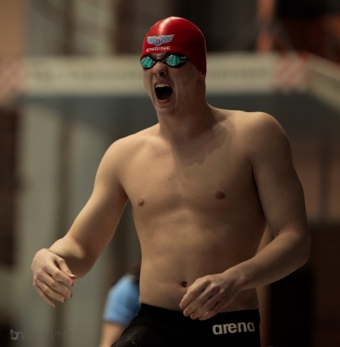
Freshman Spencer Fronk anchored the title-clinching heat for Denison, swimming the second fastest last leg and beating the next swimmer by thirty-two hundredths of a second.
- Coach Gregg Parini beats his former school, Kenyon.
- Parini, the former student of legendary Coach Jim Steen at Kenyon, out-coaches his mentor.
- Parini’s underdog Denison team ends the greatest streak of championships ever seen in the NCAA–which Parini started in 1980. The Parini-coached Denison women also ended the Kenyon women’s streak at 17.
- Denison won it’s first ever men’s swimming and diving title.
- Parini had a hand in winning both Kenyon and Denison’s first men’s swimming and diving titles.
- Denison won by the smallest margin ever in an NCAA DIII Swimming and Diving Championship.
- Denison freshman Spencer Fronk put the team’s championship hopes on his shoulders and in the final leg of the final heat of the Championships, he swam the second-fastest split among the anchor swimmers to take back third place and claim the title.
Pretty dramatic, eh?
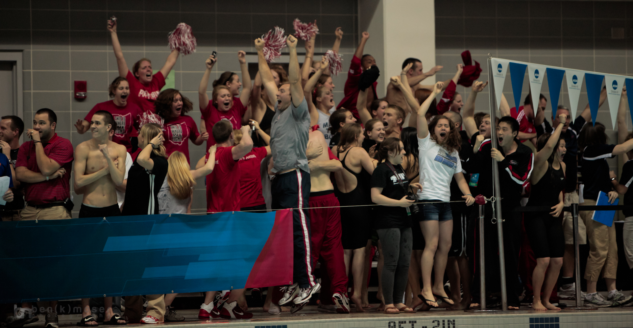
Denison's bench area erupts after the thrilling finish of the final heat.
Watching the teams, fans and coaches cheer without reservations or stigmas during the last race of the last night was symbolic to me, an outsider from the DI world. No one had any split allegiances, ulterior motives or hidden agendas–which is how athletics should be.
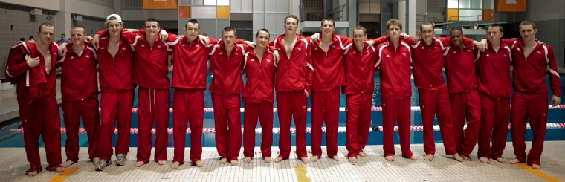
These Denison swimmers and divers will be remembered by the entire DIII swimming and diving world for a long time as the team that broke Kenyon's unimaginable streak.
In a final move of mutual respect, Kenyon’s Coach Steen came over to the Denison benches and gave a congratulatory speech to the men of Denison–and each of the athletes paid Steen his due respect, as if he was their own coach.
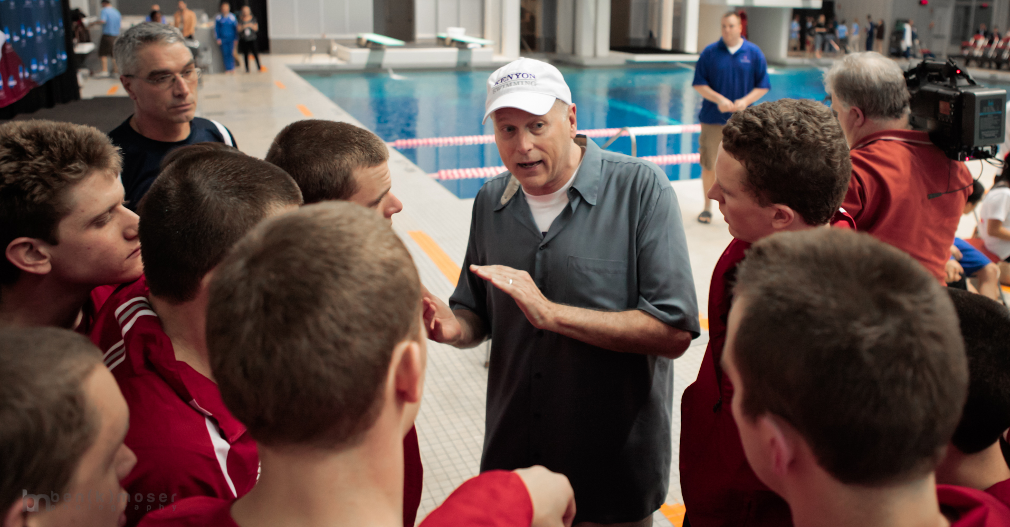
Kenyon Coach Jim Steen congratulates the Denison's men's team for their victory over Steen's men's team who had won 31-consecutive titles.
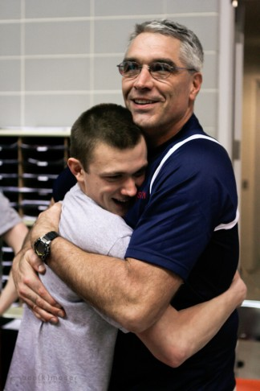
Denison Coach Gregg Parini embraces a member of his men's swimming team immediately after they won the championship.
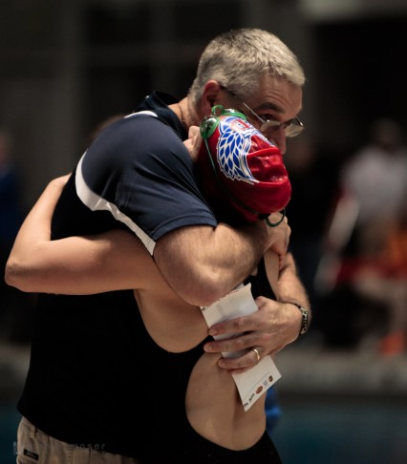
Coach Parini's relationship was visibly strong with both his men's and women's athletes. They all looked to him for support and celebration.
DIII athletics are more of a family than any sporting league I’ve ever witnessed. All the Denison athletes I followed during the four-day event treated each other like brothers and sisters and Coach Parini like a father. I saw plenty of joyous and celebratory hugs, a consolation after a disappointing disqualification and constructive criticism between the Denison athletes and their coach.
The entire experience showed me that these athletes, coaches and fans–with no other possible motivations–only had one reason for competing and cheering: For love of the sport.

