OA Graduating Class of 2017

“Life is not about warming yourself by the fire. Life is about building the fire. And generosity is the match. If you want happiness for an hour, take a nap, but if you want happiness for a lifetime, help somebody”. Larry Lucchino

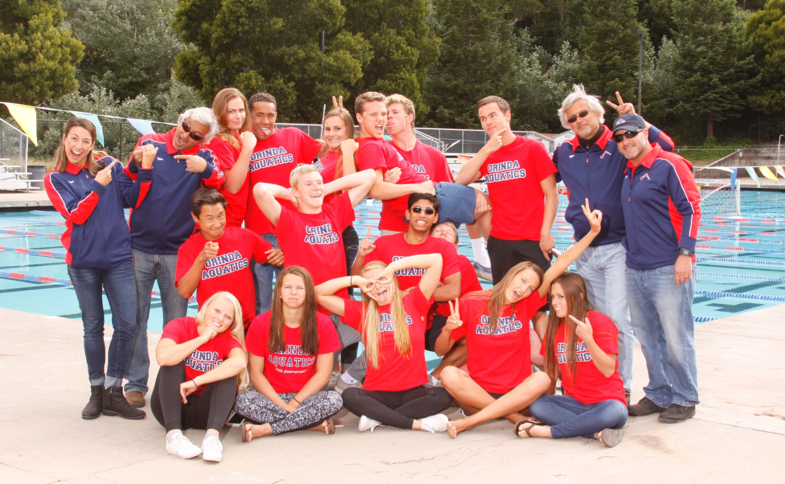

“Do all the other things, the ambitious things – travel, get famous, innovate, lead, fall in love, make and lose fortunes ... but as you do, to the extent that you can, err in the direction of kindness”.
George Saunders - Syracuse University 2013

OA Graduating Class of 2017

Average GPA – Near 4.0

Name/HS | In the Beginning! | College | Mascot! | Notes
Jolen  Griffin  Campolindo | 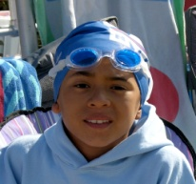 | UC Santa Barbara  Swimming |  | Three-year team captain  Senior National Qualifier  Multiple NCS Champion  Swimming All America  OA Swimmer of the Year
Rachel  Hendricks  Campolindo | 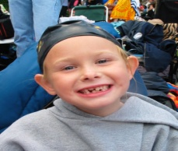 | Davidson College  Swimming | 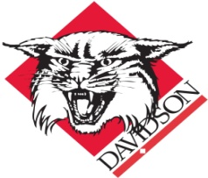 | Swimming All American  PacSwim Top Ten  Scholar Athlete  High School Inspirational/Captain  Coaches Award
Melanie Moran  Miramonte | 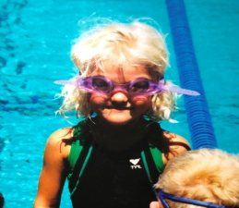 | UCLA  Triathlon |  | Academic All-American  Scholar Athlete  Sectional Qualifier  HS Team Captain  Coaches Award Winner
Mackenzie Duarte  Alhambra | 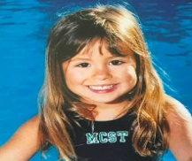 | Washington State  Swimming |  | NCS/State Finalist  Junior National Qualifier  Scholar Athlete  Ranked 4th in PacSwim  Swimming All-America Cons
Ryan Teshima  Monte Vista | 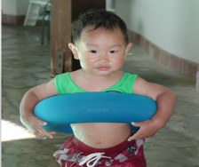 | Johns Hopkins  Swimming (TBD) |  | Academic All American  High School Team Captain  Coaches Award  Futures Qualifier  PacSwim Top Ten
Rishabh Roy  Campolindo | 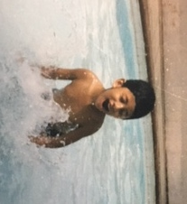 | Cal |  | Team Captain  Academic All American  National AP Scholar/National Merit Commended Scholar  Coaches Award winner
Kenna Van Steyn  Athenian | 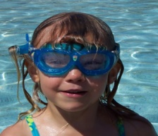 | Dartmouth  Swimming |  | Junior National Qualifier  NCS/State Finalist  Sectional Finalist  Scholar Athlete  Swimming All-American Cons.
Katherine Cane  College Prep | 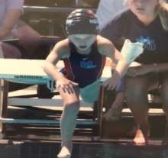 | Dartmouth  Swimming |  | Futures Qualifier  Scholastic All American  Swimming All American Cons  NCS Finalist  CPS Captain/Athlete of the Year
Neil  Binnie  Miramonte | 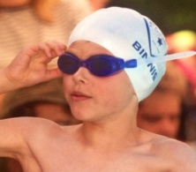 | USC  Swimming | 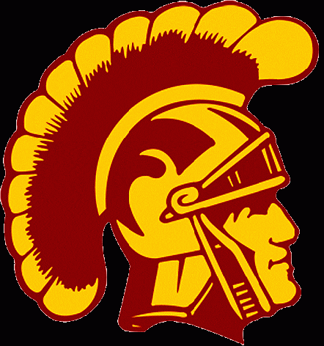 | Academic All American  Sectional Qualifier  Scholar Athlete  California Arts Scholar  MHS All Time Top Five
Spencer Lekki  Campolindo | 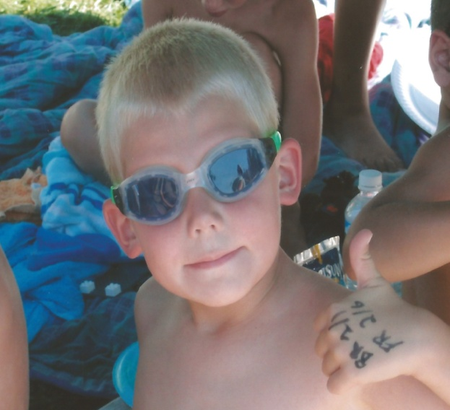 | Carleton College  Swimming |  | Eagle Scout  Scholar Athlete  Natl Merit Commended Student  Presidents Volunteer Award  Coaches Award
Callan  Hoskins  Miramonte | 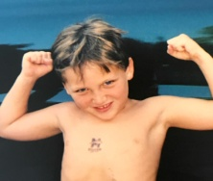 | Stanford |  | Academic All American  HS Team Captain  HS Inspirational Award  Eagle Scout  Western Zone Qualifier
Justin  Lammert  Miramonte | 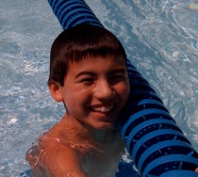 | Chapman  Swimming |  | Swimming All American  Scholar Athlete  Futures Qualifier  Sectional/NCS Finalist  Eagle Scout
Matt  Ruegg  Acalanes | 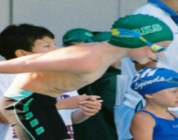 | Puget Sound  Swimming |  | DFAL finalist (4 years)  Western Zone Qualifier  Outstanding Athletic - Achievement Award  M. Lynn Memorial Scholarship
Jennifer  Sweeney  San Ramon | 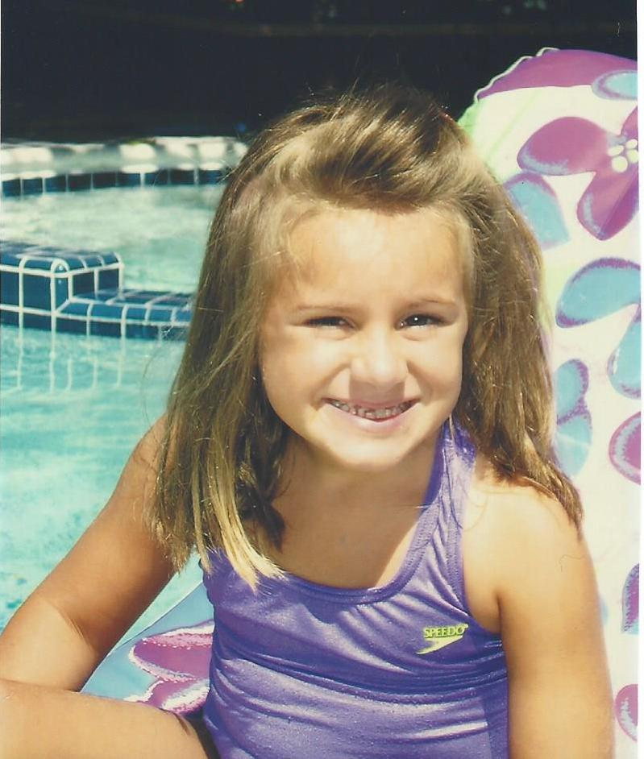 | Cal Poly |  | Scholar Athlete  Team Captain  PacSwim Top Ten  Coaches Award  NCS/Western Zone Qualifier
Eli  O’Brien  Miramonte | 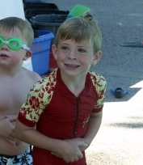 | Cal Poly |  | Scholar Athlete  Sectional Qualifier  HS Team Captain  Rec Inspirational Award  All American Cons/MHS Top 3
Jenna  Muller  Campolindo | 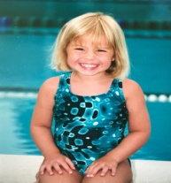 | Pacific Lutheran  Swimming |  | Scholar Athlete  DFAL Finalist  Western Zone Qualifier  NCS Qualifier

Senior Letters

Katherine Cane, Dartmouth

“When you look back on your time on Orinda Aquatics,” Donnie once said, “You will not remember the bad races and bad meets. Instead you will remember the lessons you learned, the memories you made, and the friendships you formed.” Back then, my freshman-self heard this and rolled her eyes. Of course I’ll remember adding time at Clovis in the 100 backstroke. But Donnie was right. I look back at travel trips to Clovis and don’t much recall the times of any of my races. I do vividly remember (and indeed I can picture) the red wall of teammates cheering me on at the end of my lane; the many Von’s runs where we overwhelmed the employees with our army of swimmers; and the roommates who put up with my mess and whom I came to know better and appreciate and enjoy.

To my teammates yet to graduate:
You might think you’re spending too much time at the Soda Center and are missing out on other things. I remember thinking that, too. But, I promise, you aren’t. I regret the days I didn’t attend breakfast with my teammates or go to dryland. Your time on OA will come to an end sooner than you think, and you’ll wish you had appreciated and spent even more time with your teammates.

To Donnie:
For some other teams, the Soda Center meeting room is just a place where team dinners happen. But for our team, you have made the meeting room a classroom for the lessons of life. When I first joined the team, I knew “character” was preached; since then, I’ve learned it is practiced as well. You’ve taught every one of us what character actually means. Some people may think it’s just “doing the right thing,” but you’ve taught us that character is doing the right thing — when no one is watching. Character is not something you do to be acknowledged; it’s a way to live our lives. Donnie, thank you for everything. You’ve influenced my life in so many ways. Without your guidance, I would have quit swimming after a few bad races. I would have thrown my cap and goggles in the trash can without looking back. But you taught me that my times aren’t the only thing that matter. Without you, I wouldn’t be swimming at Dartmouth College next year, and I wouldn’t be half the person I am today.

To Ronnie:
I think you’ve made me laugh harder than anyone I know. It is a well-known fact — and a sore subject — that events longer than 100 yards do not play to my strength. This year miraculously I improved my 200 free more than four seconds one day, at a meaningless high school dual meet. I texted you my time with considerable pride. You responded: “Fins?”

And do you remember Clovis in 2015? We boarded the bus for warm-ups at 7:10 a.m. sharp. You yelled, “Who’s missing?” One of the girls was nowhere to be found. We waited two minutes to see her running out of the hotel. And you looked at the bus driver and said, “Drive.” She ran after the bus, yelling “Wait!” We eventually did allow her to catch up, but watching her chase the bus for two blocks was something none of us will ever forget. We won’t be late to board a team bus — or, in life, for anything — after that. In the pool, you’ve inspired me to work harder than I ever have. Thank you for teaching me how to fight. Even on the days when I thought I put in a lot of effort, you expected more, and drew it out of me.

Now, as I prepare to leave, I realize I have learned one final lesson: We have spent years in stroke training, always trying to get a good grip on the water. Only now do I realize that the water — and my coaches and teammates at OA — have a powerful and wonderful grip on me.

Thank you.

Jenna Muller, Pacific Lutheran

Oftentimes, when I introduce myself to someone and mention the fact that I am a member of Orinda Aquatics, I am answered with a joking response of, “Oh, so you’re a part of that swimming cult.” I usually laugh and agree that, yes, I am part of that swimming cult, and I have been for seven years, so of course, I am well-acquainted with its character-first dogma.

However, I never really gave much thought about what it means to be a member of a tightly knit group of young adults with such an infectious sense of camaraderie and closeness that it has become notorious for an almost cult-like atmosphere. That is, I never really gave it much thought until I was in Clovis this year.

It was a cold February night; wispy carbon dioxide clouds spilled from our mouths with every exhalation, and a thick cloak of steam hovered above the pool. Swimmers and spectators alike were bundled up in parkas and Ugg boots except for those lucky few like me, who were about to swim the 1000 freestyle. We had to be ready behind the blocks, braving the winter chill, wearing only our caps, goggles, and paper-thin speed suits. Conditions, to say the least, could have been better.

Of course, I was nervous. Even as a distance swimmer, any race longer than a 200 made my teeth chatter (and not from the cold). But unlike every non-OA swimmer in my heat, I had teammates standing at the end of my lane, all wearing a uniform of red t-shirts, waiting to cheer for me. When the starter whistle blew and I clumsily stumbled on the blocks, I felt a nagging sense of self-doubt in the back of my head that kept repeating “Youcan’tdothisyoucan’tdothisyoucan’tdothis.” And then the starter beeped and I dove in, and the chorus of negative thoughts running through my head was replaced with the empty silence of water pressing in on all sides.

Right away, my goggles started leaking. Just as I started to think that I should give up while the race was still young, I heard my teammates cheering for me to keep going. So I did. At around the 500 mark, when I began to feel like the race would never end, my thoughts wandered back, past birthdays and New Year’s celebrations, past many Thanksgiving, Christmas Eve, and Theme Week practices, and they settled on an autumn evening in 2011: the night of my first practice on Orinda Aquatics.

I was a socially awkward eleven-year-old with the stylish one-piece tan and chlorine-bleached hair that every OMPA swimmer rocked in August. I was truly out of my element, surrounded by much older, much faster swimmers whose knees didn’t quake at the thought of a 1200 yard warm-up. I think I might have cried at least once during that warm-up set alone.

Back to the present, with only a few laps left in the race, I marveled at how afraid and alone I had felt only a few years ago. But now, a wall of red t-shirts surged forward at each flip turn, cheers piercing through the undulating surface and traveling to my ears, registering in my head as a cry to go faster, a reason to bury the negative thoughts. I finished the race with burning lungs, limp legs, and a heart bursting with gratitude.

Of course I was thankful— thankful that I stuck with swimming after all those years, thankful for the times when my coaches yelled at me to increase my stroke rate, and most of all, thankful for my teammates. Because without that “wall of red” at the end of my lane to stand guard between me and my own self-doubts, I might never have gathered up the courage, whether as a sixth-grader or a senior, to take a deep breath and dive into a life lived freely, without inhibitions.

Jenna

Jen Sweeney, Cal Poly

Dear OA Family,

The past six years of swimming for this team has transformed the way I act, think, and carry myself on the pool deck, and more importantly, in life. I have had the pleasure of swimming on OA for six years, and it has proven to be one of the most rewarding experiences of my life. Being a part of Orinda Aquatics changed the way I saw the sport of swimming, how I acted as a teammate, and most importantly, my outlook on being a better person. There are so many people who contributed to my growth as a person, and I would like to thank all of my coaches, teammates, and mentors. You all guided me to be a character-first person, and I hope that I can touch the lives of others the way you touched mine.

Beginning in my freshman year of high school, and starting in the senior group, began the most enjoyable years of swimming for me, along with some of the most challenging. And without those difficult experiences, I would not be the person I am today. Additionally, starting the senior group ignited my hope and drive to be a good mentor. During my freshman year, my coach Kevin, saw potential in me in the 200 butterfly. Later that week during a Saturday morning practice he pulled Annie Larsen out of practice to help me with my turns. Annie was incredibly happy to help and genuinely committed to improving my turn. She continually checked in on me to make sure my stroke and turn were improving. In addition, she was always there for me when I needed a friend. Not only did she support me that one day in practice, but she did for the rest of my swimming career. She was always behind my block cheering me on, and always gave me feedback to help improve my race. Even though the 200 fly did not stick, Annie’s support, guidance, and friendship did. As Annie helped me, I saw and understood what it meant to be a real mentor and I truly hope I can inspire others to be a great mentor, as Annie inspired me.

My time on Orinda Aquatics consisted of meeting some of the most genuine, talented, and extraordinary people. My mentors and coaches enlightened me to a path of being a better all-around person and athlete. In addition, my teammates have been the driving force behind my success and overall character growth. There was never a time where I felt alone in my struggles and triumphs thanks to these amazing individuals. From my teammates I learned that every day you can be inspired through one act of kindness. Looking back on my career, what I take with me is not improved times, obtaining a new standard, or even the struggle of adding time in an important race. What I take with me are the life lessons I have learned and the incredible memories I have experienced.

Lastly, I would like to sincerely thank all of the wonderful coaches I have had the pleasure to work with, specifically Ronnie, Donnie, Matt E., Mark, Matt A., Jill, Kevin, and Sophie. Everyday consisted of training hard, laughing harder, and building lasting memories, and I cannot imagine having anyone else by my side.

Thank you for the most enriching and enjoyable years of my swimming career!

Sincerely, Jen Sweeney

Melanie Moran, UCLA

Dear Coaches, Teammates and Friends,

Throughout the past four years I have learned so much in and out of the pool through the lessons I've learned and relationships I've formed at Orinda Aquatics. But while the values Ronnie and Donnie teach always seemed important, the impact of these lessons really became clearer as I got older. In the supportive and helpful environment of the pool deck, it's hard to imagine that what we do is extraordinary. We learn by the example of older kids to be early, and to help with lane lines and pool covers. It's only through watching other teams interact that I really learned how unique and important this culture is. So I advise all my peers to continue Ronnie and Donnie's lessons as you move on to the next chapter of your life. What we have learned through this program has the potential to benefit our lives, and those around us.

To me the most important lesson I have heard from Ronnie and Donnie, is to ask myself "What am I adding to this team?". Reflecting on my actions, participation, and efforts in this way helps motivate me to be a better teammate and swimmer. But this question can be applied to almost every aspect of life, like in school work, clubs, or a job. I will always remember to reflect on what I bring to my endeavors, and I hope to carry on the lessons OA has taught me throughout my life.

So thank you Ronnie and Donnie for teaching me invaluable lessons, and being great coaches, mentors and friends for the past four years.

Thank you,
Melanie Moran

Rishabh Roy, University of California at Berkeley

Five years ago, right after I had moved here from New York, I stepped on the deck of the Soda Aquatic Center to watch a junior group practice and talk to Matt and Marc. That day, and the following decision to join Orinda Aquatics, changed my life for the better and made me into the person I am today.

I still remember my first day on the team. I was standing on the deck, swim cap and goggles on, shivering in my jammers. I remember Alec Baker and Lambo welcoming me to the junior group and showing me the intricacies of the team. That was the magic of Orinda Aquatics. Everyone was included on the team, and that resonated with me and has stayed with me to this day. For me, Orinda Aquatics is not just another swim team; it is a family, a family of athletes of all swimming abilities with one common goal – to push everyone to be a better version of themselves, from a swimming or a character standpoint.

My Teammates: I could not have found a better group of peers to call my friends. All of you have had a role in making me who I am. Some of my fondest memories are related to this team, be it those made on the annual Clovis Swim Trip or the rafting trip or the team-building events. You taught me that you can look up to people of all ages, you just have to be open to such a prospect. Two such people shaped me and made me strive to be like them. One of them was Ryan Birdsall, a senior to me who showed me what being a leader and a friend meant. He showed me that cheering was the most fun thing to do, and of course, his amazing Happy Birthday singing. The other was Shannon Campbell, a junior to me, but only so in age. She showed me the true meaning of hard work, of dedication, of passion, and made me want to be more serious in my endeavors. Thank you, my teammates, for making this journey memorable, for helping me and the team no matter what, and for inspiring me to be better.

Matt and Marc: Thank you for making my brief stay in the junior group memorable, I enjoyed every day of practice, no matter how cold it got, and even that Stockton meet with ice on the blocks. I know you tried to fix my “head” in freestyle, and I realize that it is still a work in progress. I will always cherish the welcome you gave me to the team and how much you helped improve my stroke.

Donnie: Thank you for everything. You have made me the person I am today. You improved my strokes and your fly practices made my fly what it is today. You also inspired me to be a better person, a better teammate, a better friend. You taught me the meaning of humility and the “CHARACTER FIRST” mantra of the team. You made me want to be a better version of myself and thank you for showing me how a high-character person acts. I will always remember “be above the weather” and have come to realize that weather is just a metaphor for any discomfort or obstacle.

Ronnie: Thank you for your coaching and help in both, swimming and dryland. I will not forget the numerous drylands where you got after me to do the bands exercises right, nor will I forget how you had me practice underwaters with Derek Ludwig at the end of practice. You made my under waters what they are today. If you ever need help demonstrating how to do Hindu Pushups, I will happily oblige.

Armo and Jill: I only got to know you this year and albeit being a sad reality, I am happy that I had the opportunity to be coached by you. Thank you, Jill, for the early morning sprint workouts and helping me with my dives. Thank you for developing my distance freestyle Armo, and I will never forget how much you have improved my stroke, be it free, fly, back and even breaststroke. Thank you for an amazing last Clovis drive in the “Man Van” and for the other countless, fun, exciting conversations we have had (even though I sometimes should not have been talking). And it is true, “the water is not getting any colder.”

It is saddening to see a great chapter in my life at OA come to an end, but this is only a “see you later”. Thank you for all the great times and I hope there are many more for the rest of you. To the rest of you, cherish your time on the team for there is no place like it. Keep being the upstanding, positive, humble, high-character people you are, and keep striving for more.

Regards, Rishabh Roy.

Ryan Teshima, Johns Hopkins

The impact of my three years on Orinda Aquatics will be an everlasting influence in my life. I discovered the importance of commitment, transforming myself from being a guy who showed up to about half of the practices, to now, rarely missing a workout. During my rec swim years, I attended practices just to swim, but I have realized from OA that practices are not just opportunities to be in the water to swim but are times to spend with friends, pacing together in challenging sets, going to breakfast, working out, and occasionally playing pickup basketball games afterwards.

In addition to the many eye-opening experiences OA has exposed me to, the team has taught me many lessons that have allowed me to grow and develop as an individual. One lesson that Ronnie and Donnie taught me that I live by now is that I need to be accountable for myself. During my first week on the team, Ronnie told me in order to improve my breaststroke, I needed to go past four black lines off of each pull-down and take no more than seven strokes per lap. I heeded the advice for a few laps, but eventually my under waters and stroke rate returned to how they were previously as fatigue set in. He soon pulled me out and reminded me of what he said, adding that if I didn’t do it correctly, he would no longer coach me. It was a wakeup call; I wanted to improve and knew Ronnie was right (as always). I realized I am the only one who can change myself since no one else can magically do it for me. From that point on, I took his advice, even on the most challenging sets, so my under waters are one of the strongest parts of my breaststroke.

Yet another valuable lesson I learned is to always express my gratitude. Ronnie, thank you for your encouragement, especially during my first Clovis trip when you acted so excited and made me call my mom about my “outstanding” 1:05 100 breaststroke. Donnie, thank you for teaching me the importance of living a life of character and integrity and to always appreciate my family. So, I also thank my family: my parents for supporting me, my sister who drove me to some morning practices at 5 AM, my aunts, uncles, and cousins who came to many meets to cheer and encourage me. Matt, thank you for being such a positive coach at the most crucial point of my swimming career and believing in me, even when I didn't believe in myself at that one Pleasanton meet. Thank you Jill for being a great coach and an inspirational athlete that I can look up to. And a final thank you to all my teammates for being great people with whom I have spent countless hours.

Spencer Lekki, Carlton College

There’s a fulfilling joy in doing something simply because you love to do it. OA is the avenue that has allowed me to pursue swimming simply for the love of the sport. I’ve never gone to Far Westerns, or even made it to the finals of a meet for that matter. Despite this, I still love the sport of swimming, so much so that I’m going to continue pursuing it in college. I’ve been able to find joy and fulfillment in the sport separate from the external rewards associated with being at the top of the heap. This has been provided mostly through coaches and teammates who have made me feel like a valued member of the team as a whole, no matter what time I swam in a race. I have felt that if I showed up to practice, worked hard, and tried to contribute positively to the team culture, then I had a spot where I belonged.

In Lamorinda there seems to be a misconception that if you can’t be the best at something then you shouldn’t do it. People who believe in this school of thought also buy into the idea that second place is the first looser, and that any black mark on the resume of their dreams would be unthinkable. Thankfully my parents helped me see early on that I should do the things I love to do rather than try to build up a list of achievements. I say thankfully because if not, then OA might not have been for me. It’s because of the fact that I can be part of this wonderful community of swimmers and not feel as if my inclusion is conditionally based on may ability.

With that being said, I’d like to say thank you to Ronnie and Donnie for working so hard to create a team of high-character kids who show inclusivity despite all of our differences. I’d also like to thank Kevin who took the time to make me feel truly valuable to the team. Additionally, I’d like to thank Matt Armanini for his genuine concern about me as both a swimmer and a person and for helping me make the decision to continue my swimming career. OA has an amazing staff, and though I have not worked extensively with all of them, each coach has my utmost gratitude.

Before I leave for the cold white north of Minnesota next year there is one thing I’d like to pass along to the current OA swimmers. Each one of you is more than a combination of all of your times. Swim because you love to swim and because you love the team. If you keep that in mind, there’s no limit to the positive impact that you can have on those around you.

Go OA!
Spencer Lekki

Mackenzie Duarte, Washington State University

Dear OA community,

I have loved sports for as long as I can remember. When I was very little my parents introduced me to soccer, basketball and swimming without pushing one over the other. I loved playing these sports and participated in each throughout elementary school with much success. During my High School Freshman and Sophomore years I was a member of the Alhambra varsity water polo, soccer and swim teams. In an effort to get a jump start on the high school swim season I decided to participate in the OA preseason program. Marc was the coach for that program and during one of the pre-season practices, he pulled me aside and asked me if I had ever considered swimming year-round. A few practices later I was invited to swim with the club team for the remainder of pre-season. I knew then that I needed to join OA, but little did I know how much that five minute conversation would change the course of my life.

I have many reasons to thank each of the coaches for Orinda Aquatics, and each is exceptional in their own right. Donnie in particular has been instrumental in my growth as both a swimmer and a person. I joined Donnie’s group after my sophomore year and although I learned many things from him as a coach, commitment rises to the top of that list. I’ve always known that swimming was my passion, but I was a three sport athlete and reluctant to give that up. Donnie helped me to realize the importance of committing myself to the year-round program, (including the much dreaded morning practices) if I was going to meet my full potential as a swimmer. Thank you, Donnie, for teaching me about dedication, and encouraging me to put 100% into every practice and race. It is because of you that I earned my first Junior National qualifying time.

Ronnie, I’m not sure how I can thank you for everything you’ve done for me. You educate your swimmers on the benefit hard work, proper nutrition (I apologize again, for eating an It’s-It at Futures!), and most importantly, how to fight when it would be so much easier to just give up. Shortly after going to Junior Nationals, I hit a plateau. For the first time ever I didn't feel one with the water. I felt like I was fighting it at every practice and had little to no success at meets. Ronnie empathized, repeatedly told me to fight through it, and at just the right times he provided pieces of written motivation and stories of others who experienced success despite similar setbacks. Last summer, following a theme week workout, Donnie approached me and asked, “What grade would you give yourself for your effort?” I knew with that question, I had failed to meet his expectations, and before I could respond he answered his own question with, “I would give you a D-.” In that moment I knew I could be working harder.

My coaches believed in me when I had lost believe in myself. It was because of that support that I knew I couldn’t give up. Thank you Ronnie for helping me learn that value of persistence, patience and trust. Thank you for your guidance, support and lobbying for my potential when it came to swimming at the next level. It may sound cliché, but I know that I wouldn’t be in this position without you.

To my teammates, when I first joined the high school pre-season group, I had hoped for nothing more than a few new acquaintances, and mostly expected to be ostracized as the “new girl.” What I quickly realized was that my new team was comprised of some of the nicest and most welcoming people I had ever met. As a group, you have exceeded my expectations and as individuals you may never fully understand how much you mean to me. There’s a special bond we all share — one mixed of competition and support. Without that bond, this team wouldn’t be as amazing as it is. Thank you for the memories. Thank you for all of the fun travel trips. Through friends’ Safeway sushi food poisoning, helping me to survive the spooky hotel at the San Diego Sectionals trip, and your genuine concern when I nearly drowned at the rafting trip with the Executive Boat. It has been a blast.

In closing, I'd like to again thank my coaches and Orinda Aquatics for teaching me that I might not have any control over the weather or my heat in a race, but I can control and perfect my attitude, my mental focus and almost as important, I can keep my head down in breaststroke. Even though I can't control everything, I can control what is important. I am a faster swimmer and better person because of this team.

Love, Mackenzie

Rachel Hendricks, Davidson

When I look back on my six years with Orinda Aquatics, I can’t help but smile and be so incredibly thankful for everything this team has given me. I joined OA hoping to become a more competitive swimmer, but I gained so much more. I gained loving and supportive friends and mentors who became family. OA helped develop in me a strong sense of values and a commitment to character that I will hold onto forever. No other team could have provided this to me, because no other team is committed to building a strong character mentality in their swimmers like Ronnie, Donnie, and the entire OA team.

While in high school, I watched many people follow a lifestyle of bad decisions that only on the surface satisfied them. All they found were friends who were not respectful nor supportive of each other. No one was interested in helping each other succeed in the world of character and values, and very few had a strong sense of themselves. These people were left with insecure and disingenuous friends. I could have been just like them. We all stood at the same starting place freshman year. But unlike them, I found a better culture in which to immerse myself. And with that culture came a family that not only watched out for me but also taught me that bad decisions so familiar to many do not have to be a part of my life. Swimming on OA transformed me into someone with entrenched values and someone with a strong sense of right and wrong.

It has been six amazing years. To my teammates, thank you for filling my life with happiness and love. You are not just my teammates, you are my closest friends and I would do anything for you. Ronnie, Donnie, Armo, Jill, Matt, and Marc: thank you so much for being the best coaches I could ever ask for. You helped me become a better swimmer and a better person. Over the past six years, I learned some great life lessons. Thank you, Ronnie and Donnie, for helping to develop me into the young adult I am today. I hope I can take your message of character and integrity and share it wherever I go.

Sincerely,
Rachel Hendricks
Justin Lammert, Chapman University
Orinda Aquatics has been a place that I have been able to spend my free time after school for the past couple of years. I have learned so many things from this team from enjoying tough workouts (all of them) to staying positive no matter what is happening around me. Because of this team I am confident that I am ready to go to college and the road after that.
Thank you to all my teammates that helped to push me in practice while building lifetime friendships. Thank you to all the parents for putting in time for the meet shifts and bringing breakfast after tough workouts. Thank you to the coaches for being there every day to push me and to help me through all these years. Thank you 100 free for being my distance event. Finally, thank you everybody who has helped me along the way.
Justin Lammert

Matt Ruegg, Puget Sound

Dear Ronnie and Donnie,

Thank you so much for three great and amazing years on Orinda Aquatics. Without going year round my sophomore year, I don’t think I would be swimming in college. Thank you too for all the great coaching and advice from both of you. My experience on OA has been the best in my life so far and I have made so many memories with this team and many more to come hopefully!

Joining Orinda Aquatics was the best decision of my swimming career because of all the friends and moments I have made in the three years on the team. From the early morning workouts to Clovis Senior Group meet to Theme Week, everything has been amazing and a joy to be a part of.

But most importantly, my teammates and friends – you guys are my second family. I am truly grateful I have had the experience to be a part of a great and amazing culture that strives to put “Character First” in everything and I have Ronnie and Donnie to thank for that.

Matt

Jolen Griffin, UC Santa Barbara

As I approach the end of my high school experience and my years with competitive swimming on Montclair and Orinda Aquatics, there are a lot of different feelings and emotions that are consuming me. I am so excited about the future, and have come to realize that the path in front of me is only possible because of the support from my coaches, team mates, and my family. My old team where it all started; where I learned to enjoy the sport of swimming. At the time I wasn't that competitive, I was just there for the experience and friendships. Once I turned ten, I got my first JO time. A year or so later things finally clicked and I ended my career on Montclair by winning at Far Westerns.

Once I turned 13 it was time for me to put the Montclair cap down and move onto a bigger team. The first day of OA was terrifying. On the drive over I remember mentally preparing myself for the potentially deathly practice I was about to have. I arrived at the Soda Aquatic Center where Coach Matt greeted me with a smile. He introduced me to the group, which mainly consisted of teenagers that were year ahead of me. Each person came up to me and introduced themselves and talked to me for a while. I got to know them and instantly knew this was the place for me. I was amazed by how kind and social these kids were to me and not treating me as an outsider. Months went by and those 8th graders that I bonded with moved onto the senior group.

At the beginning of the next season, Coach Matt was away for the day, so Ronnie or Donnie filled in for him. At the time, both coaches terrified me and, even worse, I couldn't tell them apart. During practice, one of them pulled me out and started talking to me about my butterfly. I remember standing there in the cold watching him talk to me, yet I was thinking “which one are you and why in the world are you talking to me, of all people.” I eventually got back in to finish the set and after practice he pulled me over to talk to me again and told me he wanted me to start practicing with the Senior group twice a week; to this day I’m still not exactly sure which one he was. The first day of senior group workout was like déjà vu from the first day of junior group workout. On the way to the pool, I was worried about how hard practice would be. Once I got there, all the now Freshman that I once knew came up to me and were so excited to see me. As I walked out to the pool deck with Michael Wright and Liv Baker, Donnie pulled both of them over and told them to keep an eye out for me. Throughout the entire practice whenever we would be waiting to start the next set, Michael and Liv would ask me how I was holding up. I would always answer with “ok” but inside I was dying. After a week or so I got used to the intensity of the senior group’s practices and my answers to their questions would turn from a fake “ok” to a genuine “fine” or even “good”.

Once I entered high school at Campolindo, it seems like those years flew by for me. Freshman and Sophomore years were hard for me because I was growing as a person. Every so often I would get these talks from Ronnie on how I needed to do a better job with this or that. It wasn't easy, but because of the upperclassmen like Mary Ashby and Katie Erickson, looking up to them helped me understand who I want to be as a person. I feel like I grew into myself junior year, through the help and tremendous support from all my teammates and coaches.
One of the swimmers I looked up to my entire life is Sven Campbell. In a way I feel like I've always followed in his footsteps, from being on Montclair to joining OA as well as going to the same middle school and high school. At my first Clovis meet he looked after me every day and made sure I was doing well and doing the right thing. Even after Clovis, whenever he got the chance, he would make sure I was OK. I could not thank him enough for what he has done for me.

This team has made me learn that I while I've achieved successes, the things that ended up sticking with me the most are the accomplishments that were achieved as a team. Whether it was the team winning NCS this last May, or the medley relay at Futures in Portland and Stanford, the accomplishments of the team are what stand out to me. And, I hope I was able to mentor and support my younger teammates even half as much as I was supported. My journey continues now, in a different place with a different team and new school. However, this team provides a personal foundation that is beyond anything I could have imagined. What I learned from others, how I may have contributed to their growth, and that real success isn’t about ribbons or medals has been key. The real journey is personal and it's about friendships and ever lasting relationships.

Thanks Matt for making my entry into Orinda Aquatics easy and giving me the confidence to know I could "swim with the big boys". Thank you Ronnie and Donnie for everything that you have done for me and helping me grow as a person and as a teammate. You both made swimming enjoyable and I consider both of you my friends. To every single teammate whether it is from Montclair, Orinda Aquatics, or Pacific Swimming, thank you for letting me be a leader and for helping to have success throughout my entire career and life.

Jolen

