Orinda Aquatics

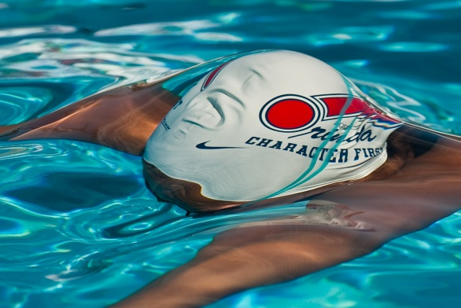

Class of 2018

“Today’s children are the future leaders in business, politics, and sports. People in such positions of authority encounter ethical dilemmas on an even grander scale. It is imperative for teens to learn about ethics and wise decision-making today in order to equip themselves for tomorrow.” Life in Perspective

Overview

We founded Orinda Aquatics nearly twenty-five years ago, with the intent of creating something different, and something that would hopefully change the lives of young athletes. We believed unequivocally that in the process of developing young athletes, it was possible to build great leaders and cultures. As our overt focus is on swimming and the inherent pursuit of success, our deepest pride is in the backdrop and foundation of this program, and this extraordinary group. We could not be more proud of this organization and what it stands for, our commitment to the greater lessons of life through sport, our commitment to putting character first, and our commitment to the community and to helping others. We sincerely hope that we have either had, or at some point will have, a positive effect on your children outside of the pool. Orinda Aquatics has truly blended success and culture in a powerful way, and the teams’ mission is now recognized by USA Swimming, ASCA, NISCA, and coaches around the world. It is our hope to show that integrity can be the most powerful force behind an athlete’s and a team’s success. And you have done that.

From a developmental perspective with young athletes, our focus and philosophy has been to develop well-balanced, efficient strokes that will support them as they grow, develop, and train and compete at higher levels. After forty years of coaching, we not only believe this is the best way to develop young athletes, but should be the only way. From a personal perspective, we hope to develop true leaders in sports and in life, to foster an environment that would support kids of all ages, to rise above the social fray and pull, and to make positive decisions and life choices.

As you and your children move on through the sport, we would encourage the emphasis to be on those things that promote a healthy, long-term swimming career and a healthy life. The time that a swimmer achieves only provides a glimpse of the process. It does not reveal work ethic, efficiency, team commitment, humility, a desire to pursue the sport, or a willingness to persevere in challenging times (which there will be). Be vigilant for these things and even be willing to abandon (early) success for the virtues and life lessons which can be obtained on a daily basis, with proper perspective. In sum, keep the focus on effort and attitude, on teammates and team success, and your child will succeed on a level that will be much more profound than a swim, a meet, a season, or an award. While many parents want early success, the real pursuit should be early growth – growth in technique, in resilience, in team support, in maturity, and in leadership.

We look back on an extraordinary year with gratitude and pride. The performance this year, from Senior to Junior Groups, has been very impressive, and would rival any in the past decade. We are truly blessed to work with such an impressive group of children and young adults, as well as our fellow coaches and dear friends. We hope this evening and this handbook do justice to the past eleven months.

Finally, we sincerely thank our swimmers and parents for supporting our team, our organization, and our message. As we close out our 2017-18 season, we review the great careers and commitments of our graduating class and look forward to a new and exciting season ahead.

Very sincerely, Donnie and Ronnie

OA College Bound

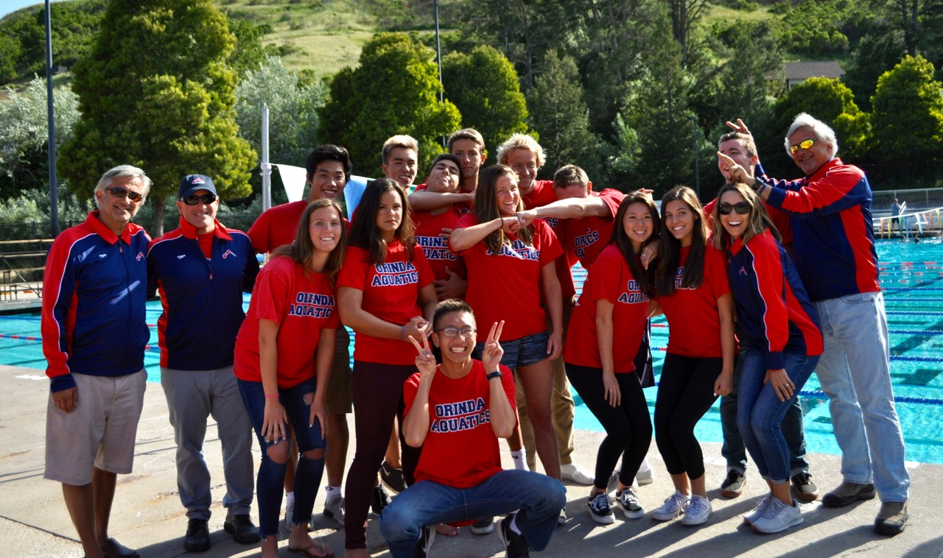

“Life is not about warming yourself by the fire. Life is about building the fire. And generosity is the match. If you want happiness for an hour, take a nap, but if you want happiness for a lifetime, help somebody”. Larry Lucchino

“Do all the other things, the ambitious things – travel, get famous, innovate, lead, fall in love, make and lose fortunes ... but as you do, to the extent that you can, err in the direction of kindness”. George Saunders - Syracuse University 2013

OA Graduating Class of 2018

Average GPA – Near 4.0

Name/HS | In the Beginning! | College | Mascot! | Notes
Megan Coplo  Campolindo | 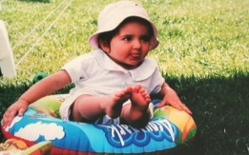 | West Point  Swimming | 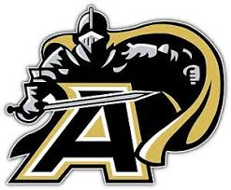 | OA Team Captain  OA/HS Inspirational Award  Swimming All American  Academic AA/scholar athlete  Congressional Nomination  Junior National Qualifier
Sophia Cavalli  Campolindo | 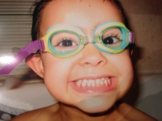 | UCLA  Swimming |  | OA Team Captain  Swimming All American  PacSwim Top Ten/NCS Finalist  Scholar Athlete  High School Inspirational
Sam  Ayers  Campolindo |  | Redlands  Swimming |  | Junior National Qualifier  OA Team Captain  NCS Finalist (2nd)  State Qualifier  Scholar Athlete
Tony Moore  Alhambra | 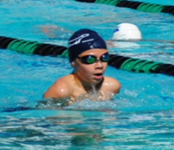 | UC Santa Barbara  Swimming |  | Junior National (LC) Qualifier  Swimming All American  NCS Finalist (2nd)  State Finalist  Scholar Athlete
Michael Wheeler  Campolindo | 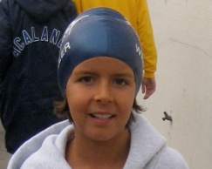 | Georgetown  Swimming |  | Swimming & WP All American  Junior National Qualifier  Academic All American  NCS Finalist  Water Polo NCS Champion
Spencer Daily  San Ramon | 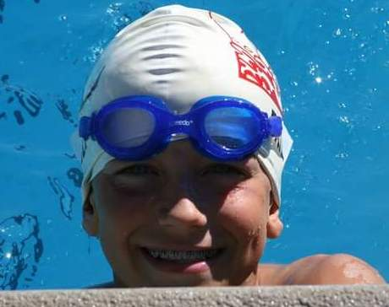 | UC San Diego  Swimming |  | Junior National (LC) Qualifier  Swimming All American  NCS Record Holder  State Champion  Scholar Athlete
Mallory Owyoung  College Prep |  | Lafayette College  Swimming |  | Scholar Athlete  PacSwim Top 25  Coaches Award Winner (OA & College Prep)  High School Team Captain
Lauren Etnyer  Acalanes | 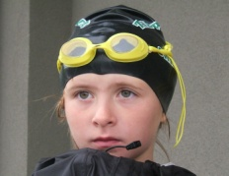 | Indiana  Water Polo |  | NCS/State Finalist (relay)  Swimming All American  Sectional Qualifier  Scholar Athlete  NCS Water Polo Champion 2014
Mason Thompson  Valley Christian |  | UC San Diego  Swimming |  | Junior National (LC) Qualifier  NCS Finalist  State Qualifier  Academic All American  High School Athlete of the Year
Derrick Garcia  Campolindo | 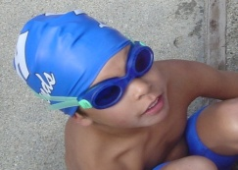 | Redlands  Swimming |  | Futures Qualifier  NCS Consol Finalist  DAL finalist  High School Coaches Award
Winston Fong  Oakland Tech | 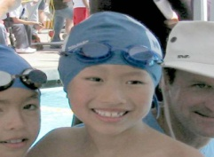 | UOP |  | State Meet Qualifier  Scholar Athlete  Far Western Qualifier  Section Champion
The following Seniors retired after the high school season
Stella Sowarby | Acalanes | UC Santa Barbara |  | Scholar Athlete
Sunny Lin | Miramonte | Amherst |  | Academic All American
Donavan Ballot | Alhambra | San Diego State |  | Sectional Qualifier
Jamie Madsen | Carondelet | Syracuse |  | Carondelet Varsity

“Live a life of purpose. Do so by filling your mind with truth, your heart with love, and your days with genuine care and kindness.” Unknown

Senior Letters

Megan Colpo - West Point

There is no greater gift that I have received, and no greater love that I have felt when I reflect upon my last nine years on Orinda Aquatics. The friends I have made, lessons I have learned, and habits I have embraced are memories that I will take with me for the rest of my life.

Like nearly every other kid in Lamorinda, I spent my summers swimming rec at Moraga Valley Pool. With each practice, dual meet, and OMPA championship I swam in, my developing passion for swimming surpassed all of my other sports. Summer became too short of a season and I began training with the Junior group in the fall and winter. By the beginning of sixth grade, I made the best decision of my life and joined Orinda Aquatics for good.

The seven years that followed have been the most influential and exceptional experiences that I have had the pleasure of being a part of. There is no hesitation when I say that this team has been the center of my life, the core of my values, and the identity with which I proclaim to others. There is a distinct feeling that overcomes me when I walk out of the community room after our Friday meetings. It is a feeling that has and will continue to dictate much of how I think and lead my life; telling me to do more, work harder, refrain from complaints, and constantly strive to improve. That room, and the ever-changing groups of people I sat with for the past five years have transformed me into the person that I am today.

As a young swimmer, I was taken under the wings of countless mentors. The love and support that I received growing up on this team is unlike any other environment I have been in. To my graduated friends Mary Ashby, Lucy Faust, and Katie Erickson, thank you providing such a positive environment and for being incredible models of leaders for me to follow and eventually become. To Emily Ward and Claire Therien, thank you for setting the example to push myself in practice, dryland, and to never miss a workout. And to all of my graduating and soon to be graduating teammates, you have been the most amazing friends I could have asked for. Having you as training partners and support groups has made all the morning practices more enjoyable, hard workouts bearable, and struggles worth it. All of your successes have been the greatest reward to me, and I can’t wait to see what the future holds for you. Just as my seniors guided me, I hope that I have done the same to you.

To the OA parents, your time, commitments, and sacrifices you make are part of what makes this team so special. From all the early morning drives to practices and hours spent getting splashed behind the blocks as timers, your efforts do not go unnoticed. I have had the greatest time talking to you on the deck and at all of the holiday parties and functions that you so graciously organize. Thank you.

To my own parents, thank you for all of the energy you have put in the past 17 years. The hard work and relentless effort you have exerted to grant me with all these opportunities has always been appreciated. Thank you for believing in me all of these years and for giving me the chance to fulfill my goals. You are inspirations and I would not be where I am today without you.

To Matt and Marc, thank you for opening up the door to year-round swimming for me. Your positivity and humor further heightened my love for swimming. Thank you for teaching me to “shoot” in breaststroke, to not to pull on the lane line, and the importance of visualization. Your stories and support throughout the years have inspired me beyond compare. You both will be greatly missed.

Donnie, I could not have asked for a better introduction into the senior group. Your commitment to the team and its values has been the greatest influence. Every day, I am motivated to adhere to these guidelines. Thank you for all of the talks, butterfly no-breath 50s, mile IMs, and breaststroke sets with multiple parachutes; while they were challenging in the moment, you helped me rediscover my capabilities. I now know that I can do a lot more than I think and while this mindset has helped me through high school, it will most definitely push me through the next four years.

Ronnie, thank you for all of the teasing, jokes, lessons, support, and help throughout these past four years. While you have taught me how to live with utmost character and humility, you have also showed me how to face adversity and demonstrate resilience. You stuck with me and stood by my side even when I was unable to improve for years. Because of this, there was never a moment where I felt hopeless. In fact, I have learned to be thankful for my struggles since they let me know what I am able to overcome. Thank you, for not only being an amazing coach, but also a devoted friend. I hope that I have served you well.

Favorite quote: | “It’s supposed to be hard. If it wasn’t hard everyone would be doing it. The hard is what makes it great.” A League of Their Own
Favorite coach saying (or bad joke): | “Colpo, drop and give me twenty” (from Ronnie), which will make me start laughing when it actually happens.
Best memory (swimming): | Having five years worth of amazing training partners. We pushed each other to be better. Their successes fills me with a great sense of pride and accomplishment.
Best memory (team): | Getting splashed at the end of the pool while cheering for my teammates, and running over to hug or high-five them at the end of a great swim.
Best lesson learned (swimming): | True success isn’t determined by times, but more by the effort you put in and the impact you have on others.
Best lesson learned (life): | Don’t complain – no matter what you are going through. It is always worse for someone else. Be thankful in the moment for all that you have.
Best “random act of kindness” from another | Countless times watching Ronnie and Donnie sit down with and pay for meals with the bus drivers on our trips, as well as random individuals they didn’t even know.
Best “random act of kindness” for another | Getting the opportunity to help coach (and help) a wide range of people, from kids to adults.
Coaches Note: Megan has represented the pinnacle of leadership, integrity, and resilience. Words cannot describe the respect and admiration that we all have for her.

Mallory Owyoung - Lafayette College

A few weeks ago, for my high school graduation, my parents gifted me a book of J.K. Rowling’s 2008 Harvard Commencement speech, The Fringe Benefits of Failure, and the Importance of Imagination. Rowling discussed the topic of failure in her speech, describing a young adult’s common fear of failure and why it isn’t so bad. By the usual standards of failure, I could say that I’ve experienced my fair share of it in swimming these past few years. Meets have flown by where I failed to make a cut, failed to drop a time. But looking back, the way that Orinda Aquatics helped me handle these “failures,” makes me realize I never truly failed. In Rowling’s speech, she states, “Ultimately, we all have to decide for ourselves what constitutes failure.” I can’t see the failure in being part of a team where both my coaches and teammates have unconditionally supported me, both in the pool, and out. This encouragement hasn’t always come from my closest friends, which attests to the true supportive nature of the team.
The coaches on OA have consistently inspired me to grow as an individual and as a member of the team, demonstrated by all their actions, quotes, and reminders. I took to heart all the times they’ve given us articles on how to be less selfish, how they’ve taught us that true happiness does not come from being materialistic, and every time they’ve reminded us to be the kind of person that others want to cheer for at the end of the lane. I continue to strive to embody the cornerstone ethics of the team. Our coaches genuinely want us to succeed as both athletes and as people. My Sophomore year, whenever I had a rough day, I had Donnie to remind me countless times that I’m not the school that I go to, and that I’m more than my times and swim results. I can’t express how grateful I was and still am for his kind words and advice.

I’m always reminded of the strong values and ethics of our team when I go to a swim meet. There are the simple things about OA that I realize I take for granted, like the slew of “good lucks” and “good jobs” sandwiching each race I swim. There are also the qualities of our team that are showcased at meets that are rare to find, such as at Clovis a few years back, when 100 swimmers came to compete, and every person that wasn’t currently swimming in finals would be behind your lane screaming their hearts out for you. Their sincere desire to watch their teammate succeed was obvious. I have never felt so much pride to be on the team as in that moment. If you walk into Donnie and Ronnie’s office, there’s a picture of the whole team cheering for a girl swimming. That photo was taken before I joined the team, and while it might represent one moment of unity and passion, I know that the same picture could be taken, year after year, as proof of OA’s lasting team spirit.

In addition to the wonderful team culture I’ve been surrounded by for the past five and a half years, I’ve been lucky enough to have parents that have sacrificed so much for my swimming, from driving me to every practice until I could do it myself, to coming to every meet to watch me swim. So thank you, Mom and Dad, for allowing me to be on a team that has had such a positive impact on me. I’m so lucky to have experienced the friendships and the encouraging environment surrounding OA during some of the most important developmental years of my life.

In her speech, Rowling reminds the graduates that “we touch other people’s lives simply by existing.” So thank you to my parents, for touching my life with your unwavering support and love; thank you to the coaches, Donnie, Ronnie, Matt A., Jill, Matt E., and Marc, for touching me and all your swimmers with your influence and drive to better our swimming and team culture; and thank you to the OA swimmers, who, in turn, touch me every day with your friendship.

Favorite quote: | “Kind words can be short and easy to speak, but their echoes are truly endless.” unknown
Favorite coach saying (or bad joke): | “The least-competitive teams have the BEST gear.” Ronnie (directed toward CPS)
Best memory (swimming): | Going to State my junior year with my high school team and seeing all the OA swimmers there.
Best memory (team): | The “haunted” hotel in Clovis – 2017 Western Zones
Best lesson learned (swimming): | I learned how to persevere when things are not going as I expected them to, especially if I’m doing what I love.
Best lesson learned (life): | I learned how to have confidence in my judgment and not succumb to peer pressure.
Best “random act of kindness” from another | I picked up Lauren at the airport EARLY in the morning so I could drive us to AM workout.
Best “random act of kindness” to another | I noticed a teammate cleaning up the team area after everyone else had left the meet.
Coaches Note: Mallory has epitomized of integrity, dedication, perseverance, and team support. She has been a great role model as an athlete and as a young adult.

Samuel Ayers - University of Redlands

Time really does fly. Four years have gone by in the blink of an eye, and now here I am, reflecting on my time at Orinda Aquatics, getting ready to take a step into the next stage of life. It will be strange not practicing from 3:15-5:00 every afternoon, but the friends that I have made, especially in the Senior 4 group, the lessons of what character means, and the memories of travel trips will never leave me.

I grew up as a dolphin at Meadow Swim and Tennis, with an addition of water polo every now and then. Swimming every day of summer and even in fall was something that became part of me, and I knew it would not leave. Being in finals at OMPA, in front of hundreds of people, swimming for my team was the highlight of each year. Then, high school came. I played water polo, but after the season ended I knew I would have to make a serious choice about swimming. Should I keep swimming at Meadow, swimming each summer, or should I take a chance on a year-round program named Orinda Aquatics? Well, I decided to take the chance, and in the winter of 2015, I started my journey down the road of long seasons and longer practices, with the hopes of becoming a successful swimmer.

Many people may think that Orinda Aquatics is just another year-round program, but there could be nothing farther from the truth. Since day one of being on the team, I have been welcomed with open arms, and compassion from each swimmer, no matter which group. From my freshman year Clovis trip, having Ryan Birdsall and Carter Chan in my room made me realize what an incredible team we have. We were all in different groups, and I was new, but they treated me like I had been on the team for years. Moving forward, having been on the team for almost four years now, I have come to realize what it means to have that kind of leadership. It is more than leading stretches and explaining dryland workouts, it is an example to others of what to do right. Orinda Aquatics has been so much more than a swim team, it is many life lessons that continue to arise, and each one will help me excel on my journey through life.

To my fellow Senior 4 swimmers, especially ‘Tha Men’. Each one of you have shown the most support and help that anyone could ask for. Always pushing me to attending to morning practices, asking to go faster in each set, and knowing how to have fun while working hard, and cheering for me, are all reasons that you all will be in my memory forever. I hope that I have lead you all well and made practices a bit more tolerable with every single throwback song. You are all extraordinary people and swimmers. Please continue to make our group the best group in the history of the team. Tony, Michael, Derrick, Mason T, Spencer, Sean, Alec, Richard, Matt, Harry, Mason L, Max, Isaac, Zach, Max, Ryan, Christian, and Cristian - each one of you brings something special, and the bond between us is something that cannot be replaced. Also, I will remember each travel trip forever, so thank you for that. I can’t thank any of you enough for making this swim season the best season that I have had.

To the parents of OA, especially my own, you are the unsung heroes of swimming. You all take the time each day to drive us to practice, take some of your weekends waiting for hours while we swim for seconds at meets, and most importantly, you take shifts as marshals at our hosted CBA+ meets. I cannot thank you enough for timing behind the blocks on winter weekends while kids soak you in frigid temperatures. You, the parents, are the one of the most important reasons that OA has become such a successful and well known team, your commitment is unparalleled, and for that, I thank you.

To Mom and Dad, there are no words that describe how grateful I am for you both. Eighteen years have flown by, and you two have stood there beside me every minute of every day. Your support, encouragement, drive, and inspiration has lead me to become what I am today. Thank you Mom, and thank you Dad.

To Donnie, you have taught me what it means to have character, what it means to be a great teammate. All of the articles, letters, pictures, and videos about ordinary people doing extraordinary things that you have shared with me have constructed an impeccable teammate, and it will most definitely carry into the next stage of my life. Throughout my life, I doubt I will ever hear anyone else say they have done a 5,000 yard swim for time, or say that to swim easy they swam no breath butterfly. Each one of those sets have made a great story and made me mentally stronger. I also must thank you for creating all of our themed workouts, from “IM awesome” to the “12 Days of Christmas”, making these sets requires lots of imagination.

To Ronnie, for all of the times that we have joked about my inability to kick underwater, keep up my stroke rate, keep a stroke count, swim IM, or swim anything over 100 yards, I have to thank you. You have taught me so much in the last two years, how to grow as a swimmer, a person, and as a teammate. I now realize that you have worked tirelessly to improve my work ethic and my ability to lead the team, and along with becoming a better person in high school, your lessons will help me in the future. Thank you for all of your humor and day-by-day coaching, and I hope my playlists and swimming are something that you were pleased with.

Favorite quote: | “Guys, it’s beautiful.” Tony Moore
Favorite coach saying (or bad joke): | “Sam, there are bad swims, and then there are your swims.” Ronnie
Best memory (swimming): | 2017 Western Zones – 100 free final with everyone cheering for me at the end of the pool.
Best memory (team): | The 2017 Sectionals van ride on the last night – “we are young”.
Best lesson learned (swimming): | It’s not an individual sport. Your group (teammates) push you to be better.
Best lesson learned (life): | Bringing others up (helping) is the best reward you could hope for.
Best “random act of kindness” from another | Alex Paterno giving me a ride home after a five hour workout.
Best “random act of kindness” to another | Giving my goggles to a random swimmer at the Huskey Invite 2016.
Coaches Note: Sam has matured into a great athlete, a selfless teammate, and a humble leader. We appreciate his dedication in the pool AND on the deck.

Mason Thompson – University of California San Diego

Four years ago I stepped onto the pool deck as a freshman. I however, was far from the typical fifteen year old walking onto the deck that afternoon. I attended private school, they didn't. This was my first swim practice, they’d been through hundreds. I had no history of athletics, they were mature athletes. Walking out to my first practice I anticipated a barrage of judgmental questions, “You go to private school, why?”, “What are your times?” and “Serious, you’ve never swam year-round before?” Fortunately, those questions never came. Instead I was embraced, similar to that of any other swimmer walking the deck that day. The only question that differed was, “Hey, what's your name?”

Donnie, throughout my time spent training I have found myself looking toward you whenever I was in need of support. No matter the circumstance or topic, you were always willing to stand alongside me and go the extra mile. Although, I was only privileged to have you as my coach for a short time, your support outside of practice has been immense. Throughout the years, I have come to you with numerous questions, concerns and favors. Never once was I turned way, and never once did you act half-heartedly to even my silliest of queries. I feel very fortunate to have been in the position to be both coached and advised by someone who wholly embodies the values of this team. I would like to give you my sincerest thanks, as without you I would not be in the position I am today.

Ronnie, with two years under your guidance I’d like to believe we each taught each other something. I taught you what it means to perform a “Full Send” and how to properly “drop the hammer” and in turn you have taught me accountability and “that in 20 years this won’t matter”. In truth, the concept of, “You do it the first time, or I don't coach you anymore,” initially appeared harsh and selfish in my eyes. I have grown to realize this is a powerful teaching lesson, and was by far the hardest concept for me to grasp. You have opened my eyes to the reality that only I can change myself, and that I am solely responsible for my actions. And with this, I want to finally thank you for believing in my potential and tirelessly working to help me improve.

Teammates, I find it hard to believe that I could find a better group of people to call my friends. From breakfasts to travel meets, some of my greatest and most influential memories have come from this team. Specifically, I would like to thank the Senior 4 group. Thank you for making every practice an entertaining and challenging event. Our group is special in that we are not strictly bonded together by our relationship to swimming, but also by the love and respect we hold for each other. Never once have I had any doubt that you wouldn't stand behind me, and never once did I feel that you weren't pushing me to be the greatest I could be. Without this group, there would be so many qualities that I would lack and experiences I would have missed. Single handedly, you have taught me more in and out of the pool than anyone else throughout high school. This team will always hold a special place in my memories, and I am saddened that the time has come for me to move on.

Lastly, I would like to thank my parents, specifically my mom, for her overwhelming support over the years. Thank you for the sacrifices you made every day in order to insure I was always on time and able to attend practice. Without your support, and consistent enthusiasm at every meet, my time on this team and my development would be far less focused and memorable.

Thank you for everything, Mason Thompson

Favorite quote: | “Send it!” – as seen on the back of the Junior Nationals T-shirt
Favorite coach saying (or bad joke): | “Try not to embarrass me” – Ronnie
Best memory (swimming): | Getting my Junior National (Winter and Summer) cuts on back to back weekends
Best memory (team): | Helping Harry get donuts for the team on his Birthday
Best lesson learned (swimming): | The only thing that matters is how hard you work
Best lesson learned (life): | Only I am responsible for my success
Best “random act of kindness” to another | Offering my home gym to anyone and bringing food from meets to others
Coaches Note: Mason’s development from freshman to Senior year has been truly extraordinary and is a testament to his discipline and fortitude (and his mother!).

Tony Moore - University of California Santa Barbara

While looking back on my three and a half years on Orinda Aquatics, I remember nothing but learning valuable lessons, meeting wonderful friends, and creating unforgettable memories, which I will cherish for the rest of my life.

I started my swimming career at five years old swimming on the Martinez Community Swim Team. As my passion grew for the sport of swimming, I made the bold decision to move to year round swimming on Orinda Aquatics. I can say now as a graduated senior that it was the best decision of my life. Setting my alarm for 4:30 a.m. three days a week was never really a highlight of my high school swimming experience, but the memories and laughs I shared at 5 o’clock in the morning will stay with me forever. The long drives from my house in Martinez weren't always easy, but I can say now that it was absolutely worth it.

From my freshman year onward, I have learned valuable life lessons from Orinda Aquatics in which I can take with me to college and the rest of my life. Besides the desire for fast swimming, I have learned that the teaching of hard work, the rid of complaints, the strive to improve, and endless support is the best gift my coaches and teammates could have ever given me. I can easily say that winning Future’s in 2017 would not at all have been the same without my coaches and teammates cheering me on right by my side. I have also learned that no feeling in the world can match the feeling of when I watch my teammates succeed. To all the swimmers in my group, thank you for always pushing me and bringing out the best of me in practice and during meets. Especially to Mason Loyet, you have been the best training partner anybody could ever ask for. I would not be where and who I am today without you pushing me right by my side. I am so lucky to have had you as a training partner and now call you a lifetime friend. To all my boys in Senior 4, thank you for all the endless laughs and support you have given me the last few years. I am so lucky to have you guys in my life as what seems like brothers to me. There is no doubt in my mind that each and every one of you will strive to do great things in your future.

To my wonderful parents: words cannot describe how thankful I am for the both of you for supporting me through all my 18 years with you. I am forever grateful for the encouragement both of you have given me and can’t imagine doing it without you guys. Because of you, I have grown up to be an independent young adult and I am excited to take the skills I have learned from you to college and the rest of my life.

To Ronnie and Donnie: thank you both for pushing me in the pool and spending endless time in effort in helping me. I came into this program as a timid freshman, but all of the laughs and the sharing of your knowledge of character made it far easier to feel comfortable. Not only am I thankful for your influence of fast swimming, but most importantly, the life lessons the both of you have taught me the past couple of years on this team. Through reading many articles and sitting through many meetings, I have learned the same thing; the qualities I have learned in swimming, such as resilience, integrity, and hard work, are far more important in the future than fast swimming. I am forever thankful for your support and help throughout my high school career. Thank you.

Sophia Cavalli - U.C.L.A.

It’s a sunny afternoon, and once again I’m trailing several laps behind everyone during a kick set. This is a common occurrence for me, because even though I’m sufficient at kicking in my races, kick sets have never really been my forte. As I crawl along at a whopping speed of 0.25 miles per hour, my eyes wander around the pool deck that has shaped who I’ve become over the past several years.

First, I see the large, newly renovated scoreboard emblazoned with huge, luminous numbers. Through the years, not only has the scoreboard kept me on my intervals and reminded me that I’ll never be able to make the interval on kick sets, but it has also displayed times after my races that remind me of the work that still needs to be done. The hard sets that I swim every day, even the “unnecessary” kick sets, are all driven by the prospect of one day lowering those times.

My gaze drifts to the pool cover reel and lane line reel, and I’m reminded of the shrill screeching sound that started most of my mornings. As displeasing as the task of taking off tarps and putting in lane lines was on harsh winter mornings, in retrospect, it helped me to learn a valuable lesson about discipline. Even though getting in the pool and working out is important, tending to external responsibilities is paramount.

As I struggle to make it to the halfway point of my kick set, I see my teammates impatiently hanging on the wall, waiting for me to finish so they can move on the next set. As some of them ecstatically cheer, “Yes Cavalli!”, I’m overtaken by a feeling of warmth and support. I’ve learned a great deal from my team. For example, I’ve learned a lot about work ethic and professionalism in training and races. More importantly, however, I’ve never felt anything but support from each one of them, even when I’m lagging behind during kicking. What would my travel meet experiences have been like, had it not been for their incessant cheering and unending positivity? What kind of swimmer would I have been if I wasn’t driven to be successful for the sake of the inspiring young men and women that I am blessed to call my team? I am eternally grateful to have had the opportunity to train with some of the most mature, humorous, and loving people around, even if they get irritated once in a while for being held up by my kicking.

Once I finally coast into the wall at the end of the kick set, I’m greeted by mixed responses from the coaches. Jill smiles at me sympathetically, Matt sincerely says “nice job”, Donnie announces to the group that the next round is with parachutes, and Ronnie stays quiet, acting like he didn’t just watch the atrocity that is my kicking. As I observe them in their work, I can’t help but be reminded of their undying care and selflessness when it comes to the best interests of their athletes. They aren’t just on the pool deck to make kids swim easy no breath fly, do eight strokes per lap catch-up free with 100% kick, or endure rigorous kick sets when they know certain kids like me won’t be able to keep up-- they’re there to ensure that each swimmer will grow into the best version of themselves they can be, in and out of the pool. More than anything, they are models of the kind of person I aspire to be, and the kind of people I let into my life.

It has been a tremendous adventure, here on the Soda Center pool deck. The memories, lessons, and people who have molded me into who I am were born from this very facility. Though my legs are burning, and I’m struggling to make it to the wall, I can’t help but feel a sweeping sensation of contentment that I’ve made the most out my time at this pool, with Orinda Aquatics.

Favorite quote: | “Real generosity towards the future lies in giving all to the present.” Albert Camus
Favorite coach saying (or bad joke): | “Well, you know what a good swimmer would do is...”--Ronnie
Best memory (swimming): | Literally, any relay that I’ve ever been in, ever.
Best memory (team): | Post-Sectionals Old Spaghetti Factory antics.
Best lesson learned (swimming): | A ‘slower’ race doesn’t mean a ‘bad’ race. There are so many important elements to a good race, so it’s important to maintain a positive attitude and acknowledge the things you do well even if your race isn’t as fast as you were hoping.
Best lesson learned (life): | I’ve learned the importance of opening my heart to others, and have come to value having positive people in my life over closing myself off from the possibility of strong relationships.
Best “random act of kindness” from another | Cheering for a kid from another team who was alone in his heat and had no one else to cheer for him.
Best “random act of kindness” to another | Giving my relay spot to someone to give them an opportunity to get on the podium at a big meet.
Coaches Note: Sophia has been of the best swimmer-water polo players we have seen and a human being of impeccable integrity and humility; a truly great role model in every regard.

Michael Wheeler, Georgetown University

I joined Orinda Aquatics when I was in sixth grade. To me, that seems like an eternity ago. In fact, a large portion of my life to date has been spent with this team. Upon reflecting on my career at Orinda Aquatics, I find it hard to comprehend just how much I have grown. What I mean by this is not physical growth, though I have grown out of the skinny frame I had and into the slightly less skinny frame that I have today. Nor am I speaking of my growth as an athlete, though I went from struggling to get Junior Olympic times to securing a couple Junior National times. I am, of course, talking about my growth as an individual, particularly regarding my perception of the world around me.

Around the same time I started swimming with Orinda Aquatics, I also started playing water polo. I split time equally between the two sports. I started off as a very mediocre player, but as I continued to dedicate time to the sport, I began to improve, to the point at which I was fortunate enough to compete at a level much higher than I had anticipated. I played varsity water polo at Campo for three of my four years and earned All-American honors my junior year. I played on a club team with players going to Stanford, Cal, UCLA and numerous other prestigious universities. All the while, I persisted that swimming was really my main sport. My water polo coaches, and some of my former teammates, would criticize me for this, even after I quit the sport to focus on swimming after my senior season. This proposed an interesting question: How can something be a team sport, when your team doesn’t give you their full support?

Swimming carries a stigma of being a purely individual sport. At Orinda Aquatics, however, this could not be further from the truth. Members of the team push each other every day to train harder and go faster. At meets, they celebrate each other’s success. At travel meets like Clovis, you can find the vast majority of the team at the end of a single swimmers’ lane, urging them the go faster. Quite frankly, I’ve never experienced a true team like this while playing any other sport. I’ve realized the importance of others, no matter how individual a task may seem. Positivity is contagious, and all it needs in order to spread is one individual.

To my teammates, thank you for pushing me to develop into the swimmer I am today, for providing support when I’m not performing as well as I would like at meets, and for providing some of the best memories of my life. I will never forget the travel meet hotel rooms, the locker room conversations, Tha Men, and the rest of the countless moments of entertainment.

To my parents, I wish I could put into words how grateful I am for your endless support. I wouldn’t be half the person or athlete that I am today without you constantly cheering for me, driving me, making me meals, and everything else you do.

To the parents of my teammates, thank you so much for your dedication to the team through hosting events, timing, working jobs around the pool deck, and raising amazing young men and women. Without you there would be no team events or meets, and essentially, no team.

To Matt and Marc, thank you for being so instrumental in not only my development as a swimmer, but also in my love for the sport. I will never forget all of the Junior Olympics meets in Morgan Hill, the annual Carson City meet, and the countless practices with you guys. Having you coach me in the Junior Group is one of the main reasons that I continued to swim and really come to enjoy year-round swimming.

To Kevin and Sophie Lai, though you are a few years removed from coaching here at Orinda, your impact on me as a person and an athlete will last forever. You brought us the 400 IM set on New Year’s Day, as well as my crown as the 400 IM champion by default. From Kevin briefly transforming me into a 200 breaststroker to Sophie making me cry through a massage, I will never forget the impact you had on my career.

To Donnie, thank you for timed 1,000s, the no-breath fly, and all of the other sets that pushed me and my teammates to our physical limits. Thank you for fixing my stroke after water polo season, and for teaching me how to “extend” my 1,000 pace for the 1,650. Without you, I wouldn’t be nearly as resilient and motivated to push through pain as I am today, both in the pool and out.

To Ronnie, thank you for continuing to believe in me as an individual. Your van driving skills do not accurately represent how positive of an influence you are on every member of the team. You have taught me to be humble and positive, no matter what the situation is. Even though you may be right that I’m not a sprinter and I’ll never be as good looking as my parents, I’ll never forget the words of encouragement you have given me over the years.

Favorite quote: | “In the middle of difficulty lies opportunity.” Albert Einstein
Favorite coach saying (or bad joke): | “Michael, your sprinting days are over.” Ronnie
Best memory (swimming): | Getting first Juniors cut at NCS
Best memory (team): | The last night at Sectionals 2017
Best lesson learned (swimming): | You can’t expect results if you are not willing to work hard and prepare.
Best lesson learned (life): | Always be kind and compassionate to others, no matter the circumstances.
Best “random act of kindness” from another | I helped some friends move into a new house after their mother had a medical emergency.
Best “random act of kindness” to another | Lydia Percin taking care of me at the hospital during my appendicitis.
Coaches Note: Michael has emerged as a tremendous two-sport athlete, a great distance swimmer (with unlimited potential), an intense competitor, and a very sincere and humble young man.

Lauren Etnyer - Indiana

There is nothing that has had a greater impact on me so far than my experience with Orinda Aquatics. The OA experience has shaped me into the person I am today, taught me life lessons, given me amazing memories, and created friendships that I know will last a lifetime. I joined OA the summer after finishing 8th grade. My dad, who had been a collegiate swimmer, encouraged me to leave the comfort zone of rec swimming and experience the world of year-round swimming. Up to that point, I didn’t even consider myself a swimmer as I had been playing year-round basketball. Well, my Dad’s convincing finally worked & I gathered the courage to head out to Campolindo for my first OA practice.

I remember how nervous I felt anticipating that day. I didn’t know anyone on the team nor did I think I was fast enough to join OA. However, within two minutes of stepping onto the pool deck a blonde-haired girl walked up to me and said “Hi I’m Caroline, Welcome to the team! What’s your name?” Immediately after, more people came up and introduced themselves and welcomed me to the team. I was overwhelmed by the friendliness of everyone. I had never experienced a team where everyone was so welcoming and supportive.

I had an amazing first summer experience with the Junior group, in fact, I missed being in the water so much during the month of August after the OA season, that I decided to start playing water polo. I had never played water polo before, but also fell in love with the sport. Once the water polo season was over in mid-November, it was time to rejoin OA and now the Senior group. Again, I was nervous joining the senior group as I didn’t know many people and I was joining it late due to the water polo season. My first practice a swimmer walked up to me and said “Hi I’m Jen Sweeney! Welcome to the senior group! You are going to absolutely love it!”. I immediately felt a sense of belonging. Something felt different about Orinda Aquatics. This was the first time I had been on a team where I felt like teammates truly wanted me to be successful. I quickly developed friendships with my teammates and found love for the sport of swimming, so much so, that I quit playing basketball to pursue both water polo and swimming.

I quickly learned balancing swim and water polo practice is no easy feat. I spent four years switching between swimming and water polo practice, sometimes even having both practices at the same time and in the same pool. While I have had water polo coaches who encouraged me to give up swimming, all of my OA coaches were incredibly accommodating with me doing both sports. In fact, Ronnie & Donnie were just as interested in how my polo season was going as they were with how fast I was swimming. OA was a breath of fresh air and I always looked forward to early winter where I would make my return to swimming after the high school polo season ended. I attribute a lot of my success in water polo to swimming, as it gave me a big advantage of speed and endurance. To all the younger water polo players/swimmers, you might encounter coaches who frown upon year-round swimming and say it’s impossible to do both, but it is possible, and you can do both well. Although it was hard at times and required discipline balancing two sports, I wouldn’t trade the experience as I would do it all over again.

Orinda Aquatics is so much more than a swim team. It is an environment that has allowed me to thrive and flourish. OA has taught me lessons that have allowed me to grow and develop as an individual. One of the biggest lessons I’ve learned is taking risks. Without taking risks you will never know what you are capable of and how much you can accomplish. If I never took the risk of joining OA I would have missed out on being a part of something so special. Another lesson I’ve learned is you don’t have to be the fastest on the team to be successful. Although I was never the fastest swimmer, my time on Orinda Aquatics was filled with many successes. I learned how to be a leader and live a lifestyle that I am extremely proud of. I have learned to lead by example as well as find my voice on this team, as a result of so many role models.

Thank you to my teammates for being the best friends I could ask for. You have shown me what being a good teammate really means. I couldn’t get through the morning practices and long swim meets without you. You have all inspired me to become the best version of myself.

Thank you to Matt and Marc for welcoming me into the junior group and onto the team. You helped me find my love for swimming and I will greatly miss your sense of humor and the conversations I have with you both after my practice ends and you get ready to coach the Junior group.

Ronnie, Donnie, and Matt, thank you for pushing me beyond what I thought I was capable of. You have taught me to be a leader and maintain high character even if that goes against the social norms. You have taught me the importance of a good work ethic and being mentally tough.

To my Mom & Dad, thank you for all the support you have provided me over the past nineteen years. Thank you for making every game and swim meet, waking up early to drive me to morning practice, and giving up your weekends travelling to tournaments & meets. Without your incredible support, belief & love, I never would have achieved my goals.

Orinda Aquatics is so special, and I wish everyone could experience a part of it or have something as positive and influential in their life. I have been a part of many teams but saying goodbye to Orinda Aquatics is going to be the hardest. I feel extremely grateful to have been part of Orinda Aquatics and know I’m well prepared for the challenges ahead at Indiana.

Favorite quote: | “He who is not courageous enough to take risks will accomplish nothing in life.” Muhammad Ali
Favorite coach saying (or bad joke): | “You had a really good practice today. I might have to call Ray Looze (Indiana swim coach) about you swimming at Indiana with Lilly King.” Ronnie
Best memory (swimming): | Swimming a lifetime best time in the 400 Free Relay at the State Meet for the last swim of my high school career.
Best memory (team): | Flying down to San Diego with OA and swimming at Sectionals.
Best lesson learned (swimming): | Trust the process. In times when you are struggling, keep working hard and trust that it will pay off.
Best lesson learned (life): | Take risks. Without taking risks, you will never know what you are capable of.
Best “random act of kindness” from another | Jen Sweeney taking me under her wing freshman year.
Best “random act of kindness” to another | Comforting a teammate who did not get into her top college choice.
Coaches Note: Lauren has been as humble and sincere as she has been dedicated and driven. She has been an incredible representative this team’s character and maturity.

Spencer Daily – University of California San Diego

Swimming has been such a major part of my life since I was nine years old. Starting out at rec swimming then finally joining Orinda Aquatics. This was a big step in my swimming career and paid off tremendously propelling me into college and beyond. This team has taught me the value of hard work and that nothing comes easy in life. Ronnie and Donnie, your work ethic has inspired me to be the best swimmer and person I can be and I will make sure to carry it on in the years to come.

I am so grateful for the friends I have made on this team. I have such an amazing group that supports and pushes each other through the good and bad days. We grew up together on this team and they have become more than just friends, they have become family.

If I had to leave this team with one piece of advice, it would be a quote from Michael Phelps, “You can’t put a limit on anything. The more you dream, the farther you get.” This mindset has helped me all these years and I hope that whoever has the drive to and passion to succeed, it will help them to. Thank you so much!

Derrick Garcia – University of Redlands

Looking back on my high school swim career, I really wished I had joined Orinda Aquatics earlier. My three years on this team has been a great time and I’m excited to have a similar experience in college. However, OA is more than just a swim team. This team has given me some of the best friends and influences that I could ever ask for. The wisdom this team has granted me has shaped me to be the man I am and the man I’ll continue to be.

Before Orinda Aquatics I was a Sleepy Hollow Legend. Swimming every summer was a great way to pass the days but I never really could reach my full potential with twelve or so weeks of training. Believe it or not, I was a backstroke and breaststroke kind of guy in rec swimming. When the end of eighth grade came, I had to choose between two conflicting spring sports, baseball, and swimming. Because of Orinda Aquatics, I’ve never doubted my decision to swim for the rest of my career. I never thought that I would join a year-round team for swimming. But after my “crazy” success on JV (JVI High-Point and MVP), I moved myself to the next level.

The culture around OA has always been welcoming regardless of the skill level of any swimmer. Each time I moved to a new group I found new friends. I remember distance sets with Arman in Senior 1 with Sophie, being slow on kick sets with Callan in Senior 2, lifting with Carson in Senior Three, and bonding with my latest family in Senior 4. Every group shifted my perspective on swimming and changed my overall character.

The one thing that I would want younger swimmers to take away from me is that you all can be leaders. We always preach senior leadership, but juniors and underclassmen can positively motivate even the seniors. Isaac, Richard, and Sean really pushed me in my senior year and I don’t know if I would have gotten my futures cut without them.

Thank you to Mom and Dad and every coach I have had over the years. You have all impacted me in a positive way and made me who I am.

Favorite quote: | “Hard work beats talent, when talent doesn't work hard.” - Tim Notke
Favorite coach saying (or bad joke): | “Derrick! It’s descend time, not effort” - Kevin
Best memory (swimming): | Getting my futures cut in the 100 fly
Best memory (team): | Feeling immense support from my team after getting my Futures cut
Best lesson learned (swimming): | There isn’t an easy path to success
Best lesson learned (life): | Real success is directly proportional to character
Best “random act of kindness” to another | Influencing the freshman I tutored for this year
Coaches Note: In a short time, Derrick has emerged as a great success story, and one of the most well-liked and respected team members we have seen.

Sunny Lin - Amherst

I would first like to thank everyone who made Orinda Aquatics possible for me, from my supportive parents to the fabulous coaches. I was blessed to be a part of a singular team culture, one that emphasizes the communal over the individual. There is no team that compares to this one in terms of spirit, culture, or character. I’m not a world class swimmer, but Orinda Aquatics has helped me develop a world-class character. Through Orinda Aquatics, I have learned how to maintain a challenging schedule as well as how to empathize with others and understand their struggles. I’ve managed to succeed academically, gain new friends, and learn more about myself. Most importantly, Orinda Aquatics taught me about decisions and values, and that every decision you make, comes with consequences or benefits and affect you and define you. If have learned that if you make the right choices, you will naturally find your way through a grounded and fulfilling life. I have also learned to truly love this sport and I now want to continue in some capacity.

I would like to again thank all the coaches, my parents, my friends, and the team. I will always remember Orinda Aquatics as a place to grow and be supported unconditionally. Thank you.

Winston Fong – UOP

Like many others that are on and have been on Orinda Aquatics, I came from the Montclair Swim Team. Because of this, I was used to having one coach and about 30 peers, so coming to OA was a huge change. I only knew about four people when I first joined OA but I didn't feel like an outsider because the coaches and my teammates welcomed me like I was one of their own.

The biggest change I realized was the inclusive culture. When the junior group was assigned senior group buddies, I was assigned to Justin Lammert, my first year. He would say hi to me every time we saw each other and support me at meets. This little interaction made me feel even more welcomed and included.

To all the coaches, thank you for spending countless hours telling supporting us and teaching us discipline, a critical skill that will help me as I move on to college.

To my teammates thank you for being great friends and great competitors in workout. Thanks for criticizing me when I sandbag a set or miss an interval. Thanks for making me laugh and I hope I made you laugh at some point. I couldn’t ask for better friends.

To the parents who are the backbone of the team, who drive us to practice and meets at unreasonably early times, thank you. We would not be able to have events that encourage team bonding and teamwork without your commitment and dedication to the team.

Thank you and congratulations!

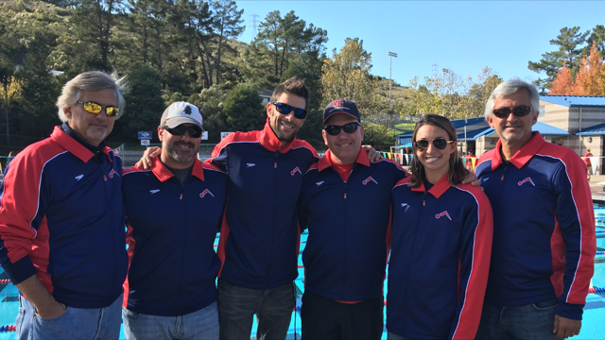

"Wheresoever you go, go with all your heart." Confucius
“Live a life you are proud of”... unknown

“Not everybody can be famous. But everybody can be great, because greatness is determined by service.” Martin Luther King, Jr.
“A truly strong person does not need the approval of others any more than a lion needs the approval of sheep. Vernon Howard

Attitude can be our best friend or worst enemy; the librarian of our past, the speaker of our present, and the prophet of our future. John Maxwell

