Theme Week 2012

An OA Tradition - (Famous) Theme Workouts!
(In Bob Steele's book "Games, Gimmicks and Challenges", he included a number of these Orinda Aquatic Theme Workouts)
- Thanksgiving
- Christmas/Holiday's
- Halloween
- 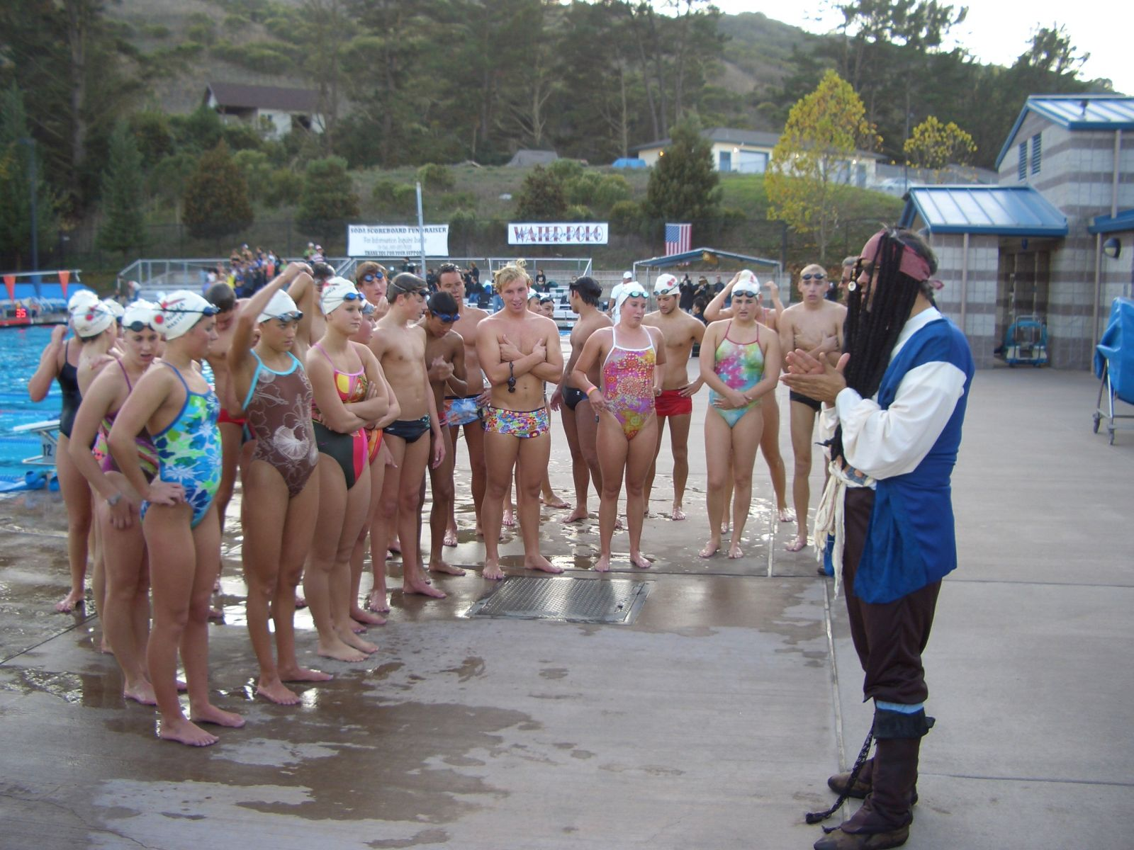
- Finals Week
- Graduation
- New Year's
- Fourth of July
- Summer Theme Week followed by Karaoke!
- 