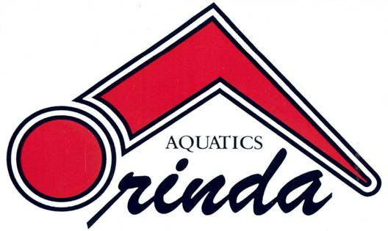 | Orinda Aquatics  2019 SEE’S CANDIES FUNDRAISER

Fall is upon us and before you know it, the Holiday season will be here! That means it’s time for our annual See’s Candies sale!

Orinda Aquatics is a non-profit 501(c)3 corporation that serves nearly 1,000 swimmers in the Lamorinda and surrounding areas in many capacities. The organization runs the year-round program as well as fall and high school seasonal swimming, masters swimming, and clinics, for the rec swimming and adult community. Orinda Aquatics volunteers to speak to organizations on team character and culture nationally and internationally, supports swimming in Swaziland, Africa and youth learn-to-swim at the Harbor House in Oakland, and assists the community with staff development and education. This effort and your support, helps maintain these programs and assists in offsetting our annual pool and administrative costs. This is the only true fundraiser for Orinda Aquatics, and we are very grateful for your participation and support.

Getting started is easy. Compile a list of all possible people who might like to purchase candy for company gifts, teachers, coaches, customers from previous years and make your sales pitch! They love the quality product you are selling, and supporting you is a side benefit. Parents can take the brochures to work for you. The minimum requirement is $325.00 in sales from each individual swimmer or $500 in sales from each swimming family. Please provide one check for the entire order placed made out to Orinda Aquatics. Absolutely no cash. Please be sure to fill out order forms completely and double check to be sure the dollar amount matches the candy order. If multiple order forms have been completed, be sure the entire order matches the number of items ordered. And please provide a contact name and number with your order.

If you choose to not sell candy, the buy-out option is $225.00 for a single swimmer and $275.00 for multiple swimmer families and you must “Opt-Out” by Tuesday, November 19th, on the website. For this option, accounts will be billed December 1st. Please note; for partial sales, there is a “partial buy-out” (see Parent Policy letter). Additionally, the buy-out is not tax deductable per IRS rules.

Top 5 overall sellers will receive an additional prize. Watch the weekly announcement emails for more information along the way. If the junior group meets or exceeds their goal amount of $12,500, they will be treated to a pizza party.

Orders Due: Tuesday, November 19, 2019. Please put completed sales forms and attached payment in the drop box marked “See’s” on the desk in the coaches’ office. Sorry, late orders cannot be accepted.

Candy pick-up date: Tuesday, December 3, 2019 at the Soda Center Community room.

Questions: Contact Pam Hemming (phemming@sbcglobal.net) or Jennifer Lurie (jenniferlurie@gmail.com). Any financial questions should be directed to the Board.

Go to http://www.orindaaquatics.org under “Upcoming Events” for a marketing flyer if you wish to extend to potential customers. Thank you very much for your support!

