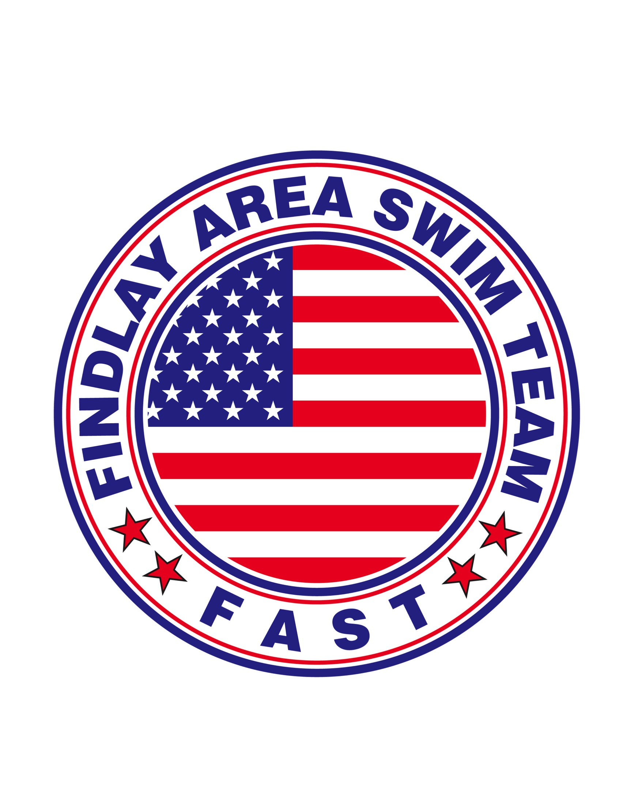

Pick 3 Fundraiser

Help support your local competitive swim team.

**** only $10 a ticket ****

Purchase a ticket from a FAST Family prior to June 28, and
get 31 chances to win $50 – every day during the month of
July 2018!
Tickets are $10 each and if your number matches the nightly
Ohio Lottery Pick 3 number (in the same order) you will win
that day’s prize of $50.

You can win as many times as you’d like
throughout the month!

Visit our web site at www.fastswim.com if you have any questions.

