Findlay Area Swim Team- 2017- 2018
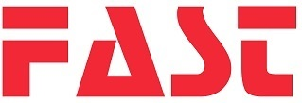
Color Block Parkas
*Please Circle One*
Male/Female Jacket: (102.00) XXXS XXS XS
S M L XL
FAST is Heat Pressed On back of jacket standing 4" tall
LOGO $15.00 (Optional) (Pictured Above)
NAME $6.00 (Optional)
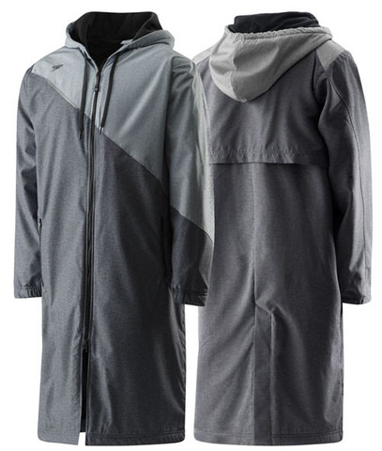

NAME and PHONE:
ADDRESS:

