Findlay Area Swim Team- 2017-2018
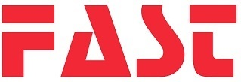
Streamline Warm Ups
*Please Circle One*
Male/Female Jacket: ($46.00) XS S M L XL
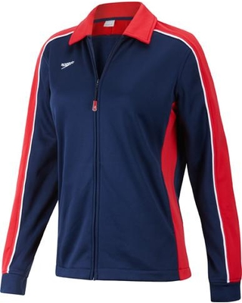
Male Jacket Only Available: XXL
Youth Jacket: ($38.00) S M L
LOGO $9.75 (Optional) (Pictured Above)
NAME $6.00 (Optional)

Male/Female Pants: ($38.00) XS S M L XL
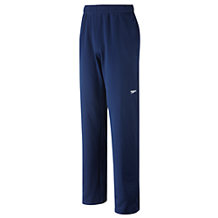
Male Pants Only Available: XXL
Youth Pants: ($30.00) S M L
NAME $6.00-_____________________________

NAME and PHONE:
ADDRESS:

