Parent Name: __________________________________________________________________

Swimmer Name: ___________________________________ (1 swimmer per order form)

E-mail: ________________________________________________________________

Phone: (______)_________________ Pool ________________ Level ___________

Name to be printed on cap (please clearly print this information):

_______________________________________________

Note: Our cap design is seen below and the names you choose to be on your cap will be in white just below the POLAR BEARS on both sides.
*When ordering, please remember you must order 2 caps per name. Please note that a set of 2 is considered 1 cap when filling in the quantity below so by putting in “1” you will automatically get your 2 caps.*
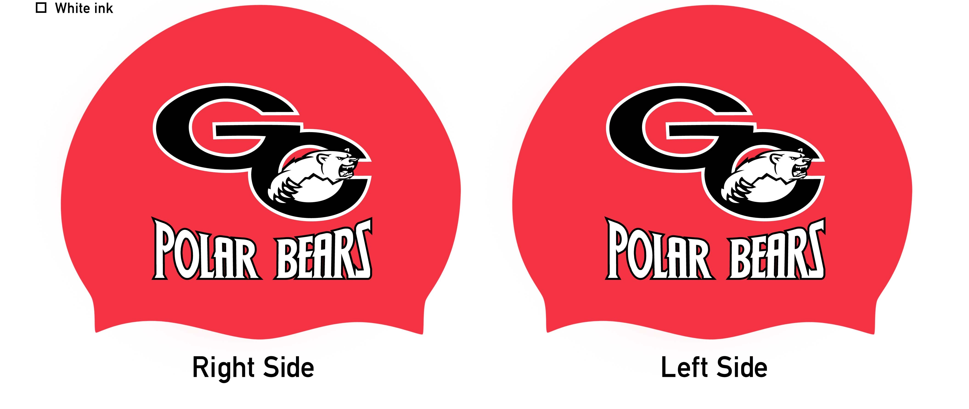

ORDER INFORMATION
Silicone Caps ($30 for 1 order which = 2 caps): Order Quantity ______ X $30 = $_______
Latex Caps ($20 for 1 order which = 2 caps): Order Quantity ______ X $20 = $_______
Total Due = $________ Check Amount Enclosed = $_______ or charge $______ my credit card

**Give your order (order form and check payable to GCSTO) to your coach at the pool and they will put it in coach Nye’s box. You may also email coach Nye your order form and request your credit card in your team portal be billed for these caps. Either MUST be done by September 30, 2018 as the cap order will be placed on Monday, October 1 & no additions to the order can be made at that time.**
Steve Nye: stevenye@sbcglobal.net

