www.usaswimming.org  www.swimohio.org | The Greater Columbus Swim Team of Ohio GCSTO  614-478-5445 www.gcsto.com
From The GCSTO Offices March 21, 2018
GCSTO Strong… GCSTO Proud!
ATHLETE PERFORMANCE INFORMATION

****** Barbara Kay Mini-Meet ******

Swimmers of The Meets

Novice
Brooks Weiland: Brooks is the Novice Swimmer of the Meet for the Barbara Kay Championship Meet. Although this was Brooks' first time participating in one of our meets you would never have guessed that if you were in attendance and had the opportunity to see her swim! She looked as though she had been racing all season! She swam events on both days and had really nice times for her first time out! Nice job Brooks!!

100% Lifetime Bests
Isabella Peirano
Samarth Sastry

All-But-One Lifetime Bests
Tej Andrews
Maya Anger
Andrew Conway
Ewan McKay

Top 10 Total Time Dropped At Meet
1 - Sonny Alioto -64.61… WOW… MONSTER Time drops!
2 - Ryan Binting -9.71
3 - Tej Andrews -9.29
4 - Lillian Essex -8.22
5 - Kash Kline -7.53
6 - Bella Peirano -3.33
7 - Lucy Ryan -2.53
8 - Talia Toler -2.36
9 - Joe Baylis -2.04
10 - Maya Anger -.28

(Total – 109.90 seconds or 10.99sec average per person)

****** Ohio Senior Circuit Meet ******

Swimmers of The Meets

Level 4
Tannor Lambert: Tannor had an absolutely incredible meet capping off a year of tremendous growth and hard work! Tannor swam 6 events at this meet and achieved 8 LTB’s! Yep… 6 best times in the preliminary swims of all 6 of his events and, after making it back in finals in 2 of those events, he swam even faster still in finals to make it 8 LTB’s! Tannor’s dedication to improvement and increase in focus on technique and strength this year is the reason for his success. It certainly paid off for him at the meet this weekend for sure. Congratulations Tannor!

Level 5
Hayden Yeager: Hayden capped off a fantastic season by swimming to lifetime best times in 5 of 6 events at the Senior Meet. He dropped a combined 18.81 seconds, including a 7 second drop in the 200 Breast (2:21.40) and a 5 second drop in the 200 Free (1:57.33). Not only did he have great time drops, but he also qualified for finals in all of his eligible events. Hayden had a very impressive season for his first year training with Level 5. I'm excited to see what he has in store for next season!

100% Lifetime Bests
William Ave
Paul Buckley
Lucas Elizondo
Natanas Gaver
Tannor Lambert

All-But-One Lifetime Bests
Justin Barnhart
Cade Helms
Hayden Yeager

Top 10 Total Time Dropped At Meet
1 - Tannor Lambert -51.87… OUTSTANDING for a Senior Championship Meet!
2 - Lucas Elizondo -31.01
3 - Paul Buckley -20.51
4 - Hayden Yeager -16.27
5 - Olivia Ave -13.90
6 - Nate Garver -11.64
7 - Will Ave -9.08
8 - Justin Barnhart -8.01
9 - Harvey Culbert -5.35
10 - Parker Hamilton -4.57

(Total – 172.21 seconds or 17.22sec average per person)

Within 3% Of State Age Group Cuts Team
Cade Helms (13-14): 100 free, 200 free, 100 back, 200 back, 200 IM
Kasey Lichtner (13-14): 50 free, 200 free, 200 IM
Annaliess Stith (11-12): 100 breast, 200 IM, 100 IM
Zoey Callander (11-12): 50 free, 50 Breast
Sam York (11-12): 50 back, 50 free
Anna Denney (13-14): 100 free
William Harpster (11-12): 50 free
Gavin Lewis (11-12): 50 back
Andy Li (11-12): 100 back

Within 6% Of State Age Group Cuts Team
Kasey Lichtner (13-14): 500 free, 1650 free, 100 back, 200 back, 100 fly
Annaliess Stith (11-12): 100 fly, 50 back, 200 free
Eli Stoll (13-14): 200 free, 500 free
Anna Denney (13-14): 50 free, 500 free, 200 IM
AJ Denny (13-14): 50 free, 100 free, 100 Breast, 200 Breast
Andy Li (11-12): 100 IM, 50 free
Alyssa Li (11-12): 100 back, 50 free
Jacob Crosson (9-10): 50 Breast
Gavin Lewis (11-12): 100 IM, 100 Fly, 200 free
Greyson Thomas (11-12): 50 free
Wylee Whittredge (11-12): 100 Breast

(The Following Teams Are Determined Off of Times Performed As of 3-1618)

GCSTO’s State Age Group Team
Gold Level (6 or more individual events)
Eli Stoll (13-14): 50 free (23.96), 100 free, 100 back (54.72), 200 back (2:01.79), 100 breast (1:04.89), 200 breast (2:20.30), 100 fly (55.39), 200 fly (2:02.87), 200 IM (2:09.40), 400 IM (4:36.60)
Andy Li (as a 9-10): 50 free (30.48), 100 free (1:07.10), 50 back (34.18), 100 back (1:13.50 ), 50 breast (37.74), 100 breast (1:23.45 ), 50 fly (33.27 ), 100 fly (1:16.44), 100 IM (1:14.16 ), 200 IM (2:41.09)
Olivia Lewis (9-10): 50 free (29.73), 100 free (1:06.65), 50 back (34.36), 50 breast (37.99), 100 IM (1:17.93), 100 Breast (1:25.67), 100 Back (1:17.51), 50 fly (33.88), 200 IM (2:49.22), 200 free (2:28.88)

Silver Level (3-5 individual events)
Annaliess Stith (11-12): 50 free (27.15), 100 free (58.61), 50 breast (34.42), 50 fly (30.04), 200 Breast (2:51.15)
Kasey Lichtner (13-14): 100 free (56.16), 100 breast (1:10.28), 200 breast (2:33.10), 200 IM (2:18.07), 400 IM (4:54.42)
Andy Li (current 11-12): 50 back (32.73), 50 Fly (31.11), 50 Breast (36.79), 200 back (2:29.66), 100 breast (1:19.32)
Gavin Lewis (11-12): 50 Free (28.00), 50 Fly (31.31), 100 free (59.45)

Bronze Level (1-2 individual events)
Ally Grieshop (13-14): 1650 free (18:53.15)
Zoey Callander (11-12): 50 free (27.93)
Chloe Albrecht (11-12): 50 free (27.99)
Cade Helms (13-14): 50 free (24.21), 100 fly (59.22)
Alyssa Li (11-12): 50 Back (32.21)

Sectional Team
Stephy Aeling – Relays
Paige Christy – Relays
Harvey Culbert – 100 Breast, 200 Breast, 100 Fly, 200 IM, 400 IM
Nate Gaver – 50 Free, 100 Free
Hannah Olger – 50 Free, 100 Free, 100 Back
Grant Cicci – 50 Free, 100 Free, 100 Fly
Graham Carpenter – 100 Breast, 100 Fly
Kasey Lichtner – Relays
Kassidy Pastor – Relays
Caroline Ramos – Relays
Grace Riddle – 50 Free, 100 Free, 200 Free, 100 Back, 200 Back
Eli Stoll – 100 Back
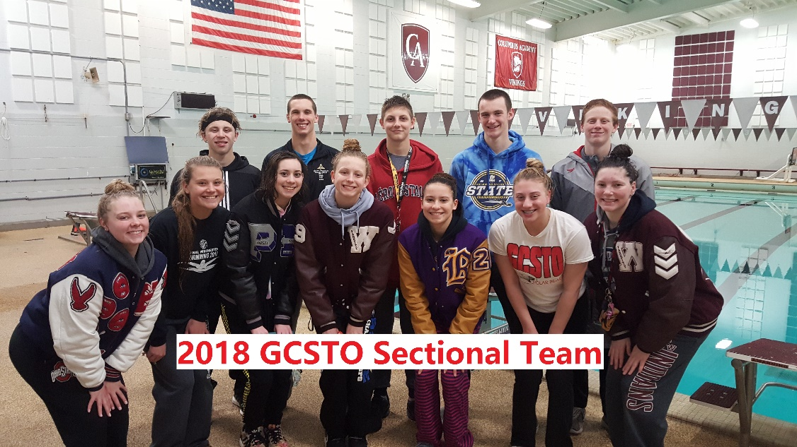
Future’s Team
Harvey Culbert – 100 Breast, 200 Breast
Hannah Olger – 50 Free
Grant Cicci – 50 Free, 100 Free
Grace Riddle – 100 Back, 200 Back

Junior National Team
Harvey Culbert – 100 Breast, 200 Breast
Grant Cicci – 50 Free

NEW TEAM RECORDS

13-14 Boys
100 Back – Eli Stoll: 53.80
200 Fly – Eli Stoll: 2:00.18
200 IM – Eli Stoll: 2:00.55

 | THANKS FOR BEING A PART OF OUR TEAM!!!!!

