www.usaswimming.org  www.swimohio.org | The Greater Columbus Swim Team of Ohio GCSTO  614-478-5445 www.gcsto.com
From The GCSTO Offices March 28, 2018
GCSTO Strong… GCSTO Proud!
ATHLETE PERFORMANCE INFORMATION

****** Ohio Swimming JO ChampionshipMeet ******
Swimmers of The Meets

Gavin Lewis: Gavin had a breakthrough meet for sure. His swam LTB’s (Life Time Bests) in ALL 3 of his events and his 4.86 time drop came in just those 3 events… pretty impressive indeed! Gavin has focused a tremendous amount on his technique this year which, when matched with his personal growth proved to be a fantastic one-two punch in terms of performance excellence at this meet. Congrats Gavin.
Olivia Lewis: Bringing together a one-two punch of her own to also be named as a SOTM like her brother, Olivia also had a monster performance at this meet. She swam in 7 events (all of which were timed finals so she only had 1 chance to do a LTB) and achieved LTB’s in 6 of those events scooping up the 2nd place positive in our Top 5 time drop list!! She also picked up her 2nd AAA time in the meet in the 100 breast to compliment her AAA time in the 50 breast, which she also lowered at the meet! Again, she’s proof that tremendous focus on technique and a positive outlook can achieve wonders. Congrats Olivia.
Kasey Lichtner: Kasey also had a fantastic meet at her last age group meet! She swam 6 events and earned lifetime best times in every event! Kasey competed in the high school Sectional and District Championship meets in the 50 Free and 100 Breast, and she still beat the times she hit at those meets. She qualified for finals in the 100 Breast, finishing 16th, and the 200 Breast, finishing 8th. She just missed a Top 16 finish in the 400 IM, coming in 18th place. Kasey earned three NAG "AAA" times: 50 Free (25.45), 100 Free (55.64), and 200 Breast (2:29.97). She will also be competing at the SPEEDO Sectional Championship meet to finish the season.
Eli Stoll: Eli had a phenomenal meet, swimming lifetime best times in all 7 events. Not only did he get best times, but qualified for finals in each event, with his lowest finish being 11th place and highest finish being 4th place (twice). He achieved NAG "AAA" times in every event and a "AAAA" time in the 100 Back. Eli broke three 13-14 GCSTO team records: 100 Back - 53.80 (beating his own time of 54.72 set at Circle City this year), 200 Fly - 2:00.18 (previously 2:02.04, set in 2003), and the 200 IM 2:00.55 (previously 2:02.36, set in 1982). Eli will be competing at the SPEEDO Sectional Championships to wrap up the season, March 22-25.
100% Lifetime Bests
Gavin Lewis
Alyssa Li
Eli Stoll
All-But-One Lifetime Bests
Olivia Lewis
Kasey Lichtner
Top 5 Total Time Dropped At Meet
1 - Eli Stoll – 15.59 seconds
2 - Olivia Lewis – 9.07
3 - Kasey Lichtner – 6.96
4 - Gavin Lewis – 4.86
5 - Andy Li – 1.84

(Total – 38.32 seconds or 7.66sec average per person)

****** USA Swimming SPEEDO Sectional Championhip Meet ******

Swimmers of The Meets

Gracie Riddle - Grace swam 5 individual events at the meet and got a best time in the 100 Free (52.60) and 200 Free (twice...1:55.98 at prelims, then 1:55.77 at finals). She was only 0.07 seconds off her best time in the 50 Free as well. She qualified for finals in the 100 Free and 200 Free, finishing 16th and 28th, respectively. She also swam in four relays, including the 200 Free relay which finished 16th overall. Grace has focused in on her freestyle more this season and her work is definitely paying off!

Graham Carpenter - Graham swam 4 individual events and earned lifetime best times in three of the four. He went a best time in the 50 Free (22.43), then beat that time leading off the 200 Free relay with a split of 22.28. He also earned a best time in the 100 Free (48.23) and split a 47.45 in the 400 Free relay. Graham earned his first Futures cut by clocking a 51.51 in the 100 Fly. He was also part of four relays that all placed in the top 6 and were all under Futures cuts. This was a great meet for Graham to finish his last short course season before college next year.
100% Lifetime Bests
Grant Cicci
Nate Gaver
Eli Stoll

All-But-One Lifetime Bests
Graham Carpenter

Top 5 Total Time Dropped At Meet
1 – Eli Stoll – 8.52 seconds
2 - Nate Gaver – 6.68
3 - Grant Cicci – 3.00
4 – Harvey Culbert – 2.74
5 - Graham Carpenter – 1.50
(Total – 22.44 seconds or 4.49sec average per person)

GCSTO’s State Age Group Team
Gold Level (6 or more individual events)
Eli Stoll (13-14): 50 free (23.96), 100 free, 100 back (54.72), 200 back (2:01.79), 100 breast (1:04.89), 200 breast (2:20.30), 100 fly (55.39), 200 fly (2:02.87), 200 IM (2:09.40), 400 IM (4:36.60)
Andy Li (as a 9-10): 50 free (30.48), 100 free (1:07.10), 50 back (34.18), 100 back (1:13.50 ), 50 breast (37.74), 100 breast (1:23.45 ), 50 fly (33.27 ), 100 fly (1:16.44), 100 IM (1:14.16 ), 200 IM (2:41.09)
Olivia Lewis (9-10): 50 free (29.73), 100 free (1:06.65), 50 back (34.36), 50 breast (37.99), 100 IM (1:17.93), 100 Breast (1:25.67), 100 Back (1:17.51), 50 fly (33.88), 100 IM (1:17.93), 200 IM (2:49.22), 200 free (2:28.88)
Kasey Lichtner (13-14): 50 free (26.99), 100 free (56.16), 100 breast (1:10.28), 200 breast (2:33.10), 200 IM (2:18.07), 400 IM (4:54.42)
Silver Level (3-5 individual events)
Annaliess Stith (11-12): 50 free (27.15), 100 free (58.61), 50 breast (34.42), 50 fly (30.04), 200 Breast (2:51.15) & also swam the 200 free relay and the 200 medley relay
Andy Li (current 11-12): 50 back (32.73), 200 back (2:29.66), 50 Fly (31.11), 50 Breast (36.79), 100 breast (1:19.32) & also swam the 200 free relay and the 200 medley relay
Gavin Lewis (11-12): 50 Free (28.00), 50 Fly (31.31), 100 free (59.45) & also swam the 200 free relay and the 200 medley relay
Bronze Level (1-2 individual events)
Ally Grieshop (13-14): 1650 free (18:53.15), 1000 free (11:44.32)
Zoey Callander (11-12): 50 free (27.93), 50 breast (36.26) & also swam the 200 free relay and the 200 medley relay
Chloe Albrecht (11-12): 50 free (27.99) & also swam the 200 free relay and the 200 medley relay
Cade Helms (13-14): 50 free (24.21), 100 fly (59.22)
Alyssa Li (11-12): 50 Back (32.21) & also swam the 200 medley relay

Sectional Team
Stephy Aeling – Relays
Paige Christy – Relays
Harvey Culbert – 100 Breast, 200 Breast, 100 Fly, 200 IM, 400 IM
Nate Gaver – 50 Free, 100 Free
Hannah Olger – 50 Free, 100 Free, 100 Back
Grant Cicci – 50 Free, 100 Free, 100 Fly
Graham Carpenter – 100 Breast, 100 Fly
Kasey Lichtner – Relays
Kassidy Pastor – Relays
Caroline Ramos – Relays
Grace Riddle – 50 Free, 100 Free, 200 Free, 100 Back, 200 Back
Eli Stoll – 100 Back
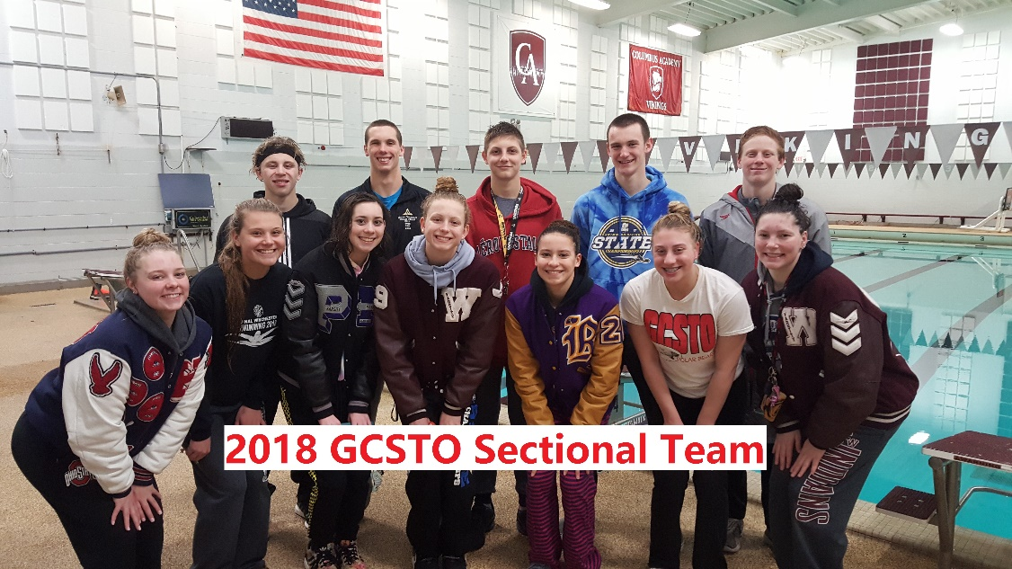
Future’s Team
Harvey Culbert – 100 Breast, 200 Breast, 400 IM
Hannah Olger – 50 Free
Graham Carpenter – 100 fly
Grant Cicci – 50 Free, 100 Free, 100 Fly
Grace Riddle – 100 Back, 200 Back
Men’s 200 Medley Relay – Eli Stoll, Harvey Culbert, Graham Carpenter, Grant Cicci
Men’s 400 Medley Relay – Eli Stoll, Harvey Culbert, Graham Carpenter, Grant Cicci
Men’s 200 Free Relay – Nate Gaver, Harvey Culbert, Graham Carpenter, Grant Cicci
Men’s 400 Free Relay – Nate Gaver, Harvey Culbert, Graham Carpenter, Grant Cicci

Junior National Team
Harvey Culbert – 100 Breast, 200 Breast

Grant Cicci – 50 Free

NEW TEAM RECORDS
13-14 Boys
100 Back – Eli Stoll: 53.19
200 Fly – Eli Stoll: 2:00.18
200 IM – Eli Stoll: 2:00.55

15-16 Boys
200 Breast – Harvey Culbert: 2:05.51
400 IM – Harvey Culbert: 4:05.19

17-18 Boys
200 Breast – Harvey Culbert: 2:03.77
200 Free Relay – Graham Carpenter, Grant Cicci, Nate Gaver, Harvey Culbert: 1:26.58
400 Free Relay – Graham Carpenter, Grant Cicci, Nate Gaver, Harvey Culbert: 3:09.58

Open Men’s (any and all ages inclusive of 19 & over)
200 Breast – Harvey Culbert: 2:03.77

Congratulations to ALL of our swimmers this year for their outstanding accomplishments!

 | THANKS FOR BEING A PART OF OUR TEAM!!!!!

