GCSTO’s Premier Private Coaching Program
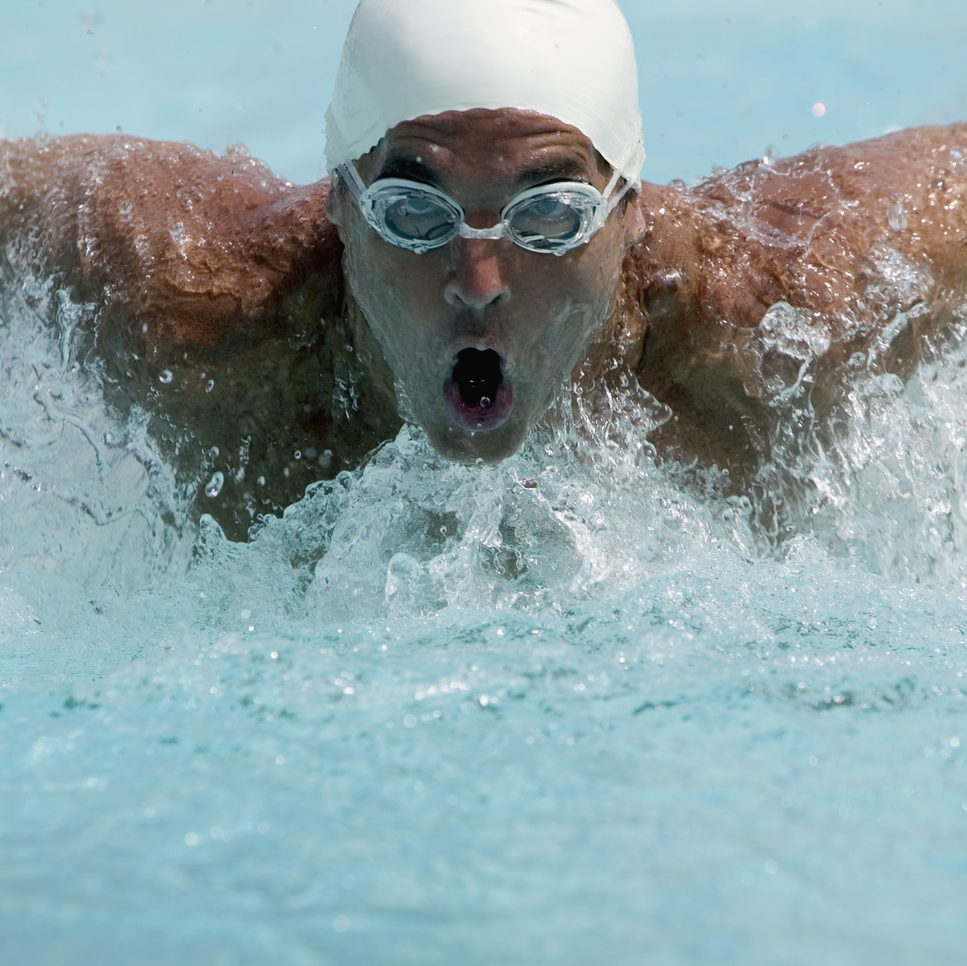
We are proud to offer our Premier Private Coaching Program to any age group, senior or adult athlete interested in improving their technical skills in this sport. Stroke technique, kick technique, turn technique, start technique, and more can be covered. You name it… we can help you with it! Sessions for our Premier Private Coaching Program can be set up with any one of our tremendously experienced staff members on a schedule that fits best for you. Lessons can be held at most any of our locations based on our available time at these facilities. In all cases, pre-registration is required and your lesson days & times are set between you and your contracted coach.

Staff Member Cost (Active Team Member Rates)
NOTE: You must actually be on the team at the time that you are taking these lessons to be eligible for the team rate!
$78 per hour ($39 per 30 minute session)
(checks made payable to GCSTO)

Staff Member Cost (Non-Team Rates)
$94 per hour ($47 per 30 minute session)
(checks made payable to GCSTO)

Note: There is a once a year $11 insurance fee due from any athlete not currently registered with USA Swimming.

Staff Member Available Pool Time
Please see our web site for these

Registration & Scheduling
To set up sessions for our Premier Private Coaching Program please contact GCSTO, Head Coach, Steve Nye at stevenye@sbcglobal.net and your inquiry will then be sent on so that one of our staff members can contact you to arrange your privates or so that coach Nye can set up your lesson with him for you. Please provide us with your name, telephone number, e-mail address, child’s name, their age, your basic area of interest, date & times preferences and any other information you think we should know. Once you are working with a staff member you may set up all future sessions directly with that coach.

Payment
Payment and completed application are to be turned into your coach by the first day of your private lessons. These coaches will handle all scheduling directly with you so that they can ensure the most efficient schedule possible for themselves and for the facility. There is a once a year $11 facility/insurance fee for any participant not currently registered with USA Swimming. This is good for up to one year after the date of your initial private lessons. EX: If you sign up for 1 session with one of our staff members and you are not currently registered with USA Swimming and are not a member of GCSTO at the time of the lesson your cost is actually $105 which is your $94 dollar lesson fee and your $11 insurance fee.

Note that all checks are to be made payable to GCSTO.

Athlete Skill Requirements
All athletes registering for private lessons through this program must be able to legally perform at least 25 yards of no less than 3 of the 4 competitive strokes (butterfly, backstroke, breaststroke and freestyle). If they are not capable of doing this but would like private lessons, they should register for these privates through “The Greater Columbus Swim School”, our swimming lesson program. Contact Erin Harris at erinharris.gcss@gmail.com or 614-582-2597 to do so.

Additional information concerning any GCSTO sponsored programming can be obtained by contacting Steve Nye, head coach and owner, at stevenye@sbcglobal.net or 614-478-5445.

