Health Education Center, University of Toledo
Stadium Drive, OH 43606
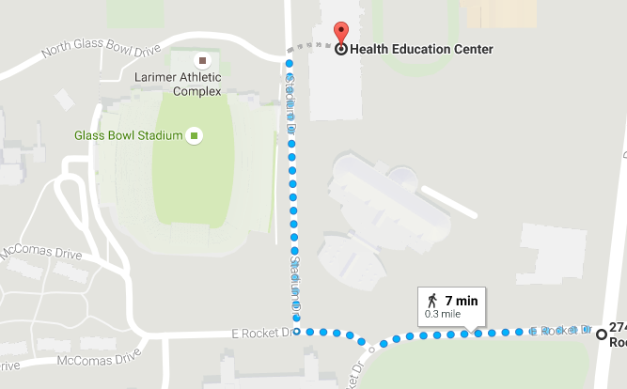
Directions from Douglas:
- Head west on East Rocket Drive
- Turn right to stay on East Rocket Drive
- Turn right onto Stadium Drive
- Left at the bottom of the hill into LOT 10

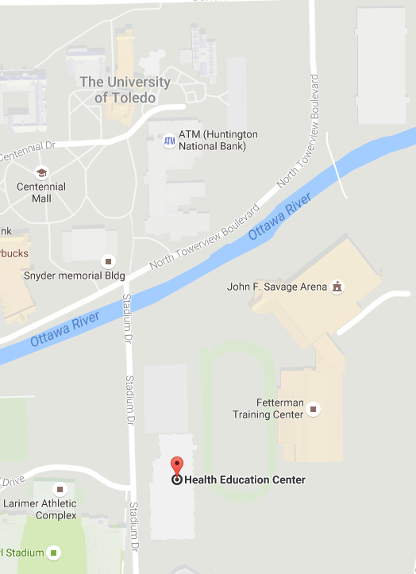
Directions from Bancroft:
- Head south on North Towerview Boulevard
- Turn left on Stadium Drive
- Turn Right into LOT 10

Drop Off ONLY:
- See directions on next page
- Suggest for youngest children only
- This area can get congested.
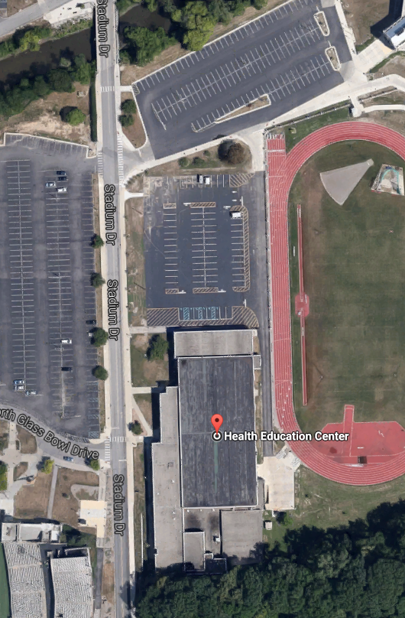
One Lane
Entry/Exit Door
Park Here
Enter Here

