Y SWIM!
Swimming is FUN!!!
Health: the best low-impact general conditioning available, swimming also increases motor skills and coordination.

Safety: develop skills & confidence for any aquatic activity at the beach, lake, or summer pool.

Lifelong friendships in a healthy, co- educational atmosphere.

Participation: everyone gets to play – there are no second stringers, no bench warmers.

Self-confidence: as swimmers eagerly accept challenges, and set & reach goals.

Opportunity: swimming champions come in all shapes and sizes: kids don't need to be big to succeed.

A lifetime sport: participants aged one to one hundred.

Qualities of character: that lead to athletic & academic success:

Perseverance Self-discipline Goal Setting
Time management Teamwork Determination Cooperation Dedication Responsibility High expectations

COACHING STAFF

Keith Kennedy has been selected to lead the team as the new director of competitive swimming. Keith has over 18 years of coaching experience, most recently as the head coach/CEO of the San Clemente Aquatics in California, where he grew the swim program from 120 athletes to over 575 in less than three years, and helped the athletes earn over $250,000 in college swimming scholarships in 2015. Previously, he was the head coach/CEO of the Greater Toledo Aquatic Club, and head coach/aquatics director at St. Francis De Sales High School in Toledo.

Keith is a great communicator, proven multi-team and multi-facility manager, with a strong focus on individual swimming and coach development. Coach Kennedy currently has swimmers at Ohio State (both men's and women's), Kentucky, Stanford, Hawaii, Arizona, Seattle and Michigan. His college swimmers have taken over the record boards at Ohio State, Notre Dame, and Wisconsin.

Keith also serves as a United States Olympic Committee national team select coach and spokesman, and has coached numerous youth to USA Swimming national teams. He has a passion to serve the community through the development and execution of swimming programs for the physically disabled and economically challenged.

Lead Senior Coach Ed Bachman, Head Age Group Coach Cal Roberts and assistant coaches, Kasey Carpenter, Emily Wethington, Julia Saxton, Amy Zelinsky, Sandy Hurtt, Mayson Hurtt, Emma Haynes, CJ Rushman and Lisa Rushman provide invaluable support in working with swimmers individually or in groups.

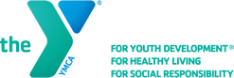

YEAR ROUND COMPETITIVE USA AND Y SWIM PROGRAM

M.E. Lyons YMCA
Anderson Barracudas

Cincinnati, Ohio
Aiming for the Stars!
ME Lyons YMCA/Anderson Barracudas aims to provide and inspire the very best opportunities for learning, nurturing, and training for the novice to highly competitive athlete by emphasizing individual progress, team unity, and family participation. We provide an environment of growth, by building a healthy spirit, mind, and body through Christian principles and the YMCA core values of Caring, Honesty, Respect and Responsibility.

www.ablyswim.org

PROGRAM FEATURES
The M.E. Lyons YMCA/Anderson Barracuda swim team offers a Pre Competitive, Competitive, and Masters swim team as well as High School Prep.
We also have programming at Campbell County YMCA and Clermont YMCA for swimmers age 6-12.

The M.E. Lyons/Anderson Barracuda swim team offers USA and YMCA swimming both regionally and nationally.

All Teams and locations emphasize the following values:

TECHNICAL: learning good technique, efficiency, and beauty in the water.

PHYSICAL: developing speed and endurance through training in all four strokes in an individual medley and endurance based program.

COGNITIVE: learning about swimming, the rationale for stroke technique, training, diet and nutrition, etc.

PSYCHOLOGICAL: learning and practicing the attitudes of a champion; goal-setting; and maintaining poise under pressure.

SOCIOLOGICAL: team building and relationships.
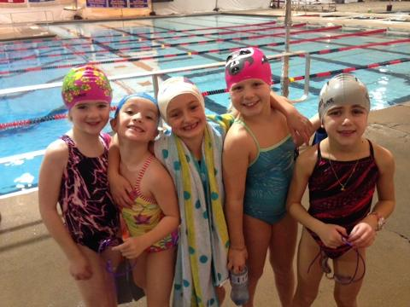
TRAINING SCHEDULE

National and Gold Groups practice 6 days a week with 12 hours in the pool and 1 ½ hours of dryland.
Senior and Pre Senior Groups practice 6 days a week with 9 hours in the pool and 1 ½ hours of dryland.
Silver Group practices 6 days a week for 1 ½ hours of practice time each day.
Bronze Group practices 6 days a week for 1 hour and 15 minutes per practice.
Cuda Group practices 3 days a week for 1 hour and 15 minutes per practice.
Campbell and Clermont County Groups practice 5 days a week for 1 ½ hours per practice.

TRAINING OPTIONS
Stroke Group
Pre Competitive
Competitive
High School Prep
Masters

TRAINING
M.E. Lyons YMCA/Anderson Barracudas is a comprehensive developmental training program, planned and administered by professional coaches dedicated to building the finest program in the nation.

We offer training up to six days per week year round. Swimmers are placed in groups by coaches according to age, skill level, and commitment. There are practice groups to suit swimmers of all levels, from novice to national.

For more information contact Coach Keith Kennedy at (310)948-1649 or kkjrswim@yahoo.com Please visit our website at www.ablyswim.org

COMPETITION

M.E. Lyons/Anderson Barracuda swim team hosts and attends USA swim meets and YMCA Invitational meets during the winter and summer seasons throughout the region.

Qualifying swimmers compete in Junior Olympics and YMCA Nationals.

