FOURTH ANNUAL JOSE CERDA SWIM CLINIC
Sunday, October 26, 2014
at Mason Community Center
6050 Mason-Montgomery Road. Mason, Ohio 45040

Reach the next level of competition by learning from top swimmers and coaches
Fine tune your strokes and learn high-level competitive techniques

$40 PER SWIMMER
All fees payable to Jose Cerda Aquatic Foundation and mailed to P.O. Box 12918 Cincinnati, OH 45212 prior to Oct.15, 2014

SCHEDULE
Time | Activity | Presenter/Responsible | Location
8:30-8:45 am | Registration swimmers up to 12 years old | Volunteers | Lobby
9:00-11:30 am | Water Instruction – swimmers up to 12 years old  Parents can watch from bleachers | Todd Billhimer | Pool
11:30 am-12:00 pm | Lunch for Coaches, Olympians, volunteers | JCAF Board | Senior Center
11:30 am-12:00 pm | Registration swimmers 13 years and older | Volunteers | Lobby
12:00-1:00 pm | Q&A with Olympians/ Autographs/ Pictures  All swimmers & parents | JCAF Board | Senior Center
1:00-1:45 pm | Study of strokes, starts and turns- All swimmers | Chris Wolford/Champions | Activity Room A
1:00-2:00 pm | College Swimming and Recruiting Q&A- Parents | College Coaches | Activity Room A
2:00-3:00 pm | Nutrition Talk- Parents | Dr. Dan Carl | Activity Room A
2:00-3:00 pm | Water Instruction swimmers 13 years and older | Champions/Coaches | Pool
3:00-4:00 pm | Specific sessions for sprinters, IMers, distance, etc.  Swimmers 13 and older | Mike Leonard/Champions | Pool

To sign up, control+click the link Jose Cerda Swim Clinic
or send an e-mail message to: jcswimclinic@cinci.rr.com to have the registration link sent to you or with questions on the Clinic.
^{Why} ?
This Clinic is in memory of the swimmer José Cerdá. José sadly missed his sectional time cut in 100 m back stroke by 0.01 seconds. This difference, the smallest measurable in swimming, had a huge impact on José. Rather than being disappointed by it, José became more dedicated to the sport to shave that one hundredth of a second from his time to qualify for the event; in essence achieve his goals.
José’s point zero one story is more common in swimming than some may realize. Recently the US men’s relay swim team was disqualified at the 2013 World Championship by 0.01 seconds. Olympian Scott Usher also shared his ‘point zero one’ moment at the 4th Annual JCAF Dinner Gala; listen to it in youtube.
We would like this Clinic to inspire your ‘point zero one’ moment, because the smallest difference can have a BIG impact.
This Swim Clinic is sponsored by the:
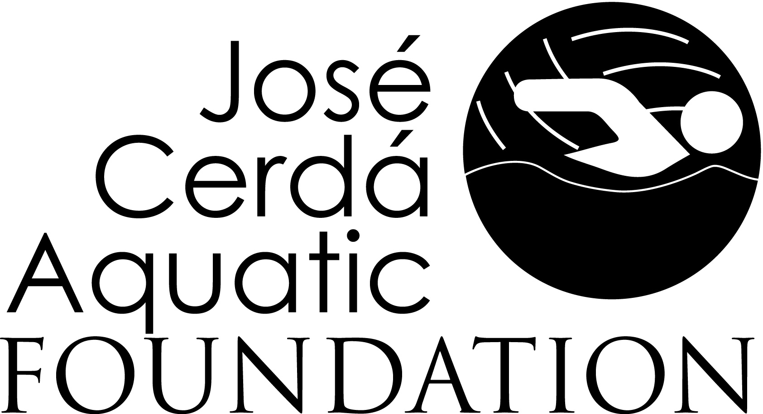
This Foundation, JCAF, has been established to honor José Cerdá by benefiting the sports he loved, swimming and water polo. For more information about JCAF, a 501 (c) 3 non-profit organization, please visit www.jcafoundation.org . José was constantly striving to move to the next level of athletic performance while also having fun and supporting his teammates and fellow competitors. For more information about Jose’s life, please visit the Memorial website www.joseito.webs.com

