Parent Name: ________________________________________________________________

Address: ________________________________________________________________

City, Zip. ________________________________________________________________

E-mail: ________________________________________________________________

Phone: (______)_________________ Cell Phone: (_______)_____________________

Swimmers: ________________________________________________________________

CHARGE TO NAAC ACCOUNT:
*** ORDER DEADLINE: JAN 26th, 2020 at 8pm ***
CHAMPS SILICONE  CAP | CHAMP: Custom Silicone Cap  with NAAC logo in Pink/White and CHAMPIONSHIPS in Pink | Team Price:  $14.00 EACH | # of Caps:

STATE SILICONE  CAP | STATES: Custom Silicone Cap  with NAAC logo in Pink/White and STATE TEAM in Pink | Team Price:  $14.00 EACH | # of Caps:

NATIONALS SILICONE  CAP | Nationals: Custom Silicone Cap  with NAAC logo in Pink/White and NATIONAL TEAM in Pink | Team Price:  $14.00 EACH | # of Caps:

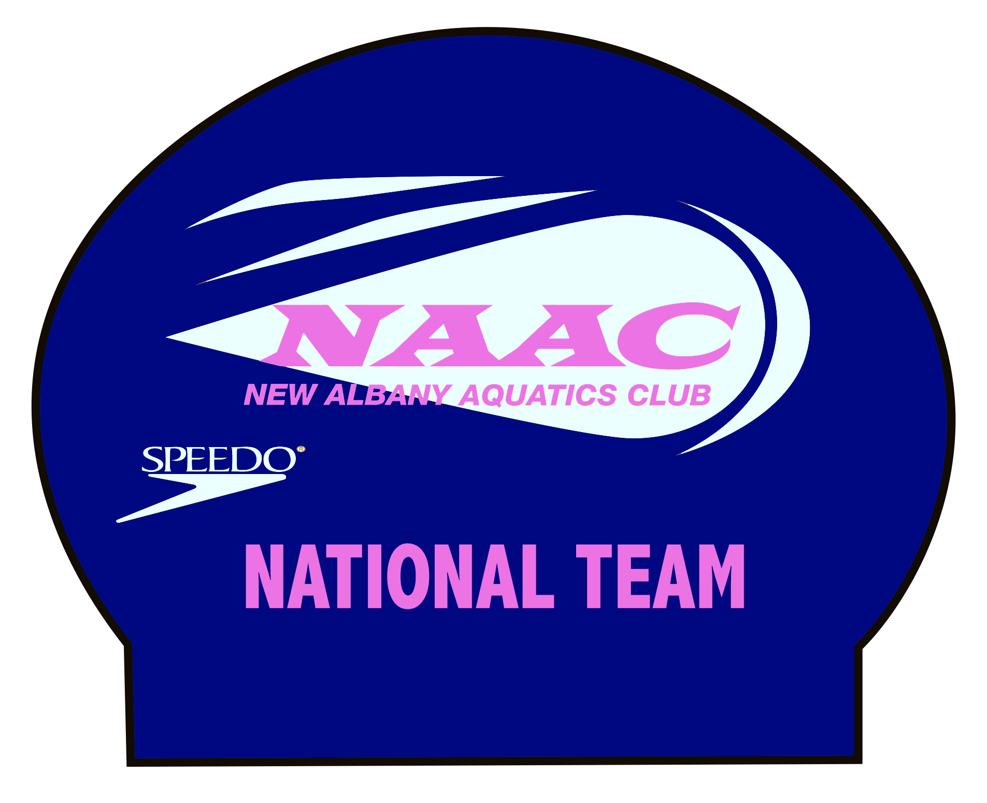

TOTAL TO BE BILLED TO NAAC ACCOUNT: # CAPS________. $_____________.

