WRITTEN PERMISSION FOR AN UNRELATED APPLICABLE ADULT COACH TO PROVIDE LOCAL TRANSPORTATION TO MINOR ATHLETE

New Albany Aquatics Club
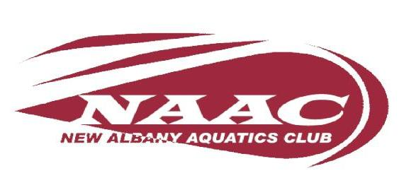

I, , legal guardian of , a minor athlete, give express written permission, and grant an exception to the Minor Athlete Abuse Prevention Policy for , an unrelated Applicable Adult Teammate and/or Coach, to provide local vehicle transportation to (minor athlete) to (destination) regularly and/or on (date/s) at (approximate time/s), and further acknowledge that this written permission is valid only for the transportation on the specified date and/or to the specified location.

Legal Guardian Signature:
Date:

