PCY Tigersharks Swim Team
REGISTER NOW FOR OUR FUNDRAISER
3 EASY STEPS
Organization ID:
23600
www.registercw.com  www.registercw.com | 1# REGISTER  Register participant at www.registercw.com  to access our handy invitation tools in the Participant Portal-Very important! | 2# SHARE  Invite friends and family to support! SHARE a link to the sale via TEXT & EMAIL using our invitation tools. Don’t forget to share with your followers on SOCIAL MEDIA, too! | 3# SHOP  Go online to SHOP and help us reach our GOAL today! With over 2,500 gift ideas there is something for everyone!
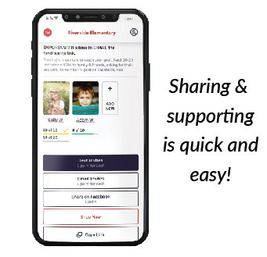
With over 2,500 gift ideas, check-off your holiday gift list and invite friends & family to support our important cause, too!
Personalized Gifts | Gift Wrap & Accessories | Charleston BagsTM
Candles | Kitchen Essentials | Gourmet

