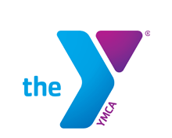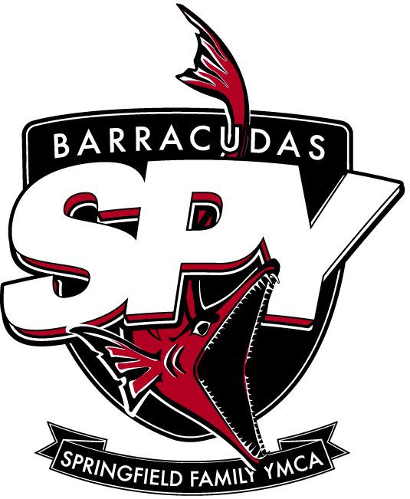
7th Annual SPY, Alumni, & Friends Golf Outing
Saturday, September 29th, 2018
Windy Knoll Golf Club, 500 Roscommon Drive, Springfield, Ohio 45503 **(Must be 21 to attend)
Funds raised will be contribute towards Spy’s David Joseph Scholarship Program, Equipment Needs, Swimmers’ Team Caps, Timing/Scoreboard Upgrades, and other swim team needs.

9:00 AM Registration ~ 10:00 AM Scramble Shot Gun Start ~2:30 PM Lunch Social
Sponsor Name for Hole Sponsorship Sign:____________________________
Team Name:________________________________________________________
- Player Name1._____________________________________________________________
- Player Name 2. ____________________________________________________________
- Player Name 3. ____________________________________________________________
- Player Name 4. ____________________________________________________________
Sponsorship Levels:(Nationals, Zones, AA sponsors be placed banner recognition at Y Pool)
- _____National Team Contribution: $500.00 Includes 4 golfers, lunches, 2 Hole Sponsors, SPY Invitational Heat Sheet Recognition
- _____Zone Team Contribution: $400.00 Includes 4 golfers, lunches, & Hole Sponsor

- _____“AA” Contribution: $100.00 for Hole Sponsorship Only

- _____Laneline Sponsor: Your choice of contribution to the SPY Swim Team $____________.

______Team Participation: $300.00; Includes 4 golfers & lunches
______Pre Order Team MULLIGAN: $20.00 (Four Muligans so one Mulligan per player)
______Individual Player: $75 per golfer & lunch. You will be assigned to a team unless otherwise specified
______Lunch Only for Non-Golfers: $20.00 per person. ______ persons
Total amount enclosed $__________ THANK YOU from SPY Swim Team
Make checks payable to: SPY Swim Team Pay by Credit Card at our Y’s Welcome Center
Mail or Drop Off to: SPY Golf Outing c/o Brenda Trinkle, 300 S. Limestone, Spfld., Oh 45505

