Sunday | Monday | Tuesday | Wednesday | Thursday | Friday | Saturday
 |  |  |  |  | 1  No practice | 2  Kelly Colley
3 | 4  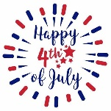  No practice | 5  Deadline to register for LC Champs | 6 | 7 | 8  RC Home meet dead line | 9
10 | 11  Deadline to register for RC Champs | 12 | 13  Speedo Sectionals | 14  Speedo Sectionals  Levi Freeman | 15  Speedo Sectionals | 16  Speedo Sectionals
17 | 18 | 19 | 20 | 21 | 22  LC Champs USA | 23  LC Champs USA  Emily Groth
24  LC Champs USA | 25 | 26  RC Home Meet  Warm- ups 4:30 | 27  Lily Johnson | 28  Kendall Kurz | 29 | 30  RC Champs
31

