Saluki Swim Club

Apparel Made Available Through Silkworm, Incorporated

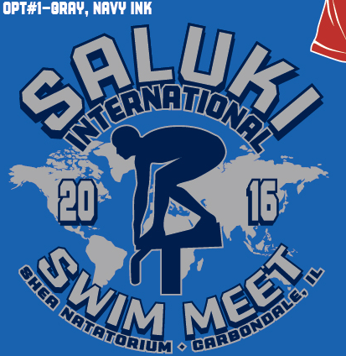

Front Back

Please order BIG ENOUGH --- No exchanges or refunds.
ITEM DESCRIPTION | COLOR | YM | YL | S | M | L | XL | 2XL | 3XL | COST | TOTAL
Short sleeve t-shirt | Neon Blue |  |  |  |  |  |  |  |  | $15.00
Name____________________________________  Phone Number____________________________  Team Name_______________________________  Amount Enclosed____________ □ Cash □ Check |  |  |  |  |  | OVERSIZE CHARGES
 |  |  |  |  |  | 2XL items add $2 each
 |  |  |  |  |  | 3XL items add $3 each
 |  |  |  |  |  | ORDER TOTAL

ORDERS ARE DUE BY MONDAY, APRIL, 18, 2016.
Orders will not be accepted after this date.

Saluki Swim Club Swimmers-payment must be made at time of order. Please give order and payment to Kate Fakhoury at the pool.

All other teams, please email your order to Sonja Cully at cullyss@gmail.com. You can pay for your order when you pick it up at the meet.

Please contact Sonja with any questions at 618/751-0318.

