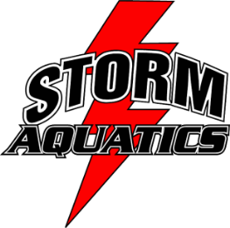
2016-2017 SPONSORSHIP FORM

As a Storm Aquatics sponsor, your contributions help us provide scholarships to swimmers who could not otherwise afford to participate along with needed equipment purchases to provide a well-rounded training program. Funds may also be used to provide a promotional item, (hand fan, lanyard, keychain, travel shirts, website, etc.) with your attached logo and business information.

Sponsorship Level
Bronze | $50.00
Silver | $100.00
Gold | $150.00
Platinum | $200.00+
Sponsor Information/Individual or Company
Sponsor Name: _____________________________________________________________________
Address: _________________________City:____________________ State:______ Zip:___________
Contact Person: ____________________ Phone: ________________________
E-Mail:___________________________ Amount of Donation: $____________________
Swimmer obtaining sponsor: ________________________________
Make checks payable to: STORM AQUATICS
*Storm Aquatics is a non-profit organization/Non-profit ID number 48-1254044
Please mail your checks to: Storm Aquatics
P.O. Box 171
Lake Stevens, WA 98258
Thank you for supporting our team!

