Storm 2014-2015 Season Suits

# Team Camo - $57.95 (female suit)

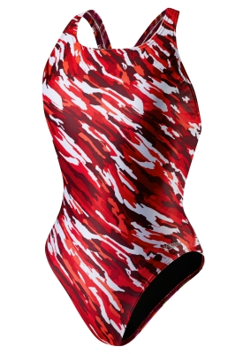

# Scoubidou ($58.44 for female suit, $40.05 jammer, $35.87 brief)

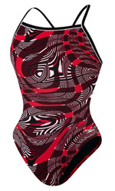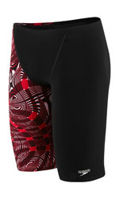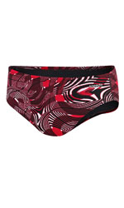

2014-2015 Equipment List by Group

# Developmental & White Groups

None Required

# Red Group

Snorkel (OPTIONAL) - $37.54

# Blue & Senior Groups

Snorkel (Required) - $37.54

Zoomers (Required) - $36.70

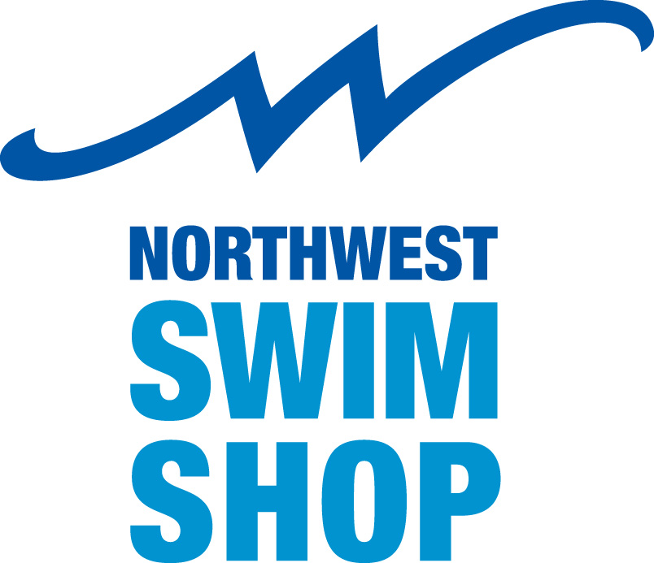Storm Swim Team

## Team Order Instructions

Welcome to Northwest Swim Shop, we are excited to be your team designated swim shop. We look forward to watching each of you have a terrific season.

Team Ordering Instructions:

1. Go to <http://nwswimshop.myshopify.com>
2. Click “Teams” in the top navigation, find your team name and click on it.
3. Login to your team page, username: Storm2012
4. Start shopping!
5. Team ordering dates: 08/23/14-09/12/14.

A few notes:

* *Personalizing Product*, please fill in the special instructions box with the swimmer name you want personalized on each product.
* Shipping: Team orders are delivered to the location picked by your team representative.
* Shipping Method: when checking out, select: Team Order – items being shipped to one central location
* The team merchandise has the special pricing agreed upon by your team rep and NW Swim Shop.
* Feel free to shop the rest of our online store! As a swim team member, you will receive 10% off your order. When checking out, enter “storm2012” into the discount code field. (Only applies to the non-team merchandise.) This discount code will apply each time you order! You can enter in a shipping address for non team items purchased.

*At Northwest Swim Shop we take pride in our excellent customer service. If you have any questions, please give us a call. We will ensure that you get the suits, apparel, and tools, you or your child needs.*

Feedback! If you have a great experience, please let us know… if you have a hard time with something, let us know! We are working our hardest to continue to improve our website and bring you the best online and personal shopping experience!

253.473.8900 | 866.999.NWSS(6977) | info@nwswimshop.com