CAAT Annual Mtg
Jun 9, 2018
Columbia City Library

Meeting was convened at 3:15 pm. 42 parents were present (2 couples, which can only vote as a family) and 12 parents sent in proxy votes by mail prior to the meeting. This is not a quorum.

Agenda:
1) Board Membership
2) FY18 Budget
3) Bylaws Changes
4) Booster Club Opportunities

1. Board Membership. There are currently 7 CAAT parents sitting on the Board: Jim Hong (President), John Scott (Secretary), John Robertson (Treasurer), Carl Baber (Fund Raising/Swim a Thon), Joon Yu (Diversity and Inclusion), Jan Frederick (Social Events Director) and Laurie Robbins (Meet Director). CAAT has been working towards a different Board structure over the past 3 years, from one in which parents are doing a combination of governance and operations to just governance. The former is also known as a “hybrid” model and the latter a “CEO” model. At the Annual Retreat in February, the Board met and voted to reorganize into a Board plus a Booster Club model. This has been an intentional process, done in consultation with USA Swimming and based on the successful Carmel (IN) Swim Club model. The new Board would consist of a President, Secretary, Treasurer, Diversity and Inclusion, Head Coach and Booster Club President. (see graphic below).

The board vote is a slate of members, who serve for a two-year term. A member questioned why they could not vote on individual members and the response was that this is how our bylaws are structured and how many non-profits and for profit organizations set up their Boards. A member suggested having a "waiting" period for members to be eligible for Board positions (this focused on the conversation around what if a Board Member has poor performance.) There was desire from the members to have a process outlined for action items around a poor performing board member. A member also stated that it has not been transparent when these positions become open. In response, Jim said that this has changed with last two positions (D&I, Booster Club President) in which applications were sought. For D&I, the current Board interviewed and voted on the position. There was only one applicant for Booster President (Laurie Robbins). One member asked why there were no representatives from Tukwila, Evergreen, Kent, Newport Hills, and Mercer Island pools. The response was that is not certainly the intent and people were encouraged to apply for Booster Club positions. There are no term limits but positions typically open up every 1-2 years (half of the Board has served for 2 yrs or less). A member asked what the Board will do with less “day to day” operations and the response was that they will get more involved in long term strategy and planning, such as creating better benefits for the coaches (i.e. health insurance for all) and exploring building a new pool. Feedback from member(s) was that the proxy vote mail in process was too quick (2 day turnaround), would like to see more time in the future. The Board agrees and will give a longer lead time in the future.

Please see structure below:
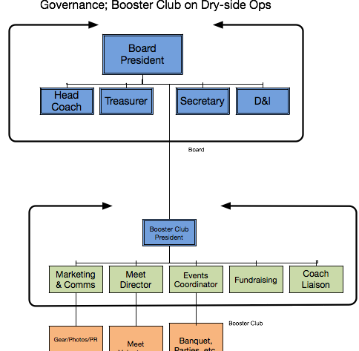

The current slate up for re-election are: Jim Hong, John Scott and Ken Spencer. Since Laurie was just recently selected in May 2018 and Joon and Carl both started in 2017, they are not up for re-election. The vote was unanimous to approve this slate

2. Budget. John R presented the financials and proposed budget for FY2019. SMAC’s financial position is strong, with assets of $434,000 and liabilities of $152,000. Almost all of these liabilities are for financial aid. For 2016-17 budget year, CAAT ended with revenue of $477k vs. $456k of expenses. For 2017-18 budget year as of 5/31/18, CAAT had income of $593k vs. $528k. Thus, for this year, we have $65k of net income, but the summer is generally a loss because we lose swimmers and then have payroll in August with no offsetting revenue and pools bill us in arrears.

The costs of renting pool space (42% of total expenses) will increase in the next year, mainly because Seattle University and Seattle Parks and Rec have raised pool fees and also because the North End pools have higher lane fees. Compensation for coaches (52% of total expenses) will be $571,000 and reflects the addition of four, high quality coaches. Overall expenses are expected to be $1,112,500. Swimmer fees will need to be raised slightly to offset these expenses: 5% for most groups, except Senior will be 11% and Master’s 3%. These fees are considerably lower fees for the other top swimming programs in PNS. Our expected revenue is $1,280,000, resulting in net positive of $42,000. The budget was unanimously approved except for one abstention.

There was discussion around Registration and bookkeeping, and a member asked if we were considering moving towards a professional bookkeeper as paid staff. The answer is yes.

A member wanted to know how we would differentiate between the Senior Performance and National Group. If fee structure is different, will pool time, overall training time and caliber of meets be different? The answer is yes; the National Group will have more pool time, overall training time and caliber of meets, although the details on pool time are still being planned.

3. Bylaws. The following bylaws changes were put forth:
- Section 2.3 - We have adjusted the "waiting period" to coincide with the USA Swimming "120 Day Rule". If any swimmers in a transferring family are subject to the rule, the family will "attach" on the same day the swimmer "attaches" to the club and have full voting rights.
- Section 5.3 - We have amended this section to address the logistical difficulty of scheduling an Annual Meeting. This section states that we may use electronic means to allow for communications as well as proxy voting.
The reason for Section 2.3 was that it coincides with when a swimmer can attach. The reason for Section 5.3 is self-explanatory. There was no discussion and the motion was approved unanimously.

4. Looking Forward (Jim). The success of the club is heavily dependent on parent volunteers. We don’t want people thinking this is a service business we are running for them. It is something we are running WITH them. The next year will focus on the following items.

- Implement Organizational Changes
  - Grow Booster Club
  - Support Head Coach in Operations
- Continue to Integrate and Unify
    - Strengthen SMAC Community
    - Integrate and unify intelligently
- Provide Leadership in PNS Community
  - More meets & Bigger meets
  - Participate in LSC governance
- Continue to Invest in our Swimmers
    - Create new opportunities
    - Increase training options
- Continue to Look for Ways to Improve SMAC
  - Additional Programs
  - Continue to Improve Member Experience
  - Continued Organization Agility

5. Booster Club Positions (Laurie). The following positions are open:
-Meet Director
-Fundraising Director
-Social Events Director
-Volunteer Director
-Secretary
-Marketing & Communications Director

Lead Roles open for:
Photographer(s)
Meet Hospitality
Pool Reps

Meeting adjourned at 4:10 PM.

