Hello Coaches and Swimmers,
We are excited to welcome you to the Fife Aquatic Center! For those of you who have not yet been to our facility, we have a 6-lane, 25 yard pool that ranges from 3.5-5 feet deep. The water temperature will be approximately 80 degrees (good for all of you who have been doing open water swimming over the last few months)! Please continue reading for more information on what to expect at our facility with COVID guidelines in place.
- Upon entry to the facility, you will see the below warning sign. Please read it and know you are entering the facility at your own risk.

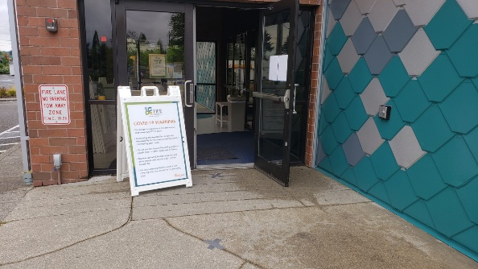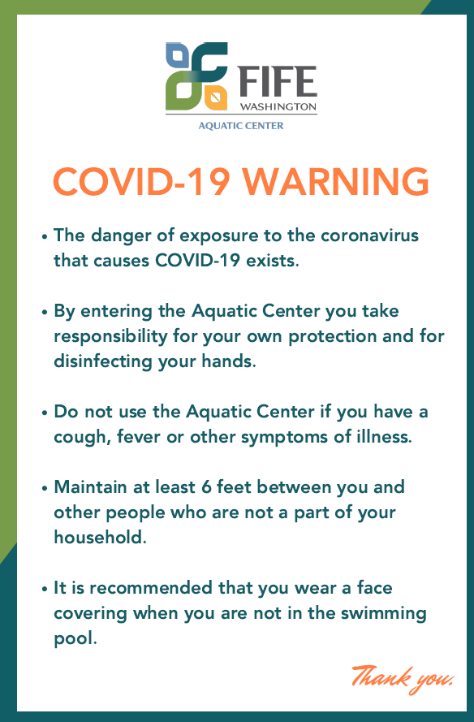

- After entering the facility, please disinfect your hands with the hand sanitizer provided. You may also choose to sign-in at the voluntary sign-in sheet, which will be used by the Health Department for contact tracing purposes if there is a confirmed COVID case in our facility. If you choose not to sign in, we recommend the swim team keep good records of the swimmers who attended each practice to ensure immediate contact can be made with all participants should there be a confirmed case.
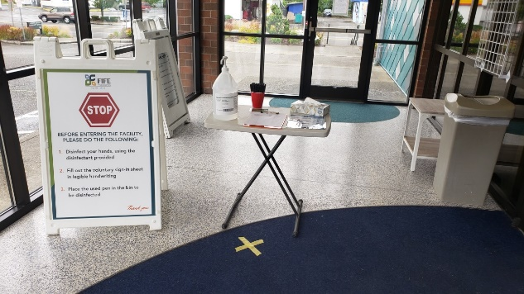
- If you have any questions, or need assistance, please feel free to check in with our receptionist. Our receptionist are all certified lifeguards as well, so please feel free to reach out if you are in need of something. If you have not yet signed the electronic waiver, and instead bring in a physical copy, please turn it in to the receptionist. Please do make sure you maintain at least 6 feet of distance at all times.
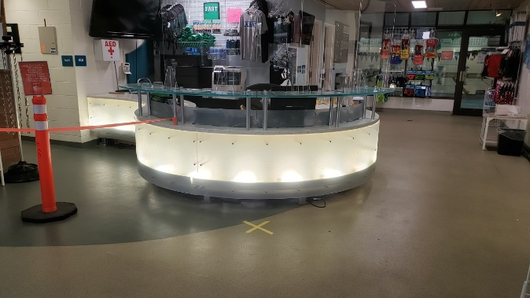

- The locker rooms will remain closed. However, the restrooms in the lobby are available for use and will be disinfected after each use by our staff. Please do not congregate near the restrooms.
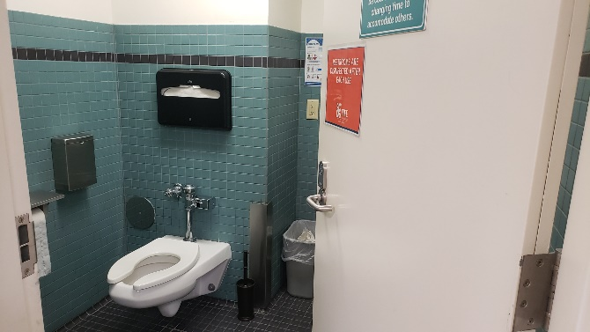
- Upon entering the pool deck, please place your belongings on the first available row, on one of the yellow “X’s”. After each group vacates the facility, these spots will be disinfected by our staff to ensure they remain clean. Additionally, our staff will be going through the facility and disinfecting high-touch surfaces on an hourly basis.
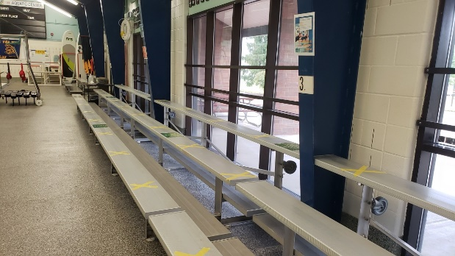
- Additional hand sanitizer and tissues are available on the pool deck if needed.
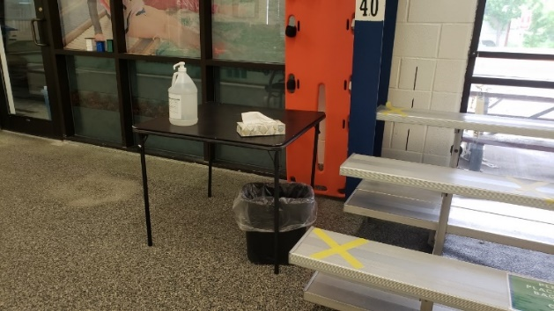
- Special seating for a team’s Safe Sport Rep and COVID Safety Rep is available at the far end of the pool. These two people are the ONLY people allowed to enter the facility outside of the swimmers and coaches. If you are filling one of these rolls, please identify yourself at the front desk before proceeding onto the pool deck.
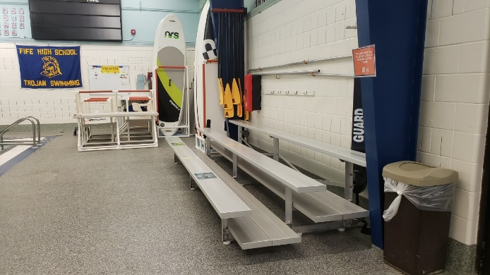

If you have any questions, please let us know by contacting aquaticcenter@cityoffife.org. We look forward to seeing you next week. Welcome back to the water!

City of Fife

