Acknowledge of MAAPP

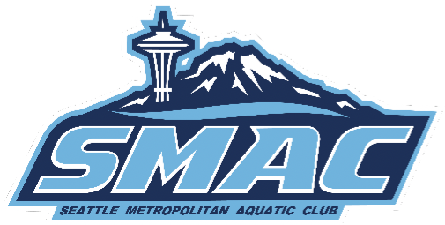

I acknowledge that I have received and read and understood the Minor Athlete Abuse Prevention Policy(MAAPP) and/or that the Policy has been explained to me and my family. I further acknowledge and understand that agreeing to comply with the contents of this Policy is a condition of my membership with Seattle Metropolitan Aquatic Club. MAAPP full Policy: https://www.usaswimming.org/docs/default-source/safe-sportdocuments/maapp/usaswimmingmaapp.pdf

Name:____________________________________________

Signature:_________________________________________

Date:__________________________________

