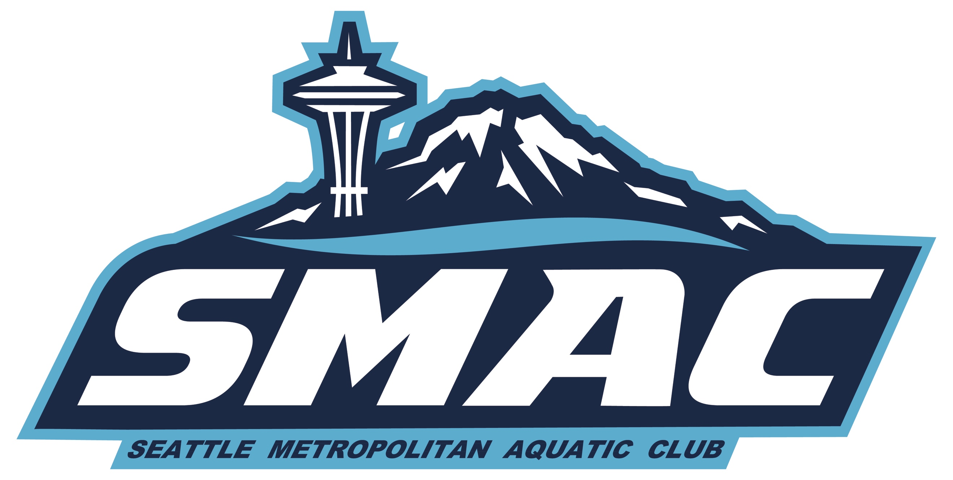
SMAC Nov Board Meeting
Dec 16, 2020

Attendees: John S, Ken S, Jim H, Laurie R, Joon Y, Shane S, Doug R

The meeting started at 7:05PM. Quorum was met with 7 attendees.

1) November Minutes. Ken motioned to approve, John seconded. Approval was 7-0.

2) Planning for COVID-19 surge. The latest DOH guidelines from today say that practice can continue as before but meets cannot be held, so this scratches this weekend’s meet at Evergreen and “winter juniors” at Snohomish in early December.

Some families have expressed concern about continuing with swimming. John reviewed data from scientific studies of COVID transmission in schools and youth sports: it is extremely low and no additional risk than other activities like going to grocery store. Ken has consulted with other swim clubs and PNS leadership and other clubs have similar policies We discussed that swimming is helping keep athletes’ spirts up. Individual families need to make that own determination of risk/benefit.

3) Booster Club Report.
General Updates
- Mary Wayte and Snohomish have confirmed facilities for meets Jan-April.
- Rodgers pool still TBD for meets.
- Safe sport Dec clinic had 40 parents attend.
- Pool reps worked with Shane for our “Thank you coaches” video.

In Process;

- Facebook marketplace
- SMAC Video Challenge over the next month
- Food drive in Feb (run by pool reps)
- Coaches gifting fund $10,000 donated to date (past 2 years has been 7,000), reminder going out Tues, collection ends Wed.
- Jan/Feb Safe Sport training clinics

Upcoming Meets
We have bid on, and we awarded all of the following Meets moving forward.
- Dec 19/20 Snohomish Aquatic Center- Cancelled
- IMX Invitational (Jan 9-10, 2020) Mary Wayte Pool, Mercer Island (unlikely to happen)
- Jan 23rd-Snohomish Aquatic Center (unlikely to happen)
- Winter Challenge (Jan 30-31 2021) Rogers-Pool not currently open
- IM Ready (Feb 13th) Mary Wayte Pool, Mercer Island
- Feb Divisionals (Feb 29-March 1, 2020) Rogers Pool in Puyallup-Pool not currently open
- March 27/28 Holding Snohomish (AGR date)
- Spring Showdown (March 20-21) TBD
- IMX Invitational Long Course (July 17-18) King County Aquatic Center
**Rodgers is now currently allowing high school swimming, we are in touch with next steps for meets.

Meets

- Will need to decide on Jan 9/10 meet for Seniors within the next few days to be able to set up, sanction etc.
- For meets, we need 3-4 weeks notice to get set up to run.
- For any meets that are cancelled, but set up we will continue to credit volunteer hours for all shifts that are signed up for.

Safe Sport
- Safe Sport clinic 12/9, 40 families signed up, USAS is providing monthly training, will post for parents ongoing.

Fundraising
- Amazon smile and Fred Meyer script programs communicated to families to encourage enrollment.
- SMAC masks, with bands around the head, for ease of use during meets launched 11/16, now with pick up option for no cost shipping.
- Beginning to pull together Swim A Thon team. Would like to move to April, post Spring Break. This also gives us more time with COVID. We may just need to run during all practices during a selected week.

4) President’s report (Jim). OKRs are due in January. Might be an opportunity to reach out to club parents to ask for volunteers on some of these items. Please send out a brief blurb on needs to Laurie. On USA Swimming front, the club presidents meeting are sporadic, not a lot of communication from central office.

5) Coach’s report. We continue to operate safely under our COVID protocols. The growing number of cases locally and nationally is a concern. With no meets on the horizon, groups focus on keeping swimmers both mentally and physically healthy and to provide a safe, real and meaningful experience on the team.

Ken continues to work with pools. We have agreed on a new contract with KSTC, which will mirror existing contract. Normandy Park has been down for two weeks because of boiler issues and does not have very good covers. Fortunately, Ken has some spare ones and we expect boilers to be online next week. We have a new (verbal) contract with Lakeridge. Good news is that Evergreen will defer big maintenance until the summer. Don’t foresee Medgar Evers opening anytime soon due to the pandemic.

College kids are doing well, quarantined for requisite time before joining practices. Laurae will bill on a 2 week basis but give first week free. They don’t need to register with USA Swimming because they’ve done that with their colleges or incur volunteer time. They will swim with their old groups and be charged the current rate for that group. May have a special college group at LR if we face capacity limits.

PNS did well with its investments but overall membership is down 30%. Fifteen teams are apparently kaput. We will pick up ~$30k one-time from PNS based on $70/swimmer, in order to help teams through crisis.

6) Treasurer’s report. Doug clarified that investment gains/losses should not be included in P&L to evaluate operating profit. Overall, things are a bit better than we’d expected given the challenges with COVID.

7) Brand Director’s report (Shane). Nothing to report.

8) D&I report (Joon). Had two new financial aid applications. We are able to cover these new applications. We talked about whether there should be some assurance about FA prior to signing up for registration. There are a couple of variables to consider: group placement and insurance. Ken thought we could do in parallel but not FA first and then registration.

Meeting was adjourned at 7:40 PM.

Our next meeting will on Zoom on Jan. 20th at 7PM. We will talk about Objectives & Key Results (OKRs) then.

