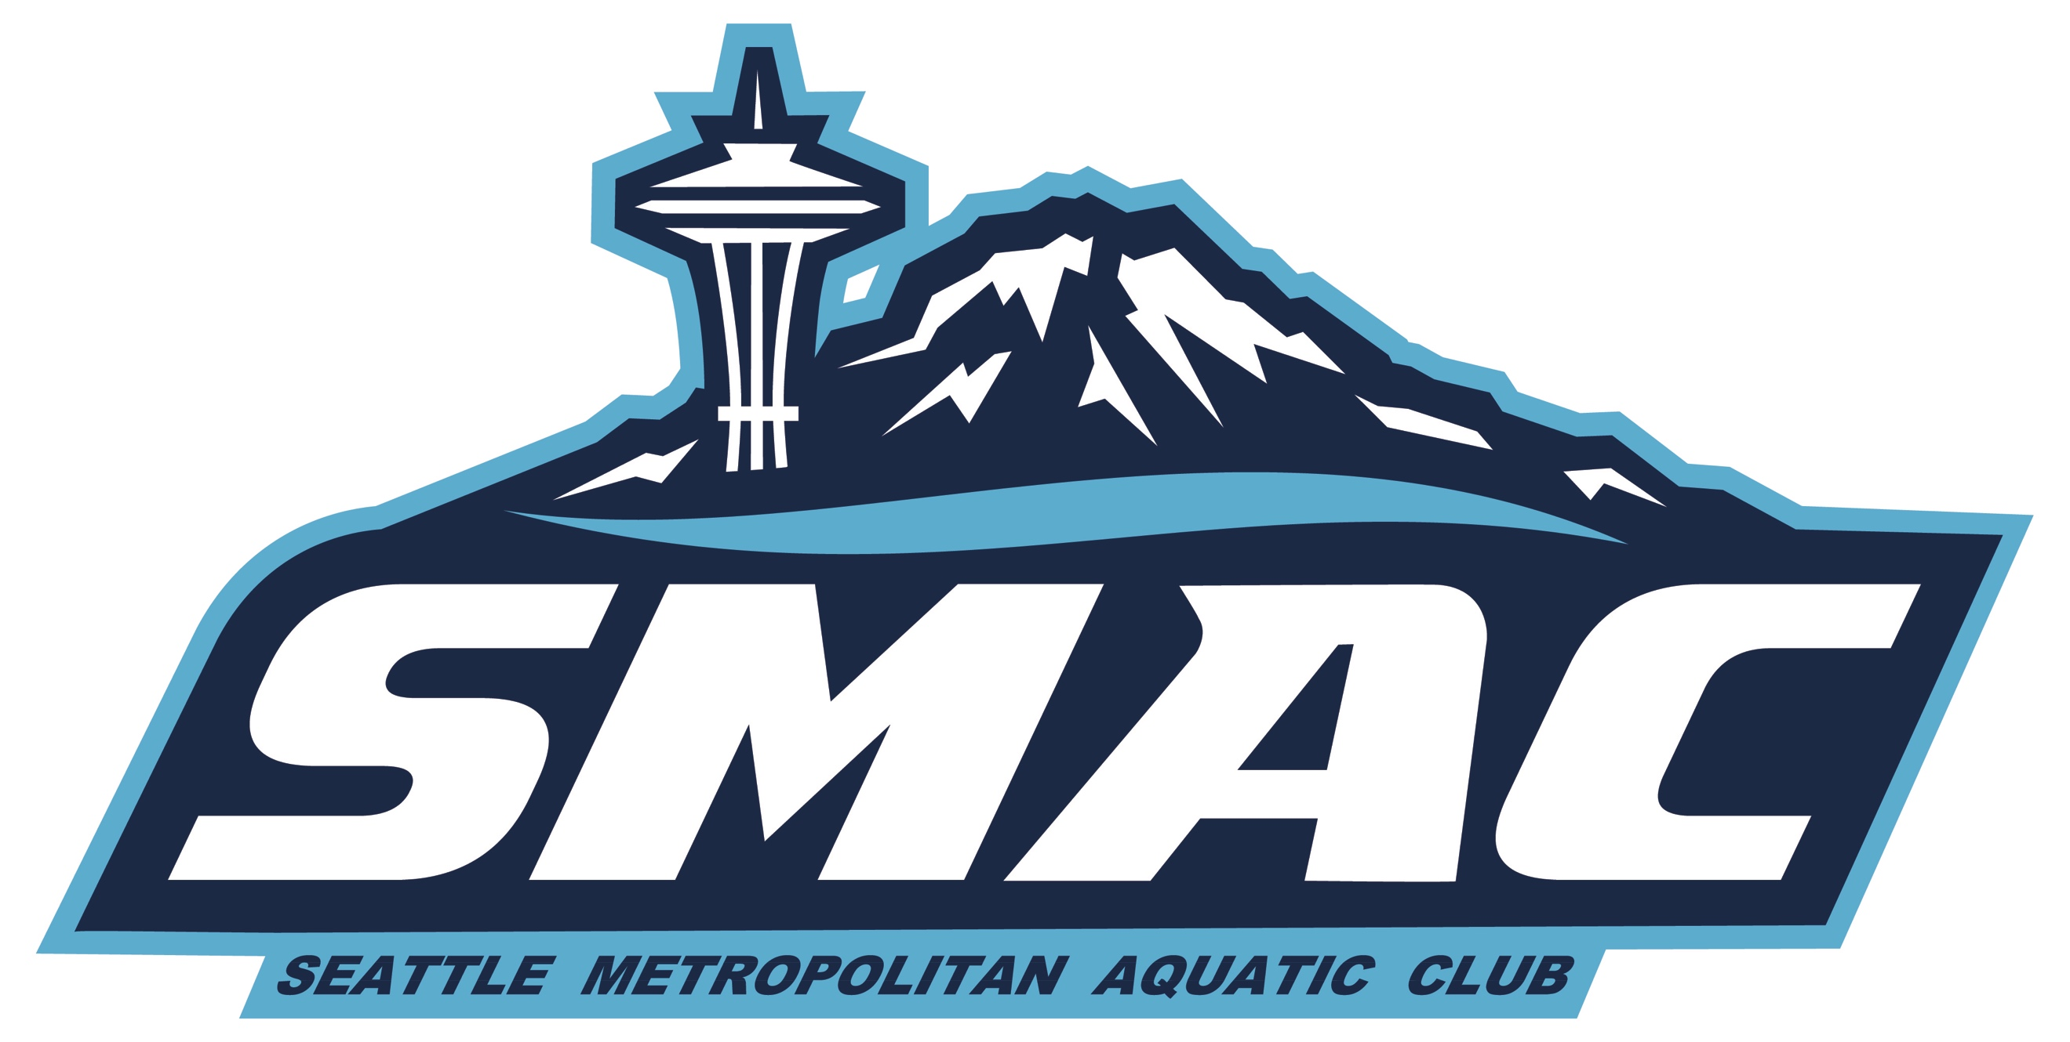
SMAC Nov Board Meeting
Jan. 20, 2021

Attendees: John S, Ken S, Jim H, Laurie R, Joon Y, Shane S

The meeting was called to order at 7:05 PM. Quorum was met with 6 attendees.

1) December minutes. Laurie motioned to approve, Shane seconded. Vote was 6-0 to approve. Minutes will be posted to SMAC website soon

2) Booster President update.

General Updates
- Mary Wayte and Snohomish pools have confirmed facilities for meets Jan-April.
- Rodgers pool still TBD for meets, just opened for lap swim, high school etc.
- Safe sport Parent clinic had 40 parents in Dec, and 40 in Jan.
- Coaches gifting final $11,900
In Process:
- SMAC Video Challenge over the next month-volunteers have been tricky, Tomas to
communicate with coaches, one final call for volunteers.
- Food drive in Feb (run by pool reps)
- Swim A Thon planning, finalize date, prizes. With timing for March 27/28 SAC meet, and Spring Breaks would like to run week of April 26th

Upcoming Meets
- Jan 23rd -Snohomish Aquatic Center
- IM Ready (Feb 13th) Mary Wayte Pool, Mercer Island
- Feb Divisionals (Feb 29-March 1, 2020) Rogers Pool in Puyallup-Pool not currently open
- March 27/28 Holding Snohomish
- Spring Showdown (March 20-21) TBD-probably won’t happen
- April-SC Meet in absence of LC kicking off. Rodgers/Mary Wayte?
- SAC has availability in May. Recommend that we reserve May 1 st /2nd
- IMX Invitational Long Course (July 17-18) King County Aquatic Center
**Rodgers is now currently allowing high school swimming, we are in touch with next steps for
meets.
**Working on pools for meets in April and May, with the goal of adding a meet a month, plus
Ken working on TT Mt Rainiers during practice.
**Pool rentals charging same fees, with less athletes allowed these meets will run most likely at
a loss. Estimated $500 loss on SAC Jan 23 rd meet.

Safe Sport
- Safe Sport clinic 12/9, 40 families signed up, USAS is providing monthly training, will post
for parents ongoing.
- Safe sport Athlete Training. Carl working with Tomas on March date for USAS, or will
schedule more convenient time for SMAC only class.

Fundraising
- Swim Outlet Q4 $542, Facemasks $546.

3) Treasurer’s Report.
Things are looking better than expected. However, we are still losing money because of COVID restrictions. We submitted PPP request yesterday and will receive grant money from PNS (see below in Coach’s report)

4) Marketing Report.
No updates

5) D&I Report.
No updates

6) Coach’s Report.
Senior Sectionals at KCAC has been cancelled in March. Ken is in touch with 4 Corners Sr Sectional Meet planners in Phoenix, AZ. Ken is leaning towards taking a team but a lot of the travel details will be left to individual swimmers. We would need to have swimmers sign a waiver related to COVID exposures.

Looking how to plan the rest of season so we can get official times for swimmers. Working on pools and capacity limits. March AGR meet will not be at KCAC, which is currently being used by King Cty for COVID testing and vaccination site.

Pool Updates:
Nothing new. Medgar is still TBA, No KCAC.
New SD group in Tukwila Starting in February.
Normandy Park is up and running again. Covers delivered from LR.

Diversity Training
Running through PNS. Four sessions. Ken, Derek, John S, Laurae &amp; LeAnne are attending.

PNS Board
Ken is heading up a Task force of PNS coaches to advocate for maintenance and building of new pools in King County and western Washington. This just formed so learning more about what will be needed from team to support.

This will primarily:
- Advocate for funding and maintenance for existing facilities.
- Provide Grant $ for funding and maintenance for existing facilities.
- Advocate for new construction to include competitive facilities in the PNW region.

PNS subsidy Funding
We’ve applied for Round 2 funding from PNS. This round will be $70 per USA Reg swimmer.
PPP Loan Round 2
Laurae sent in our application this week

OKR’s
Objective 3.

Key Result 3. Increase BIPOC swimmers by 10%. Ken has floated some of these goals with Mt Rainier, Tukwila pools and they are interested but want to have conversation in 1-2 months.
Volunteer engagement

Key Result 4: Increase the number of families who complete their volunteer
requirements by 15%.
Key Result 5: Decrease number of families who complete ZERO hours of their
volunteer requirement by 33%.

Focus on improving the following groups and events for both key result 4 and 5.
o New Families and CATfish. Issues:
- Lack of understanding from new team vs old team
- Lack of understanding with new to swim
- CATfish may not do meets, educate on other opportunities

Considerations for next year;
- Videos on “how to”
- New parent meetings (virtual)
- Welcome letter from Boosters
- Create Lead Parent Volunteer position that Is “New and Transfer Member
- Ambassador”
- Membership survey at registration of skills/interests

o Sr and above Issues
- Family fatigue with volunteering
- Swimmers drive themselves/families not at meets

Considerations for next year:
- Engage swimmers for service hours that most schools require.
- Educate families that other family members can also volunteer.
- Penalty if swimmer in meet, vacant volunteer positions and family does
- not volunteer?

o Championship Meets
- Offer double hours
- Summer meets at certain date to apply to next year

Objective 4.
We reviewed onboarding and orientation documents that John and Jim put together. We talked about whether there should be an annual conflict of interest statement and we decided this should be included in code of conduct statement. Otherwise, these documents are in pretty good shape and this key result is completed.

A lot of the other key results are in progress. We talked about whether there should pre-specified evaluation criteria for staff and head coach. We agreed that there should be regular, written evaluations for staff and head coach.

Meeting was adjourned at 8:20. Next meeting will be the FOURTH Wednesday given mid-winter break, Feb 24, 2020 at 7pm via Zoom.

