2017 Pacific Northwest Swimming Swimposium Athlete Swim Clinic w/ USA Olympian Jacob Pebley

Clinic Details: PNS is excited to be hosting 2016 Olympian Jacob Pebley on September 30th at WKCAC for two custom swim clinics for PNS athletes only. There will be two separate sessions based on age. The clinics will be held in conjunction with the 2017 PNS Swimposium, which is open to coaches and parents.
Jacob will Cover: Starts/Turns, World Class underwater dolphin kicking, distance per stroke for backstroke and freestyle and will also be available for photos/autographs and Q&A with the swimmers. Jacob will be accompanied by several coaches on deck, who will be assisting during the clinics.

Date/Time: 12&Under Session 9:30am – 12pm; 13&Over Session: 1pm – 3:30pm

Cost: $40 per swimmer
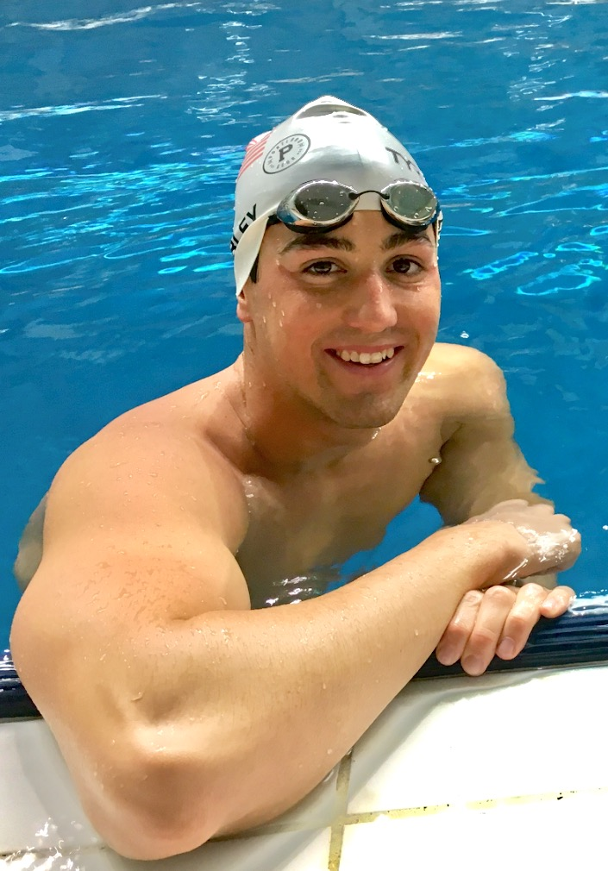
US Olympian Jacob Pebley

Limited space per session: Each session will be capped at 40 swimmers total and these clinics will fill up, as they are open to the entire LSC.
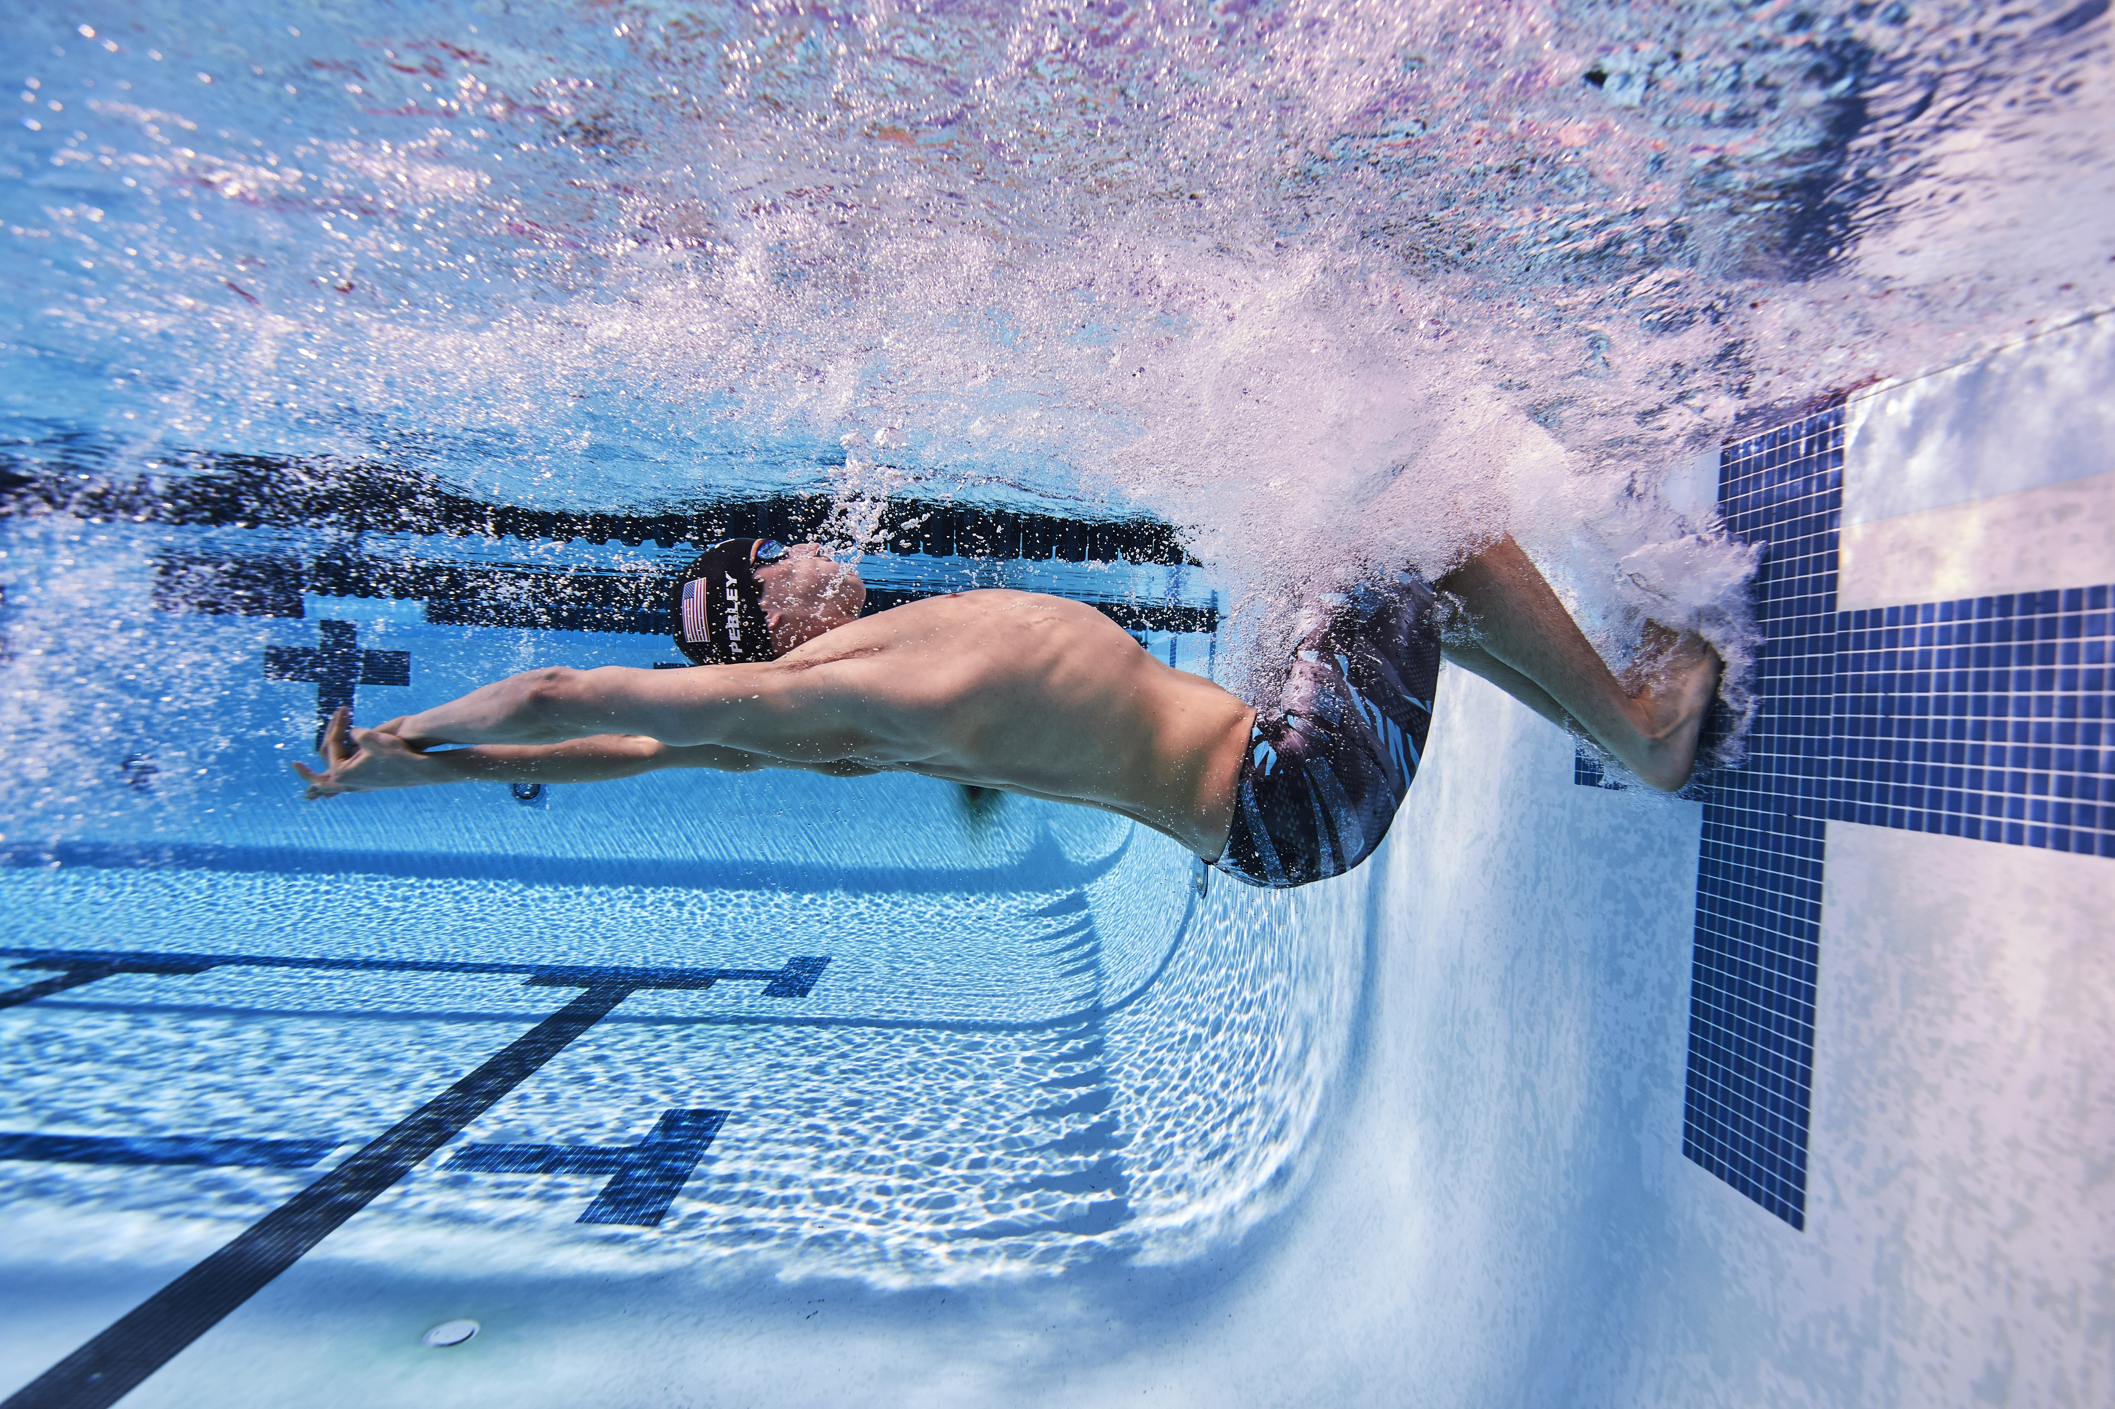

Registration form and check must be received at the PNS Office by Friday September 22nd, 2017.
Mail Check (payable to PNS) and registration form to the PNS Office 501 30th St. NE, Suite D, Auburn, WA 98002.

Athlete Information:

Name: Click here to enter text.
DOB Click here to enter text.
Gender: F☐ M☐

Which session are you signing up for: ☐ 12&Under (9:30am to 12pm) ☐ 13&Over (1pm – 3:30pm)

Address:Click here to enter text.
City: Click here to enter text. State: Click here to enter text. Zipcode:Click here to enter text.

You must be currently registered with USA Swimming

USA Swimming Membership #: Click here to enter text.
Club Affiliation:Click here to enter text.
E-mail:Click here to enter text. Phone:Click here to enter text.

