Palo Alto Stanford Aquatics- Rinconada Site
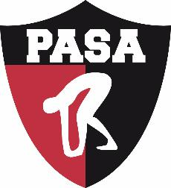

I acknowledge that I and all adult members of my family have received, read and understood the Minor Athlete Abuse Prevention Policy. I further acknowledge and understand that agreeing to comply with the contents of this Policy is a condition of my membership with Palo Alto Stanford Aquatics-Rinconada Site (USA Swimming member club).

Name:
Signature:
Date:

