Tiger Aquatics FALL 2017 Spirit Wear Order Form
Items Ordered Will Be available For Pick Up in 4 Weeks at: Stage Two 2123 Pacific Ave – Stockton (209)957-8463
The Following Items Will Be Embroidered:
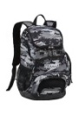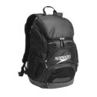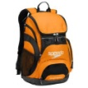Swim Backpack LARGE Colors: CAMO, BLACK or MARIGOLD - Includes 1 Name NAME__________ COLOR____$71.00
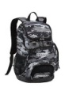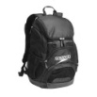 Swim Backpack MEDIUM: Colors: CAMO or BLACK - Includes 1 Name NAME___________ COLOR______$67.00
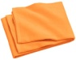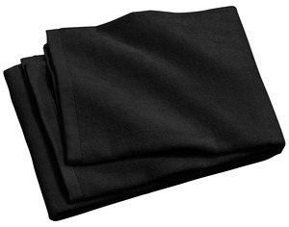 Beach Towel: Colors:TANGERINE or BLACK - Includes 1 Name NAME_________ COLOR_______$37.50
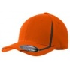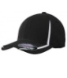 Colorblock Hat Colors:ORANGE or BLACK Size: XS,S/M or L/XL SIZE________COLOR________$23.00
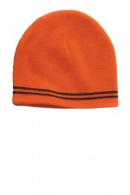 Beanie One Size $14.00
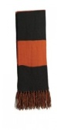 Scarf (this item is plain with NO embroidery) $11.00
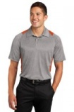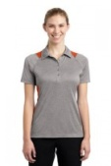Contender Polo (Grey/Orange)Fem Size XS-4X & Male Size XS-4X SIZE_______$32.00
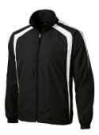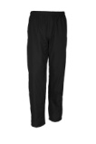ADULT WARM Up SET Includes 1 Name on Pant & Jacket NAME_________ SIZE________$90.95
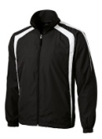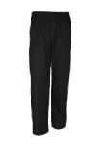YOUTH WARM Up SET Includes 1 Name On Pant & Jacket NAME_________ SIZE________$85.95
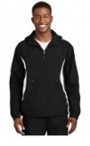 Adult Anorak Includes 1 NAME__________ SIZE_________$54.00
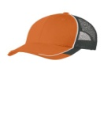 Mesh TRUCKER One Size $19.00
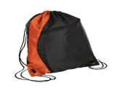Cinch Pack One Size - Includes 1 Name NAME__________ $17.00

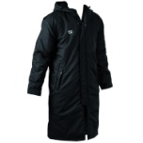ADULT Arena Parka Size Adult: XXS-3XL Includes 1 Name NAME_________ SIZE________$136.00

The Following Items Will Have Screen Print:
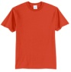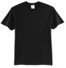Tiger Logo TEE Colors: BLACK or ORANGE Sizes: Child Size XS-XL & Adult Size S-6XL COLOR_______SIZE_______$20.00

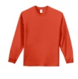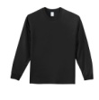Tiger Logo Long Sleeve Colors: BLACK or ORANGE Sizes: Child Size XS-XL & Adult Size S-6XL COLOR_____SIZE_______$22.00
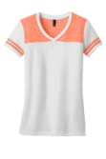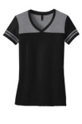Womens Varsity V-Neck Tee Colors: ORG/WHT or GREY/BLK Ladies Sizes: XS-4XL COLOR_______SIZE________$26.00
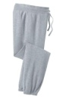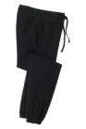Womens Jogger Colors: GREY or BLACK Ladies Sizes: XS-4XL COLOR_______SIZE________$34.00
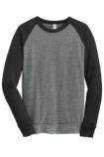AdultUnisex Crew Neck Sweat Shirt Color: GREY/BLK Sizes: Adult XS-4XL SIZE________ $47.00

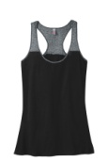Womens Varsity Tank Color: BLK/GREY Ladies Sizes: XS-4XL SIZE________$20.00
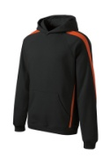Adult Cotton Hoodie Color: BLK w/ ORG Adult Size: XS-4XL Size_________$47.00
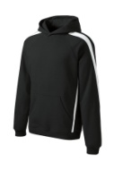Kids Cotton Hoodie Color: Blk w/Wht Child Size: XSC-XLC Size_________$42.00
Personalized Silicone Swim Cap w/Tiger Logo
**Must Order a Minimum of 2 Caps Per Personalized Name**
NAME________________________________QTY______X $17.00__________
NAME________________________________QTY______X $17.00__________

Silicone Cap Sub Total______________

Sub Total of All Items________________
Plus Sales Tax (9.0%)
TOTAL____________________________

