 | IMX-PERIENCE Meet  January 15-16, 2022  Sanction # PVC-22-XX | 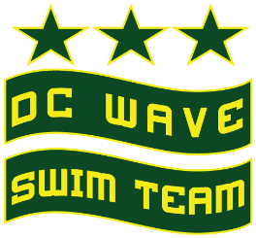
MEET DIRECTOR  Rob Green  robert.green@dc.gov | MEET REFEREE  Erika Livingston  erika@aimstutoring.com | CLUB OFFICIALS CHAIR  Erika Livingston erika@aimstutoring.com
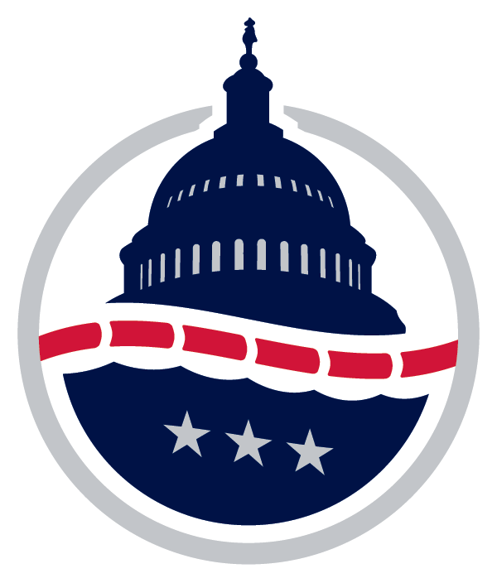
SANCTION | - Held under the sanction of USA Swimming through Potomac Valley Swimming: PVC-22-XX.  - In granting this sanction it is understood and agreed that USA Swimming, Potomac Valley Swimming, DC Wave Swim Team, and the Wilson Aquatic Center shall be held free and harmless from any and all liabilities or claims for damages arising by reason of injuries to anyone during the conduct of this event.
FACILITY | Wilson Aquatic Center  4551 Fort Drive NW,  Washington, DC 20016  (202) 730-0583  - The pool at the Wilson Aquatic Center is a 50m x 25yd pool with a moveable bulkhead. Competition will be held in 8 lanes, 25 yards, running from wall to wall at the northern end of the pool. 16 lanes will be available for warm-ups.  - Water depth range of 9.0’ - 13.6’ at the starting end and at the turning end.  - The competition course has not been certified in accordance with current USA Swimming Rules and Regulations, Article 104.2.2(C).
ENTRY DEADLINE | Friday, January 7 at 11:59 pm  IMPORTANT: The above date is the deadline for clubs to submit their entries to the Meet Director. Therefore, clubs usually set an earlier deadline to receive entries from their swimmers. Check with your club for this information.
SCHEDULE | Saturday & Sunday Warm Up: 9:00 am – 9:50 am | Events: 10:00 am  *Note: Meet manager will determine if session start times will need to be adjusted or if age groups need to be moved to different sessions based on the number of entries received. A timeline will be established and forwarded to each team by Wednesday, January 12th.
ELIGIBILITY | - Open to all registered Potomac Valley Swimmers.  - No swimmer will be permitted to compete in the meet unless the swimmer is registered as an athlete member of USA Swimming as provided in USA Swimming Rules and Regulations, Article 302.
DISABILITY SWIMMERS | - PVS and host clubs along with their meet directors are committed to the Inclusion Policy as adopted by the PVS BOD. Athletes with a disability are welcomed and are asked to provide advance notice of desired accommodations to the Meet Director. The athlete (or athlete’s coach) is also responsible for notifying the session referee of any disability prior to competition.
TIMING SYSTEM | - Automatic timing (touchpads primary) will be used.
COVID-19 CONSIDERATIONS | - An inherent risk of exposure to COVID-19 exists in any public place where people are present. COVID-19 is a contagious disease that can lead to severe illness and death. According to the Centers for Disease Control and Prevention, senior citizens and individuals with underlying medical conditions are especially vulnerable.  - USA Swimming, Inc., cannot prevent you (or your child(ren)) from becoming exposed to, contracting, or spreading COVID-19 while participating in USA Swimming sanctioned events. It is not possible to prevent against the presence of the disease. Therefore, if you choose to participate in a USA Swimming sanctioned event, you may be exposing yourself to and/or increasing your risk of contracting or spreading COVID-19.  - BY ATTENDING OR PARTICIPATING IN THIS COMPETITION, YOU VOLUNTARILY ASSUME ALL RISKS ASSOCIATED WITH EXPOSURE TO COVID-19 AND FOREVER RELEASE AND HOLD HARMLESS USA SWIMMING, POTOMAC VALLEY SWIMMING, DC WAVE SWIM TEAM, AND THE WILSON AQUATIC CENTER AND EACH OF THEIR OFFICERS, DIRECTORS, AGENTS, EMPLOYEES OR OTHER REPRESENTATIVES FROM ANY LIABILITY OR CLAIMS INCLUDING FOR PERSONAL INJURIES, DEATH, DISEASE OR PROPERTY LOSSES, OR ANY OTHER LOSS, INCLUDING BUT NOT LIMITED TO CLAIMS OF NEGLIGENCE AND GIVE UP ANY CLAIMS YOU MAY HAVE TO SEEK DAMAGES, WHETHER KNOWN OR UNKNOWN, FORESEEN OR UNFORESEEN, IN CONNECTION WITH EXPOSURE, INFECTION, AND/OR SPREAD OF COVID-19 RELATED TO PARTICIPATION IN THIS COMPETITION.  - We have taken enhanced health and safety measures for all attending this meet, however we cannot guarantee that you will not become infected with COVID-19. All attending this meet must follow all posted instructions while in attendance. An inherent risk of exposure to COVID-19 exists in any public place where people are present. By attending this meet, you acknowledge the contagious nature of COVID-19 and voluntarily assume all risks related to exposure to COVID-19.  - By choosing to attend this meet you agree to comply with all health and safety mandates and guidelines of USA Swimming, Potomac Valley Swimming, the District of Columbia.
COVID-19 PROTOCOLS | - Before signing up your young swimmer, please consider that they can manage themselves for the duration of the meet with just their swim coach overseeing them, including being able to visit the bathroom independently.  - Locker room use should be minimized.  - No one with symptoms of COVID-19 is permitted in the facility or outside team seating area.  - Athletes should arrive and depart in their suits if possible.  - All attendees (athletes, coaches, officials, and volunteers) must wear a mask to enter the facility and throughout the facility, with the exception of athletes when competing or warming up/cooling down.  - All attendees (athletes, coaches, volunteers, officials, etc.) must complete an online COVID waiver and health screening before they are permitted in the facility. The link to the online form will be emailed to all participating teams prior to the meet.  - Athletes will be seated in the balcony bleacher area overlooking the competition pool.  - All attendees should maintain a minimum of three (3) feet distance from all other participants whenever possible.  - The meet will be limited to no more than 200 swimmers per session.  - Only swimmers, coaches, meet volunteers, and officials will be permitted in the team areas and on the pool deck.  - Each team MUST assign a certified Coach to always remain in the assigned Team Area to ensure COVID-19 guidelines are being followed and to assist with Clerk of Course.  - A designated staff member, official, coach or volunteer will be in place to observe/marshal COVID-19 guidelines and report back to the coaches and officials on concerns or improvements.  - Swimmers must wear their masks until they arrive at their lane and they will take it off and place it in a bag. The bags will be placed in baskets by the starting blocks during warm-ups and competition. Swimmers will immediately put their masks back on at the completion of their swims before they leave the starting area.  - Swimmers must follow all directions as posted and adhere to all marshal directions.  - Swimmers will walk around the pool deck as directed and line back up in the designated area with proper social distancing until they are cleared to go back to their seating area.  - All swimmers must remain in their designated seating area for their group until they are called for their event and they must return to their area immediately following their event.  - Any swimmer not following the meet protocols will be subject to immediate removal from the meet.  - All coaches, officials, and volunteers must bring their own water bottle and snacks.  - We request that all attendees notify the meet director as soon as possible if they have tested positive for COVID-19, shown symptoms or have been in contact with anyone exposed to COVID-19 after attending the meet.  - No spectators will be permitted. Competition will be live-streamed via the DC Wave Swim Team Twitch channel https://www.twitch.tv/dcwaveswimteam.
RULES | - Current USA Swimming rules shall govern this meet.  - All applicable adults participating in or associated with this meet acknowledge that they are subject to the provisions of the USA Swimming Minor Athlete Abuse Prevention Policy ("MAAPP"), and that they understand that compliance with the MAAPP policy is a condition of participation in the conduct of this competition.  - No on-deck USA Swimming registration is permitted.  - In compliance with USA Swimming Rules and Regulations, the use of audio or visual recording devices, including a cell phone is not permitted in the changing areas, rest rooms, or locker rooms. Per PVS policy, the use of equipment capable of taking pictures (e.g., cell phones, cameras, etc.) is banned from behind the starting blocks during the entire meet, including warm up, competition and cool down periods.  - Deck changes are prohibited.  - Any swimmer entered in the meet must be certified by a USA Swimming member coach as being proficient in performing a racing start or must start each race from within the water. When unaccompanied by a member-coach, it is the responsibility of the swimmer or the swimmer’s legal guardian to ensure compliance with this requirement.  - Operation of a drone or any other flying devices is prohibited over the venue (pools, athlete/coach areas, spectator areas and open ceiling locker rooms) any time athletes, coaches, officials and/or spectators are present.  - Dive-over starts will be used.  - The Meet Director and the PVS Technical Committee reserve the right to limit events, heats, swimmers or adjust the format to conform with the 4-hour provision for sessions that include 12 & U events per Rule 205.3.1F.
EVENT RULES | - All events are timed finals.  - All events will be pre-seeded.  - Athletes may swim a maximum of three (3) events per day.
POSITIVE CHECK IN | - All events will be pre-seeded.
WARM-UP | - The prescribed PVS warm-up procedures and safety policies will be followed. The Meet Director may determine the structure of warm-up, including times/lane assignments.
SUPERVISION | - Coaches are responsible for the conduct of their swimmers and cleaning up for their team areas.  - Each team MUST assign a certified Coach to always remain in the assigned Team Area to ensure COVID-19 guidelines are being followed and to assist with Clerk of Course.  - No spectators will be permitted in the facility.
SEEDING | - Standard seeding will be used.
SCORING | - N/A
AWARDS | - N/A
PROGRAMS | - Meet programs will be emailed to teams and available on Meet Mobile.
CREDENTIALS | - Parents not working the meet as a deck official, volunteer timer or other position are not permitted on deck. Only athletes, USA Swimming certified coaches, and deck officials will be permitted on the deck. Coaches and Officials should have proof of active USA Swimming membership with them at all times.
SPECTATOR ENTRY FEE | - Spectators are not permitted inside the facility. Competition will be live-streamed.

OFFICIALS | - Each participating club is requested to provide at least one table worker or official (Referee Starter, Chief Judge or Stroke & Turn Judge) per session if entering 25 or more splashes.  - Officials interested in volunteering should contact the Meet Referee, Erika Livingston, erika@aimstutoring.com.  - Officials volunteering for this meet should sign in at the recording table prior to the start of warm-ups. Certified officials who have not previously volunteered should contact the referee upon arrival to make their services available. A comprehensive officials briefing will precede each session during warm-ups.
TIMERS | - Participating clubs are requested to provide timers in proportion to their entries. One timer is requested for each 25 entries.  - One timer per lane. There will be two Head Timers per course.  - An online Timer’s Signup will be emailed to participating clubs.
ENTRY PROCEDURES | - Entries should be submitted by email to the Meet Director.  - Include in the subject of the email, “IMXPERIENCE Meet - ****” with the club’s initials in place of the asterisks. If your club submits multiple entry files include training site in the subject of the email.  - Include in entry email: entry file, report of entries by name, report of entries by event.  - In the body of your email provide entry numbers (girls, boys, totals), contact information (email, phone, officials contact).  - Entries directly from individual team members will not be accepted.  - Entries by phone or fax will not be accepted.  - The Meet Director will acknowledge receipt by return email within 24 hours. If acknowledgement is not received in a timely manner, please contact the Meet Director.  - Any club that enters an unregistered or improperly registered athlete, falsifies an entry in any way, or permits an unregistered coach to represent them will be fined the sum of $100 by PVS and no further entries will be accepted from that club until the said fine is paid.
ENTRY FEES | Per Swimmer Surcharge: N/A Individual Event Fee: $5.00  - Entries fees are to be made payable to the “DC Wave Booster Club”. Fees are non-refundable. Entries will not be considered received until all fees are paid. Fees for individual events are $5.00.  - Each team/club is requested to remit only one check or money order to cover entry fees. NO CASH PAYMENTS WILL BE ACCEPTED.  - Entry fees should be sent to:  DC Wave Booster Club  6323 Georgia Avenue, NW  PO BOX 55661  Washington DC, 20040  - Entry fees are due with meet entry. Unpaid fees will be reported to the PVS Administrative Office at the conclusion of the meet.

IMX-PERIENCE Meet
January 15-16, 2022
Warm Up | 9:00 – 9:50 AM; Events | 10:00 am
SATURDAY, January 15 |  |  |  | SUNDAY, January 16
GIRLS | EVENT | BOYS |  | GIRLS | EVENT | BOYS
1 | 9 & 10 100 Backstroke | 2 |  | 19 | 13 & Over 200 Backstroke | 20
3 | 11 & 12 100 Backstroke | 4 |  | 21 | 9 & 10 200 Freestyle | 22
5 | 13 & Over 400 I.M. | 6 |  | 23 | 11 & 12 500 Freestyle | 24
7 | 9 & 10 100 Breaststroke | 8 |  | 25 | 13 & Over 500 Freestyle | 26
9 | 11 & 12 100 Breaststroke | 10 |  | 27 | 9 & 10 200 I.M. | 28
11 | 13 & Over 200 Breaststroke | 12 |  | 29 | 11 & 12 200 I.M. | 30
13 | 9 & 10 100 Butterfly | 14 |  | 31 | 13 & Over 200 I.M. | 32
15 | 11 & 12 100 Butterfly | 16
17 | 13 & Over 200 Butterfly | 18

