The FISH Class of 2017 Questionnaire
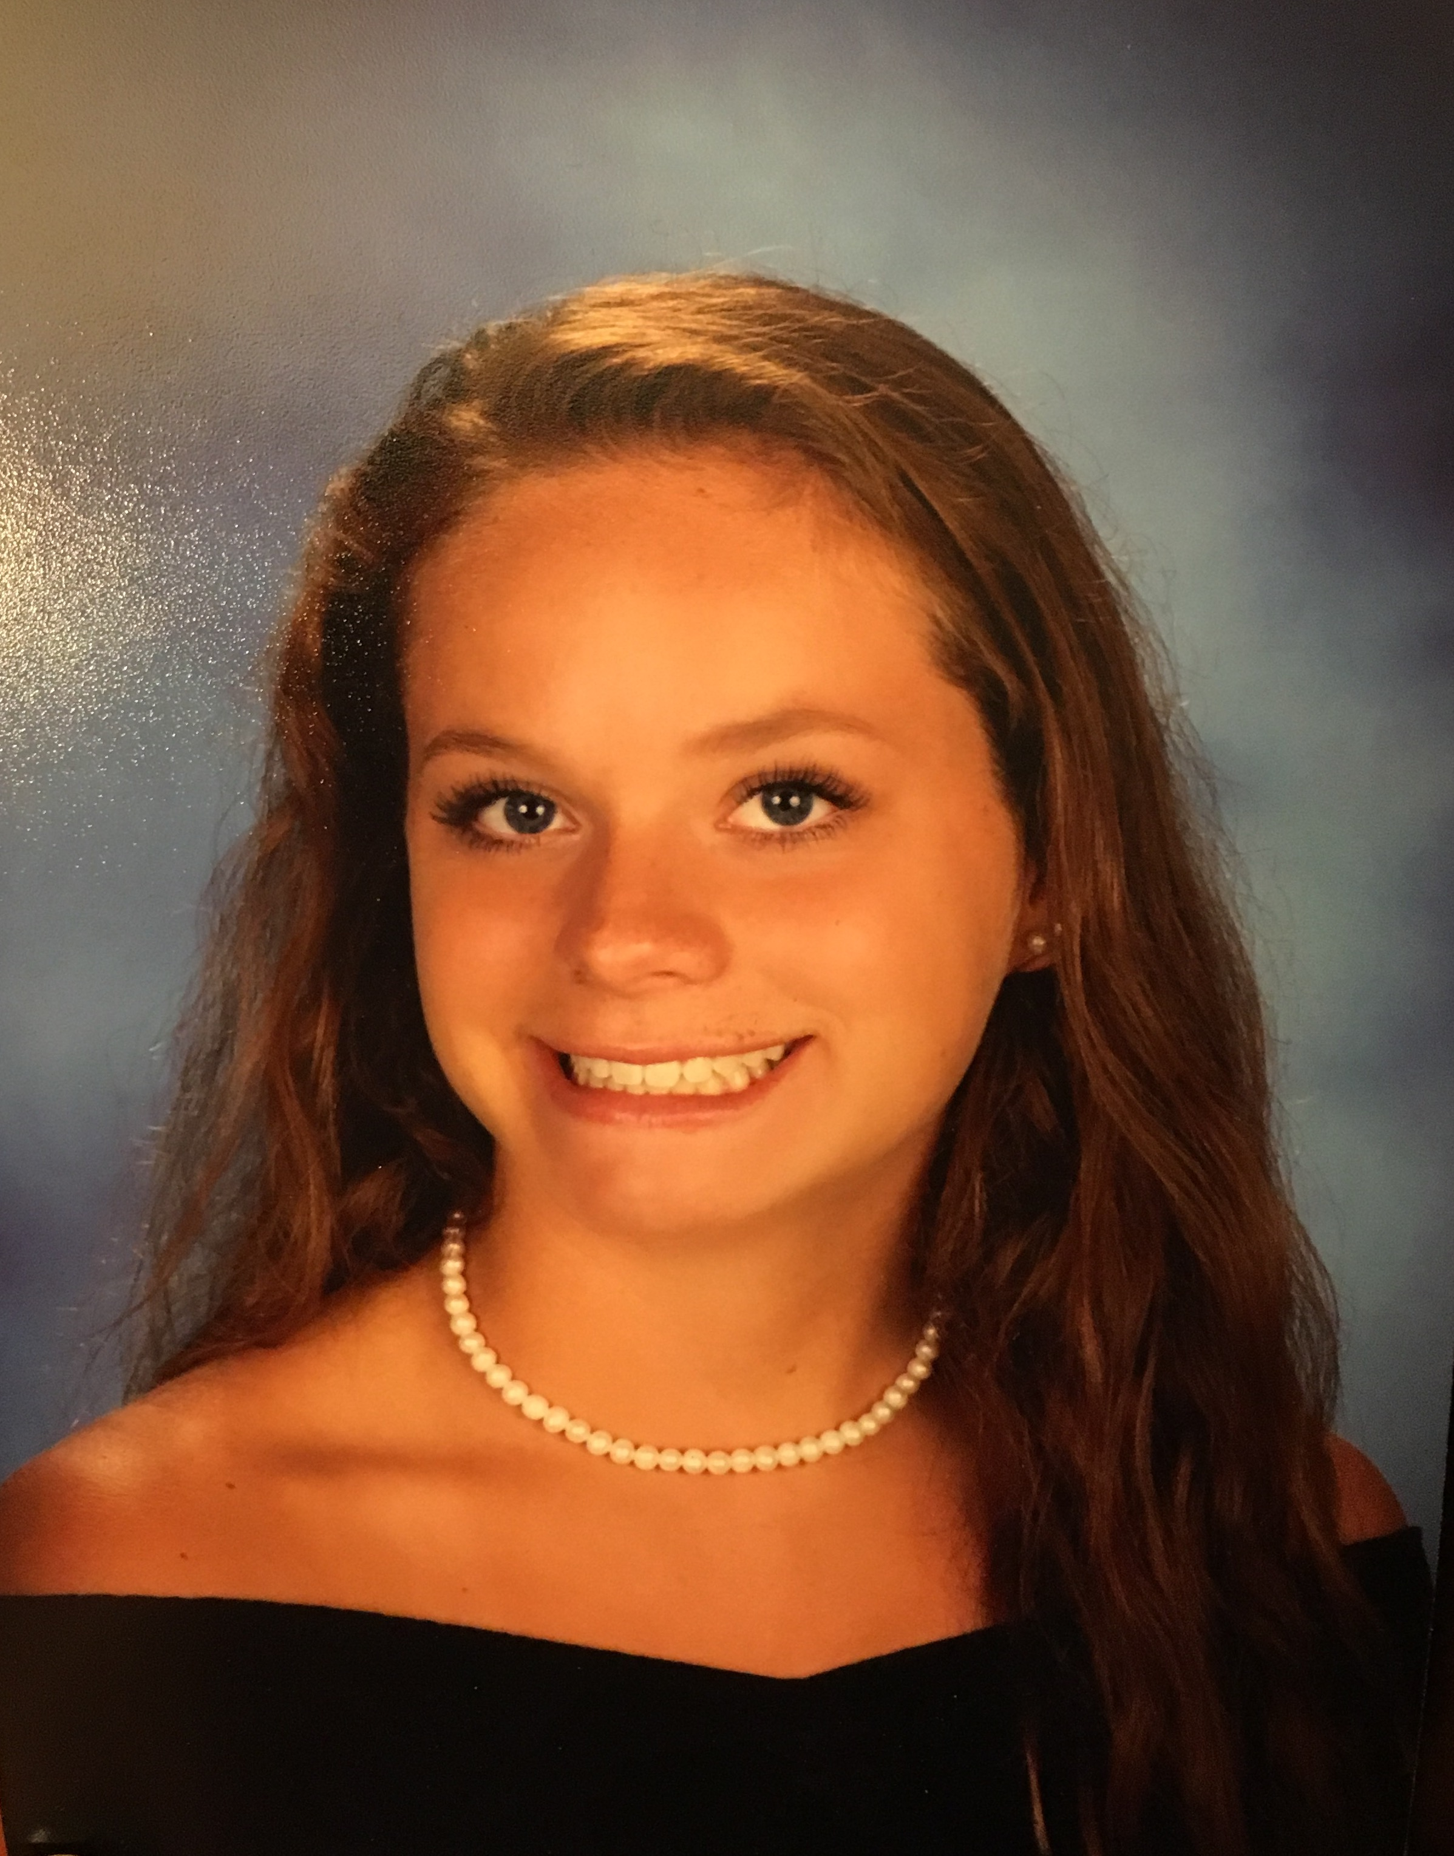
Name: Gillian Cutrell

Nick Name:

FISH Group: Incredible Prep
Home Town: Herndon

High School: Herndon High School

Future College: University of South Carolina

Parents & Siblings: George, Cathy, Grace, and Georgia.

When did you join the FISH, and what has been your most memorable experience while being on the team? Joined in the Fall of 2015. My most memorable experience was when I first tried out at Westwood and died at that practice because I wasn’t used to long course.

What was your most rewarding and exciting meet during your FISH career? Districts when I was able to get best times.

What is your favorite set? 16 x 400.

What are your favorite events? 200 and 500 free.

What is the biggest challenge for you in swimming? Making it across the pool.

What motivates you most? Knowing I can eat whatever I want after practice.

Which aspects of swimming do you apply in everyday life? Determination, because at school I get tired and it is hard for me to finish out the day, but I manage to get through it with my will-power.

You are beginning a new chapter in your life, college. What are you most looking forward to? How has FISH prepared you? I am excited to meet new people since I only know a few going to my college. I didn’t know anyone in FISH when I first joined so was forced to make new friends which will help me in college.

What advice can you give your teammates in your group and especially your younger teammates who are just starting out? Try your hardest because time flies and before you know it, you will already be done with swimming.

Tell us a little bit about you; what do you like to do when you are not swimming or busy with schoolwork? I like to go out to eat, hang out with friends, work out at my gym, and watch movies.

