February FISH of the Month
Ella Loftis
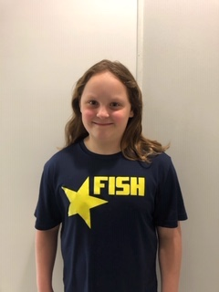

Congratulations to Ella Loftis for being named the FISH of the Month for February! Ella is 10 years old in her second year on the team and she swims at Audrey Moore in Age Group 3. Ella has been working hard on her technique and conditioning this year, and her underwater dolphin kicking has improved tremendously. Ella loves swimming so much that she’s even been putting in extra work at Spring Hill morning practices!

All that hard work paid off for Ella at the 2020 PVS 18 & Under Qualifier where she was able to post 6 new best times – and 3 Junior Olympic qualifying times! Making JO’s was her big goal for the season, and to make it in 3 different events on the same weekend was incredible! In fact, she considers qualifying for JO’s to be her favorite FISH memory so far.

Ella loves being on The FISH because she gets to swim, have fun with her friends and teammates, and she loves cheering everybody on! Her favorite sets are freestyle sets, but she also loves swimming butterfly drills in practice – the Bowman Drill is her favorite.

Outside of the pool you can catch Ella working on a new art project, doing some creative writing, playing soccer, and playing with her animals. When you see Ella around, make sure to congratulate her on being named FISH of the Month!

5 Fast Questions with Ella:
1. Coke or Pepsi? Orange Fanta
2. Ski or snowboard? Ski
3. Favorite pro swimmer? Katie Ledecky
4. Favorite Movie? Harry Potter
5. Favorite Book? Charlie Thorn and the Last Equation

