January FISH of the Month
Evie Walker
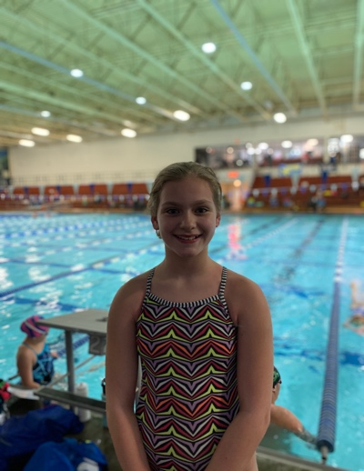

Congratulations to Evie Walker on being named our January FISH of the Month! Evie is 11 years old in her second year with the FISH and swims at Audrey Moore in Fantastic AAG. Evie is on track to have another amazing season. She has been working hard at every practice in improve her technique, and speed. Evie is also taking advantage of her dryland opportunities to help make herself stronger!

Evie’s hard work paid off at the Retriever Classic in Baltimore, where she was able to final in 8 of the 9 events that she swam at the meet. Swimming her first event of the weekend, the 50 Butterfly, Evie posted a new best time of 32.92 to earn herself a 3rd place seed going into finals. Later that night, Evie dropped another .20 off her time to earn a 2nd place finish and over a 2 second drop in her favorite event. This was just the start to her amazing weekend where she swam finals in another 7 events. We are looking forward watching Evie have more great swims like this in her FISH career.

Outside of the pool you can catch Evie hanging out with her friends, reading a new book or walking/playing with her dog. Next time you see her on deck make sure to say Hi and congratulate her on being named the January FISH of the Month!

Quick Questions with Evie:
- Favorite FISH memory? Having my friends cheer for me when I am racing
- Favorite subject in school? Math
- Gatorade or Powerade? Powerade!
- Cake or Pie? Cake, Chocolate Cake

