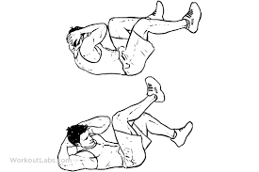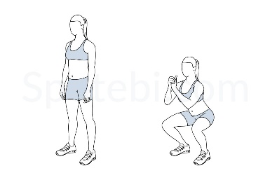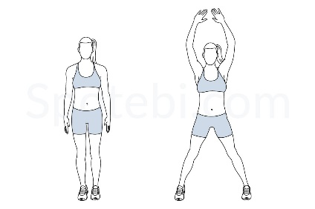 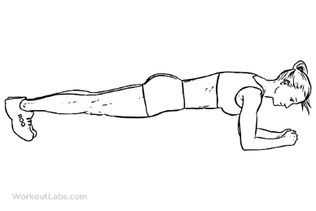

Squats X 10

Bicycle Crunches X 10 each side

Elbow Plank @ 30 seconds

Jumping Jacks @ 30 Seconds

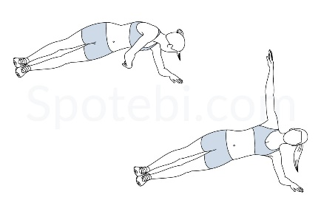

X 3 circuits

Other activities:

Take a 30 minute walk

Design a bag tag

Create a swim practice of 4375 Yards

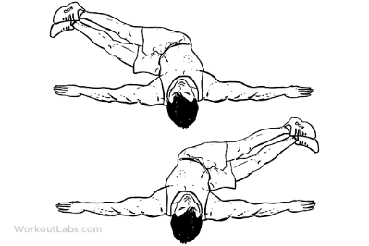

Plank Rotations X 10 each side

Windshield Wipers 10 each side

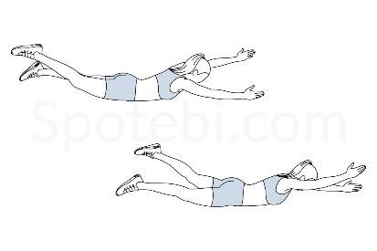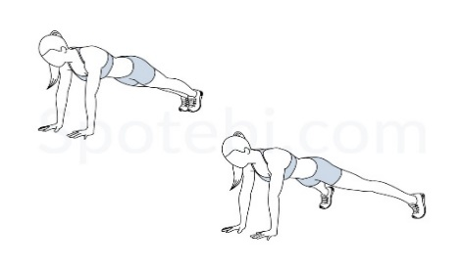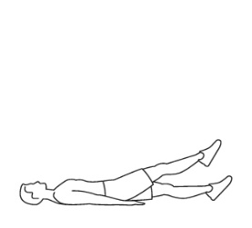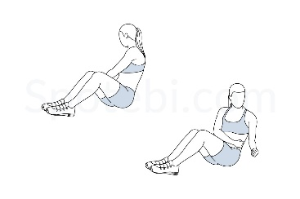

Swimmers @ 30 Seconds

Plank Jacks @ 30 seconds

Russian Twists 10 each side

Flutter Kicks X 10 each leg