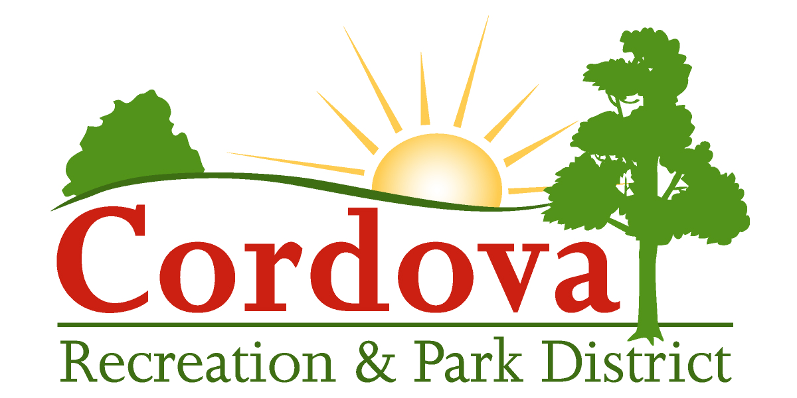
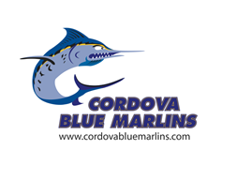
Cordova Blue Marlins
Parent/Guardian Code of Conduct

I hereby pledge to provide positive support, care and encouragement for my child participating on the Cordova Blue Marlin Swim Team by following this Parent/Guardian Code of Conduct:

- I will encourage good sportsmanship by demonstrating positive support for all swimmers, coaches and officials at every practice, meet and at other Cordova Blue Marlin events.
- I will not yell at or degrade my child(ren), team or other teams’ swimmers, coaches, fans or officials.
- I will place the emotional and physical wellbeing of my child(ren) ahead of my personal desire to win.
- I will insist that my child(ren) participate in a safe and healthy environment.
- I will support coaches, officials and staff working with my child(ren), in order to encourage a positive and enjoyable experience for all.
- I will support a sports environment for my child(ren) that is free from drugs, tobacco, alcohol and will refrain from their use at all Cordova Blue Marlin events.
- I will refrain from using profane gestures and language at all Cordova Blue Marlin events.
- I will do my best to make swimming fun for my child.
- I will set a positive example for my child(ren) and my actions will be free from discrimination, including harassment, bullying and intimidation, on the basis of actual or perceived disability, gender, gender identity, gender expression, nationality, race or ethnicity, religion, sexual orientation or any other characteristic that is contained in the definition of hate crimes set forth in Section 422.55 of the Penal Code. Discrimination also is prohibited based on a person's association with a person or group with one or more of these actual or perceived characteristics.
- I understand that this Parent/Guardian Code of Conduct applies to my invited guests and other family members as well and that I may be held accountable for their actions.

I understand that if I do not conduct myself in a positive and supportive manner that I may be asked to leave a practice or meet by CRPD officials. I understand that Cordova officials include: CRPD Staff and Cordova Blue Marlin Parent Board members. My failure to comply with their instructions to leave will result in my child being immediately dismissed from the team, without reimbursement of fees. I further understand that repeated violations or violations of a serious nature may result in my child being dismissed from the team, without reimbursement of fees.

I understand that above Parent/Guardian Code of Conduct may not include all prohibited behaviors and that CRPD Officials reserve the right to determine whether any behavior violates generally accepted behavior standards.

Parent/Guardian Name (Please Print) Date

Parent/Guardian Signature

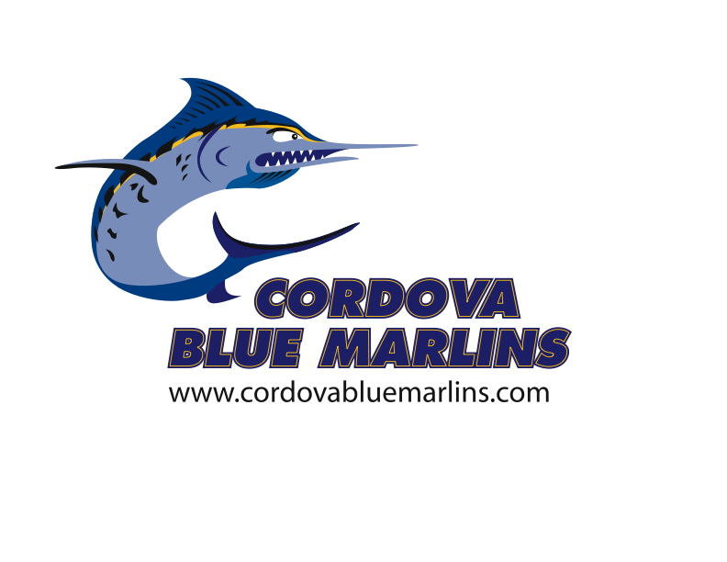
Cordova Blue Marlins
Swimmer Code of Conduct

I hereby pledge to provide positive support, care and encouragement for my teammates and other swimmers participating in the Valley Foothill Competitive Aquatics League by following this Swimmer Code of Conduct:

- I will encourage good sportsmanship by demonstrating a positive attitude and respect for all players, coaches and officials at every practice, meet and at all Cordova Blue Marlin events.
- I will not yell at or degrade my teammates or other teams’ swimmers, players, coaches, fans or officials.
- I will place sportsmanship ahead of my personal desire to win.
- I will insist that I participate in a safe and healthy environment.
- I will support coaches and officials working with me, to encourage a positive and enjoyable experience for all.
- I will support a sports environment free from drugs, tobacco and alcohol and will refrain from them.
- I will refrain from using profane gestures and language at all Cordova Blue Marlin events.
- I will refrain from inappropriate behavior.
- My actions will be free from discrimination, including harassment, bullying and intimidation, on the basis of actual or perceived disability, gender, gender identity, gender expression, nationality, race or ethnicity, religion, sexual orientation or any other characteristic that is contained in the definition of hate crimes set forth in Section 422.55 of the Penal Code. Discrimination also is prohibited based on a person's association with a person or group with one or more of these actual or perceived characteristics.

I understand that if I do not conduct myself in a positive and supportive manner that I may be asked to leave a practice or meet by CRPD officials. I further understand that repeated violations of the Swimmer Code of Conduct or CRPD Rules and Regulations or violations of a serious nature may result in my being dismissed from the team, without reimbursement of fees.

I understand that this Swimmer Code of Conduct may not include all prohibited behaviors and that CRPD Officials reserve the right to determine whether any behavior violates generally accepted behavior standards.

Swimmer Name & Signature Swimmer Name & Signature

Swimmer Name & Signature Swimmer Name & Signature

As the swimmer(s)’s guardian, I have reviewed the above Swimmer Code of Conduct with them and verify that they fully understand the expectations and consequences of behavior as participants of the Blue Marlins.

Parent/Guardian Signature Date

