1 2 3 4

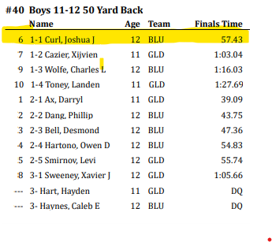
Second Heat
First Heat

The results will show display the event information at top.
The results display swimmers based on heats. Swimmers
in the first heat will be listed first and in order of how they
placed in the heat. Note: They lane the swam in will not
matter for this report.
were in
- How swimmer placed based on time. In this example,
Joshua Curl placed 6 based on time

- How swimmer placed in assigned heat. In this example,
the numbers 1-1 mean he was in the first heat, with
he best time. 1-2 is first heat, second place time.

- BLU represents the team. For Blue and Gold, swimmers
were placed into two separate groups BLU and GLD to
have a little team rivalry. During most meets, our team
will display CBM and the other team will have their own
designation.

- Swimmer Time or DQ

