Congressional Country Club
8500 River Road
Bethesda, Maryland 20817
Main Number (301) 469-2000

Host Club Arrangements

Congressional Country Club is proud to host the 2016 CCSDA Championship Swimming Meet. Our goal is to provide the venue and infrastructure for a safe, rewarding and memorable event for each participating CCSDA swimmer and their parents.

- Guidelines for CCSDA Championship Swimming Meet at Congressional Country Club

Safety is paramount. All athletes, coaches, and spectators must comply with published and posted regulations and follow the direction of Congressional pool staff and meet marshals.

Specific instructions include:

  - Swimmers may not enter the Competition Pool deck unless swimming or waiting for their heat.
  - Everyone must stay off the diving boards and guard stands.
  - No running or horseplay in the pool areas.
  - No swimmers are allowed unattended in the warm-up and warm-down pool area.
  - Teams should assign an assistant coach or parent to the team area to maintain order and to ensure that swimmers report to Clerk of Course on time.
  - After each day’s session, teams should clean their team area and remove all trash and personal belongings. Please place all trash in the provided containers.
  - Spectators must remove all towels and personal belongings from the spectator bleachers at the end of each day.
  - Food and beverage service will be offered during on each day of the meet. Food and beverage tickets will be sold at the entrance to the Competition Pool and may be purchased with cash only (except that members of Congressional may use their Club number).
  - No outside food or beverages may be brought into the Club.
  - Proper attire is required inside the Clubhouse. Guests in proper attire are invited to dine in our restaurant facilities using reciprocal Club numbers. Swimmers wearing bathing suits should not enter the Clubhouse unless there is an emergency, and they are instructed to do so.
  - No tobacco products with the exception of inside your car.
  - No talking on cell phones anywhere on Club premises except in the parking lots.
  - First aid assistance is available at the Aquatic Director’s office.

2. Location

Congressional Country Club is located at 8500 River Road, Bethesda, Maryland, 20817. Directions are attached.

A diagram describing the flow of swimmers during the meet and the location of principal activities such as the Clerk of Course, Team Areas, Locker Rooms, Refreshment Stands and Warm-up areas is attached.

Please note that access to the pool areas will not be until 8:00 a.m. each morning. Swimmers, coaches and families should not arrive any earlier as they will not be able to access the pools.

3. Parking

Parking will be available on Club premises but spaces are limited. We STRONGLY encourage carpooling. Priority parking passes will be distributed to coaches and/or team representatives at the Scratch Meeting. All others may park as directed by Club officials on the Club grounds. The following should be noted during the entire meet:

- There will be a clearly marked off drop off area for swimmers.
- Please drive slowly and carefully entering and leaving the Club.
- Please respect pedestrians.
- Please note posted signs and obey instructions for Club personnel directing traffic.

- Locker Facilities and Rest Rooms

Toilet and shower facilities are available in the girls’ and boys’ locker rooms adjacent to the Competition Pool, and in the women’s and men’s facilities adjacent to the warm-up/warm-down pool. Two additional restroom facilities are available at the pavilion near the Clerk of Course on the Competition Pool deck.

- Team Area

The attached diagram designates a team area for each team. Teams are invited to bring a tent or shelter for sun and rain protection. Each team is requested to assign an assistant coach or a parent to its team area to maintain order and to ensure that swimmers report to the Clerk of Course on time. Teams are requested to keep their assigned area policed during the trials and finals and completely cleaned at the end of each day.

6. Off Limits Areas to Athletes and Spectators

The following areas are off-limits to athletes and spectators:
- Fitness Center
- Main Clubhouse Locker Rooms
- Golf and Tennis Facilities
- Main Clubhouse, except for designated eating areas, with the appropriate attire.

7. Competition Pool Deck

The pool deck shall be open only to officials, coaches, and swimmers. A coaches’ area has been established along one side of the pool deck. Each team will be assigned two on-deck passes for coaches. Marshals shall ensure only authorized officials, coaches, and swimmers are on the pool deck. Safety is paramount. All athletes, coaches, and spectators must comply with published and posted regulations and the direction of Congressional pool staff and meet marshals.

8. Clerk of Course

The Clerk of Course will be located at the Pavilion adjacent to the Competition Pool.

- Program and Merchandise Sales

CCSDA volunteers will sell programs and meet merchandise at designated sales tables. Tee shirts and tank tops will be sold for $20 and shorts for $25. Prelim programs will be $5. Finals programs will be $10. Acceptable forms of payment are cash or check (payable to CCSDA) only.

10. Refreshments and Meals

Congressional Country Club will offer food and beverage service on each day of the meet. Tickets will be required for the purchase of all food and beverages during this time. Tickets may be purchased starting at 8:00 a.m. on each day of the meet at the tables located at the entrance to the Competition Pool. Cash is required for the purchase of food and beverage tickets on Monday and Tuesday. ALL TICKET SALES ARE FINAL.

- The Snack Bar Pavilion will be serving breakfast, lunch and snacks on Monday and Tuesday from 8:00 a.m. – 4:00 p.m.
- A luncheon buffet will be available on Monday and Tuesday from 11:00 a.m. – 2:00 p.m. on the Ballroom Terrace.
- Bar service will be available at the Stone Bar on Monday and Tuesday from 11:00 a.m. – 4:00 p.m.
- The Chop House will be open for coaches, officials and volunteers who have been provided a previously purchased wristband by their home Club. Wristbands are required for entry to the Chop House. The cost is $25 per person per day. The Chop House will be open from 8:00 a.m. – 4: 00 p.m. and will serve breakfast and lunch. Snack and drinks will be available throughout the day.

PLEASE DO NOT BRING FOOD OR BEVERAGES ONTO THE PREMISES.

11. Sportsmanship

CCSDA was founded on June 4, 1950 to foster age-group swimming and diving competition. The objectives of CCSDA and its 15 member Clubs are: to promote competitive swimming and diving between member Clubs; to foster amateur swimming and diving; to encourage good sportsmanship; and to protect and promote the mutual interest of its members. Spirit and enthusiasm are an integral part of this swimming competition, which must be properly bounded by good order and discipline. Excessive displays shall be dealt with accordingly.

The annual Parade of Teams will be held Tuesday before the meet.

Please ensure that all pagers and cell phones are turned off or have audible ringers disabled during the meet. Talking on cell phones is not permitted anywhere on Club premises, except in the parking lots. Kindly maintain quiet for the Start. No flash photography is permitted during the Start.

13. Emergency Procedures

IN THE EVENT OF AN EMERGENCY, ALL ATHLETES, COACHES, DECK OFFICIALS AND SPECTATORS SHALL COMPLY WITH THE INSTRUCTIONS OF THE POOL STAFF.

____________________________________________________________

CCSDA Representatives

CCSDA President CCSDA Vice President
Jim Griffin Kevin Howard
703-994-1161 (cell) 202-669-0757 (cell)

Congressional Country Club Representatives

Assistant General Manager Director of Aquatics Team Representatives
Michael Troyner Kerry Ellett Christine Drummond
301-469-2040 (office) 301-469-2057 (pool office) 301-455-3843 (cell)
240-355-7946 (cell) Deanne Giarraputo
301-512-5670 (cell)

Directions to
Congressional Country Club
8500 River Road
Bethesda, Maryland 20817
(301) 469-2000

FROM MARYLAND & POINTS EAST

Take I-495 West/Capital Beltway toward Northern Virginia; Take Exit 39, MD-190 West (River Road) toward Potomac; Congressional is on the left.

FROM VIRGINIA & POINTS SOUTH

Take I-495 North/Capital Beltway toward Rockville/Baltimore crossing into Maryland;
Take Exit 39A, MD-190 West (River Road), toward Potomac; Congressional is on the left.

FROM FREDERICK & POINTS NORTH

Take I-270 South toward Washington; Keep right at I-270 Spur which turns into I-495 South/Capital Beltway; Take Exit 39, MD-190 West (River Road) toward Potomac; Congressional is on the left.

Congressional Country Club
CCSDA Swimming Championships
July 25-26, 2016
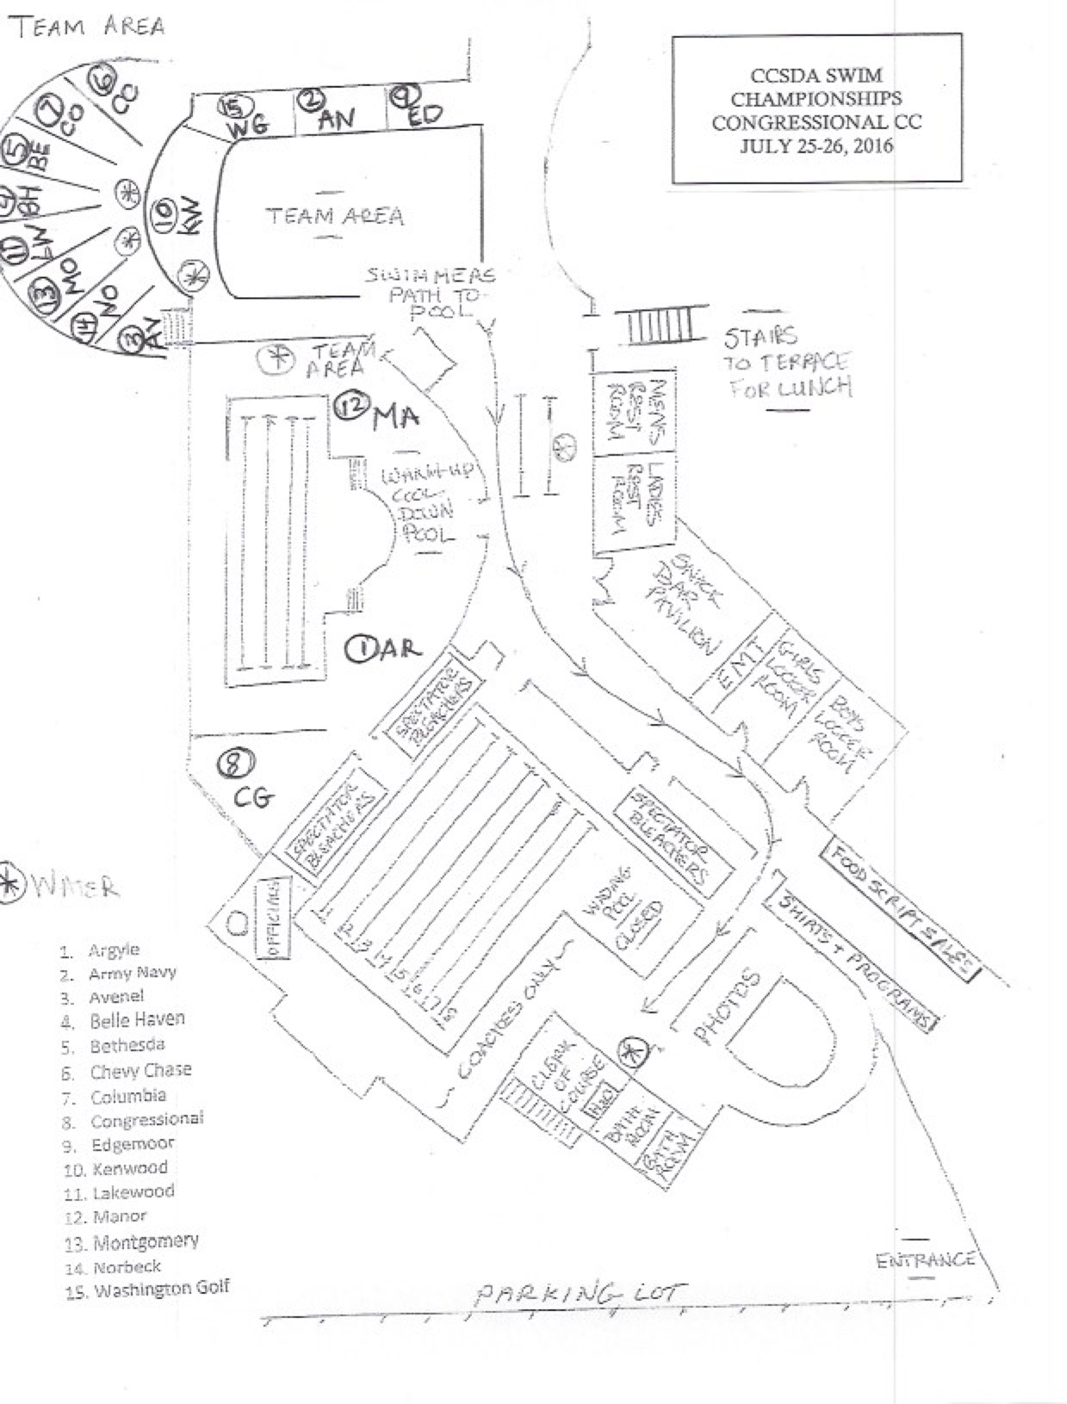

Congressional Country Club
CCSDA Swimming Championships
July 25-26, 2016

SNACK BAR PAVILION (8:00 AM - 4:00 PM)

Coffee @ $2.00
Hot Tea @ $2.00
Assorted Sodas @ $3.00
Bottled Water @ $3.00
Gatorade @ $4.00

Breakfast Sandwich @ $5.00 – available until 10:00AM
Assorted Donuts @ $2.00
Individual Fruit Cup @ $4.00
Bananas @ $2.00
Large Assorted Muffins @ $3.00
Bagels, PC Cream Cheese @ $4.00
Individual Pasta Salad Cup @ $4.00
½ Chicken Caesar Wrap, Fresh Fruit $10.00
Turkey Sandwich on Wheat Bread, Fresh Fruit @ $10.00
Grilled Chicken Caesar Salad, Caesar Dressing @ $12.00
Fresh Fruit Platter w/Chicken Salad or Tuna Salad @ $15.00
Individual Wrapped Chocolate Chip Cookie @ $2.00
Individual Wrapped Brownie @ $3.00
Ice Cream Novelties & Frozen Candy Bars @ $3.00

BEVERAGE STATIONS THROUGHOUT POOL / GREAT LAWN / TERRACE (8:00 AM – 4:00 PM)
Assorted Sodas @ $3.00
Bottled Water @ $3.00
Gatorade @ $4.00

STONE BAR ADJACENT TO THE WARM-UP/WARM-DOWN POOL (11:00 AM – 4:00 PM)

Domestic Beer @ $6.00
Imported Beer @ $7.00
Wine by the Glass @ $8.00
Standard Cocktails @ $ 8.00

Congressional Country Club
CCSDA Swimming Championships
July 25-26, 2016

LUNCHEON BUFFET ON THE SUNROOM TERRACE (11:00 AM - 2:00 PM)

STATION 1 – GRILL
Hamburger, Cheeseburger
Hot Dogs
BBQ Grilled Chicken Breast
Classic Mac Salad
Fruit Salad
Buns, Lettuce, Tomato, Onion, Pickles, Ketchup, Mustard, Relish
$15.00 per person

STATION 2 – SMOKE HOUSE
Smokey BBQ Pulled Pork
Brisket Scented Baked Beans
Congo Chicken Fingers, Ketchup
Mac & Cheese
Cole Slaw, Corn Bread
Fruit Salad
$15.00 per person

STATION 3 – GREENS & THINGS
Salad Station
Chopped Romaine, Iceberg Lettuce, Baby Spinach, Shredded Kale, Mesclun Greens
Green & Red Peppers, Basil, Cilantro, Red Onion, Organic Sprouts, Roasted Beets, Grape Tomatoes, Broccoli, Roasted Sweet Potatoes, Carrots, Cucumbers, Corn, Mushrooms, Black Beans, Chickpeas, Quinoa, Shredded Cheddar, Avocado, Egg, Toasted Almonds, Raw Seeds (Organic Flax, Sunflower & Sesame), Candied Pecans, Red Grapes, Apples, Cranberries,
Pita Chips, Croutons, Assorted Rolls & Butter
Fruit Salad
Grilled Chicken, Asian Shredded Beef, Bacon
Balsamic Vinaigrette, Lemon Wedges, Champagne Vinaigrette, Ranch, Bleu Cheese, F.F. Italian
$15.00 per person

STATION 4 – DESSERT
Cinnamon Sugar Fried Dough
Fruit Salad
$7.00 per person

