You can buy fins and goggles (and other accessories) at sports stores, specialty swim stores, online and in some discount stores.
You buy your fins based on your size, your physical ability and where you plan to swim. Full foot fins should fit comfortably without binding, yet not feel loose. It helps to wet your bare feet when trying on full foot fins. For a given fin size, the larger and stiffer the blade, the more strength you need to use it. In looking at fins that accommodate your size, physical ability and where you intend to use them, your primary concerns are (you guessed it) fit and comfort.

For the Wahoos practice, look for medium length fins that cover the whole foot (not the strap kind)! Swimmers practice with fins for numerous reasons including: 1. Using fins increases swim speed. 2. It bolsters kicking strength. 3. It allows the swimmer to focus all her attention on her upper-body movement and perfect her stroke.
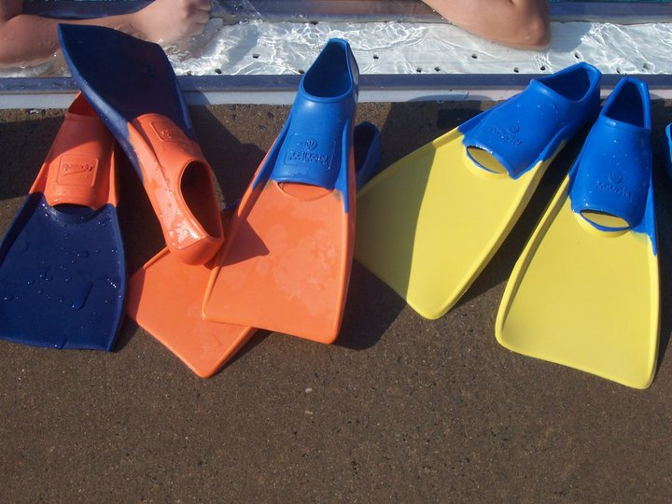

Goggles
Nearly every competitive swimmer wears goggles if not for the meets, then at least for practice. When trying out goggles, you need to make sure that the cups suction around your eye sockets, that the nose-piece is the correct size, and that the straps will adjust to fit your head. If you’ll be swimming mostly outside, make sure that you pick a tinted pair of goggles. However, if much of your training will be indoors, then you might want to go with a clearer pair.

Pool Buoys (Old Town Pool and Chinquapin have them. It is up to the swimmer if they want to purchase their own)
When held between the thighs, pool buoys keep the legs from sinking so that the swimmer may concentrate on pulling only. Pool buoys are often used in conjunction with paddles so that the swimmer may work on upper body strength and stroke.

Kickboards (Again, our pools have some, but we have a big team. Donate to the Wahoos boosters and hopefully, we can have our own supply!)
Kickboards are for all ages. Keeping your chest and arms afloat, the kickboard allows the swimmer to practice his or her kicking.

