**TEAM T-SHIRT**

**PARENT T- SHIRT**

**Broadlands**

**CSL**

**Swim Team**

**Spirit Wear**

**2013**

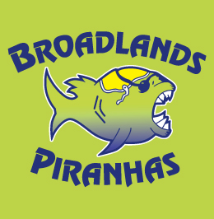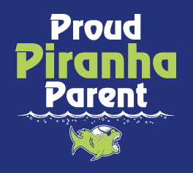

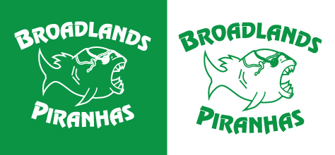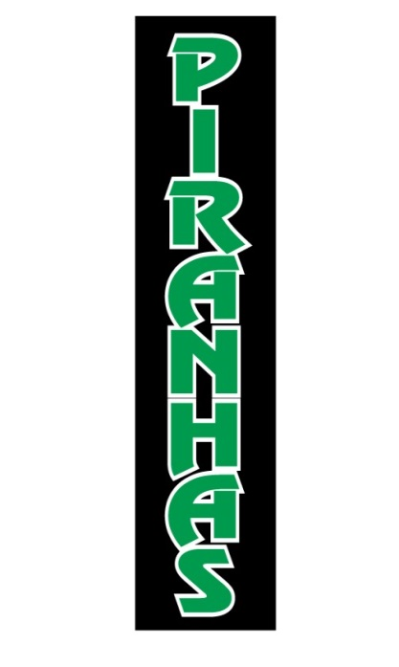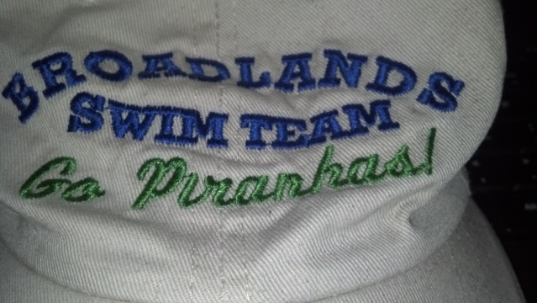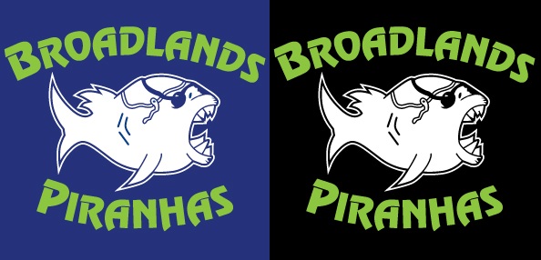

**Reversible TANK**

Kelly Green to White

**Black Sweat** **pants**

**LONG MESH SHORTS**

ROYAL BLUE OR BLACK

Logo in bottom right



**Black Hooded Sweatshirt**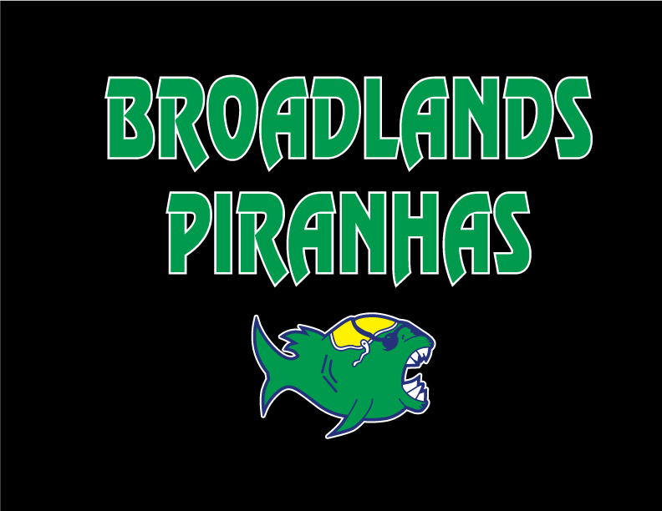

**Embroidered**

**Baseball Cap or Visor**