New Parent Information Guide
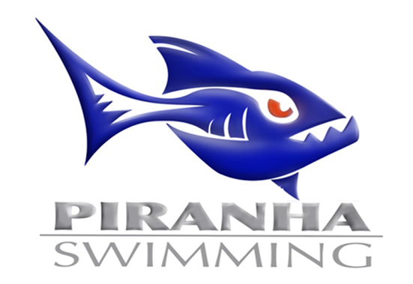
Welcome
Welcome to CSL Broadland Piranhas. Our program offers each and every swimmer the ability to reach their potential in and out of the pool. We are glad you have decided to join our team!

What should you bring to the meet:
- Arrive wearing the team suit and in team shirt / apparel.
- Cap, goggles & towel (always a good idea to have two of each).
- Seating Parents: Most pools don’t have much seating on deck so bring your own chairs.
- Seating Swimmers: Bring something for you swimmer to sit on in the team area.
- Flip-flops / deck shoes
- Water bottle – Even swimmers can get dehydrated – drink lots of water.
- Cash for the snack bar.
- Sunscreen!

How do I know what my child is swimming in the A or B meet?
The coaches will post the Wednesday meet schedule at the Wednesday practice. The Saturday meet schedule will be posted at the Friday practice.

What time do we need to be at each meet?
There will be an email communication from the team in the days leading up to a meet that will provide the necessary arrival time.
Where do I park for a meet?
For home meets, we allow the visiting team to park in our team lot so find a spot on one of the streets near our team lot. For away meets, the other team’s lot is available for us to park at.

What do I do when we get to the meet?
For home meets, there will be a ‘swimmer check-in’ area in front of the pool before you enter. For away meets, generally check in one of the coaches. The events your child is swimming will be written on their arm.

How do I find the results from my child’s event?
Download the ‘Meet Mobile’ app to track you child’s time at the meet. All final times are posted in the ‘Meet Sheet’ within 24 hours on our team site under the ‘Meets/Events’ tab.

What if my child is disqualified from a race?
If a swimmer is disqualified (DQ’d) from an event, the official will contact the coaches and the
coaches will inform the swimmers. Consider being DQ’d a valuable learning tool. The coaches will explain to the swimmers during the following practice what got them disqualified and how to avoid it going forward.

When can we leave a meet?
If your swimmer finishes their events prior to the conclusion of the meet, be sure to check with the coaches to be certain that they are not needed for a relay at the end of the meet, before leaving!

Team Uniform:
The Piranhas have a blue/orange team suit (one piece for girls; jammer or brief for boys) and swim cap (latex or silicone), available for purchase. Sample suits will be available during the first weeks of practice. To have a fitting done and to order your suit, visit Cassel’s Sports & Awards (703-435-4446) 2816 Towerview Rd, Herndon, VA 20171. Pictures of our suits are available to view on our site under the ‘Apparel’ header.
Team Apparel:
Caps and other Piranhas spirit wear will be available for purchase the first weeks of practice and in our online store (Reston Shirt & Graphics at 703-318-4802). While caps are not required, Piranhas swimmer may only swim in Piranhas caps at CSL meets. Each swimmer will also need goggles (and a backup pair). Remember to label your swimmer’s name on everything!

Awards Banquet: This is usually held at the end of the season between Divisionals and All-Stars). It is a potluck dinner, followed by award presentations. Each swimmer is recognized. Coaches highlight individual and team achievements including records set, most-improved, etc.

Once you have attended a few meets this will all become very routine. Please do not hesitate to ask the Parent Liaison cslparentliaison@broadlandsswimteam.org for help or information! These meets are a lot of fun for the swimmers! They get to "race" and see how much they have improved from all the hard work they have put in at practice.

For more detailed information about these topics and much (much!) more, please refer to the Piranhas Handbook under the ‘Parent Info’ header on our team site.
Welcome to the Piranhas!!
