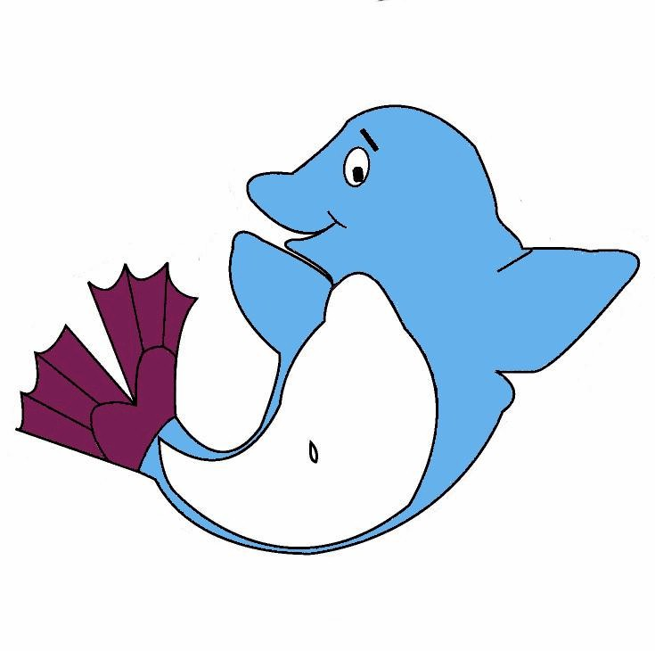

PLEASANT HILL DOLFINS
TEAM MEETING/AWARDS NIGHT
MEETING MINUTES

Friday, September 5, 2014

BOARD MEMBERS PRESENT
Robert Allen; Matt Lovett; Lois Shaw; Eric Janssen; Sharon Murphy; Amy Ross; Devon Knight; Gus Jullien, Korey Riley

ADDITIONAL PEOPLE PRESENT
Sara Silver; at least 100 Dolfin parent club members

The meeting was held at the Pleasant Hill Community Center;

CALL TO ORDER:
The meeting was called to order at 7:00 by Robert Allen. Robert announced it was time for elections for the following offices:

- Vice President – Peter Hutcheson running
- Secretary – Amy Ross running
- Treasurer – Merry Burns running
- Member-at-Large Snack Shack – Sharon Murphy running
- Member at Large – Meenu Chauhan running
- Member at Large Team Operations
- Member at Large Social Director

Ballots were distributed to all members present and collected. The Secretary, Lois Shaw, counted the ballots and all five positions were voted in. There were several “write in” candidates for various positions. The board will reach out to those individuals to see if any of them are interested in joining.

Awards were presented and the meeting was adjourned at 9:00pm.

NEXT MEETING:
The next Dolfins Board meeting is scheduled for Monday, October 13, 2014 from 7:00-9:00pm.

