

**Enjoy an evening out (or in), while we entertain the kids at the pool!**

**This year we have a new spin on our party with the kids. The 12 hour relay will finish as the party begins.**

**Swimmers and Divers can come cheer on the relay!**

When: Friday, June 26, 8:15 to 10:30 p.m.

Where: Jack Florence Pool

Cost: $20 per child, $15 for each additional child

Snacks, drinks, games, and fun will be provided.

Children must be 5 years of age or older.

This is not open to the general public, but siblings and friends of DARTS swimmers and divers are welcome!

*Reservations aren’t required, but are appreciated*

Please return form and payment to Coach Bill or Allison Saksa. Cash, Check(made payable to DARTS), and

Debit/Credit Card accepted.

Completed form and payment will also be accepted at the door on June 26.

Any questions, please email allisonsaksa@gmail.com

We would love to participate in the Darts Pool Party!!

Name of Child(ren) & age: ____________________________________________________________________________________

Parent(s) name: _________________________________________________________________________________

Home phone: _______________________ Cell phone: _______________________

Allergies: _________________________________Medical Conditions: _____________________________

I, __________________________________________________ (parent/guardian) understand that this form is considered a release of responsibility. I agree that I will not hold DARTS INC., coaches, or other persons associated with “Darts Pool Party” responsible for any injury or accident my child may receive while participating in activities of the evening.



**FEEL THE STING AT THE DARTS**

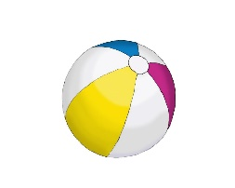

**POOL PARTY!**