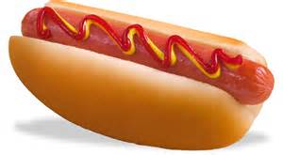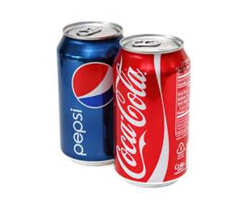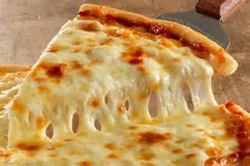
Drinks

Water 20oz bottles 1.00

Soda 12oz cans 1.00
20oz bottles 2.00

Gatorade 20oz 2.00

Food Menu
Hot Dogs 2.00 Cheesedog 2.50
Pizza 2.00 Cheese Fries 3.75
French Fries 2.75 BaconCh Fries 4.75
Chicken Fingers (3piece) 4.00
Hamburger 3.00
Cheeseburger 3.50
Bacon Cheeseburger 4.50
Uncrustables (pb&j) 2.00
Mozzarella Sticks (4piece) 3.00
Nachos 3.00
Nachos w/cheese 4.00
*extra cheese 1.00
Grilled Cheese 2.00

All candy 1.00
Chips .75
(plain, bbq, sc&on, fritos, doritos, TGIFridays chips, goldfish crackers)
Rice Krispie Treat 1.00
Party Mix 1.00
Slim Jims 3 for 1.00
Fruit Snacks 1.00
Combos (pizza or cheddar) 1.00
Famous Amos cookies 1.00
Oreos 1.00
Soft batch choc chip 1.00
Veggie straws 1.00
Toastchee crackers .75
Airheads .25

Ice Cream
Choc Chip Cookie Sandwich “chipwich” 3.00
Ice Cream Sandwich 1.00
Nutty Sundae King Cone 2.50
Cherry Screwball 1.50
WaterIce (lemon, cherry, blue raspberry) 1.00
ICEE (cherry, sour apple, blue raspberry) 1.00
