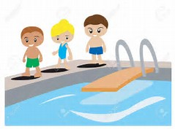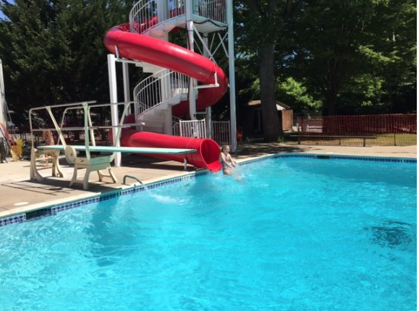

The last day of the season is Monday, September 4th!

Don’t forget to pick up

your chairs by the 4th.

Do you have an idea, talent, profession or passion that would be helpful to Karakung? Reach out to [karakungcomm@gmail.com](mailto:karakungcomm@gmail.com) We’d love to hear from you!

***Swimmers and Divers-- please pick up team pictures and awards from Awards night, Championships and Mini- Meet!***

**Karakung PRO Shop:** We have Karakung towels, bathing caps, and head bands for sale at the front desk! Please see a desk attendant to make a purchase from our Pro Shop☺

We have lots of Karakung towels for sale—they will make a great birthday or Holiday gift!

**LOST SOMETHING?**

e the **LOST SOMETHING?**

Please see the lost and found bin, located behind the diving board by the pump room, for any misplaced items.

Guests are $6 per day, pay at the front desk.

Thank you!

**Morning Master’s/Adult Swim**

Mondays: 5:30-6:30am

Wednesdays and Fridays: 6-7am

$5/members; $7/non-members.

Must sign waiver on website.

**Interested in becoming a Board member?** If you are interested, and have been a member in good standing for at least 1 full year, please reach out to a current Board member or send an email to [karakungcomm@gmail.com](mailto:karakungcomm@gmail.com)

SUMMER 2017

Week of August 27, 2017

**Hours for the week of August 27, 2017:**

**Monday-Saturday 11-8**

**Sunday 12-8**

### **WEEKLY NEWS**

KARAKUNG SWIM CLUB