2021 INSTRUCTIONS FOR DSSL TEAM STATISTICIANS

Table of Contents

Section 1 INSTALLING AND SETTING-UP TEAM MANAGER 8.0 1
1.1 INSTALLING TEAM Manager 8.0 1
1.2 New statisticians 3
1.3 Setting-up team manager 8.0 3
1.4 entering team information 5
1.5 entering athlete information 5
1.6 printing team roster 5
1.7 entering meet information 6
1.8 entering events 7
Section 2 DSSL Statistician Procedures Before and After Meet 7
2.1 BEFORE THE MEET 7
2.2 After the Meet 7
Section 3 Reporting Duties for Team Statisticians 8
3.1 MEET SET UP 8
3.2 REPORTING MEET RESULTS 8
Section 4 DSSL LISTING OF EVENTS 9

INSTALLING AND SETTING-UP TEAM MANAGER 8.0

INSTALLING TEAM Manager 8.0
There is no change to the TEAM MANAGER 8.0 software for 2021.
From the main screen, click “Check for Updates” and follow the instructions. If this does not work, go to https://hytek.active.com/downloads.html, click on update under 8.0. Then save that file, open TEAM MANAGER, go to file then install update.
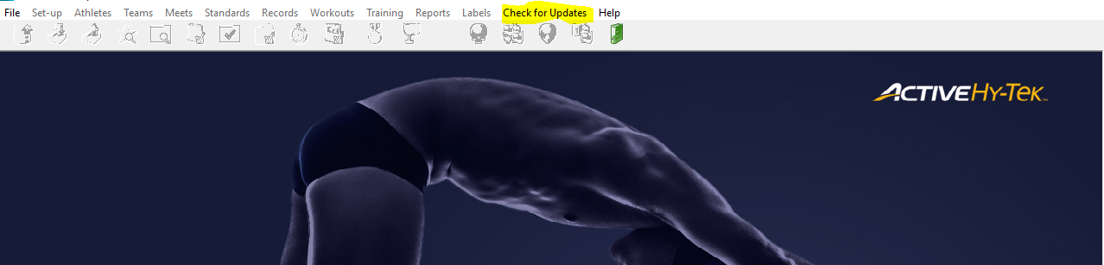
You will always see the version of Team Manager in the lower left hand corner of the main screen.
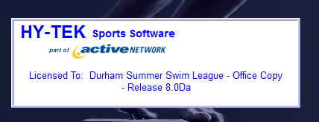
When you check for updates, you will see a pop up asking if you wish to download the update.
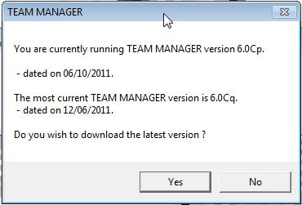

The update will download and you should install (the application will automatically restart).
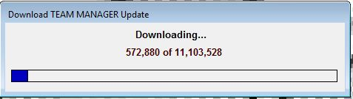

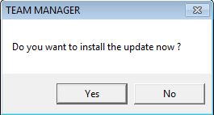

New statisticians
If you are a new statistician, have last year’s statistician give you a backup database from last year’s Team Manager for Windows and then restore it to Team Manager 8.0.
- Click on File on the Main Menu, then click on Restore.
If a backup file is not available, you will have to start from scratch this year. It’s a little more work, but not a problem.

Setting-up team manager 8.0
Set-up the Team Manager System defaults and personal preferences. When you open a new database, Team Manager will automatically route you to the System Preference screen. To change System Preferences after your database is established, click on Set up on the Main Menu, and then click on System Preferences. In this screen you can customize your team’s reports. There are some boxes that all teams should check:
Sex Designation – Boys/Girls
Athlete Browser Options:
√ Show ages
√ Show birthdate
√ Last name first
Default Registration - USS
Default Team Type – Age group
Default Country – USA
Default LSC – NC
Default State – NC
Meet Age up Date – 06/01 current year
System Age up Date – 06/01 current year
The Meet Age-Up Date and the System Age-Up Date should be set to June 1st of the current year. So, for example, the Summer of 2019 would be 06/01/2019 whereas the Summer of 2021 would be 06/01/2021.
By using the USS Default Registration, each child will have a unique ID number in the League database. This means that no two children with the same name will be differentiated from each other as long as they swim for different teams.
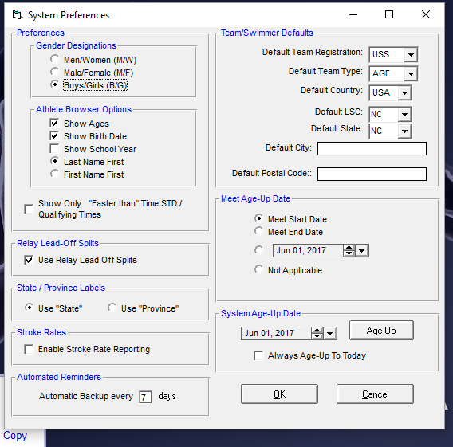

The next screen is optional.
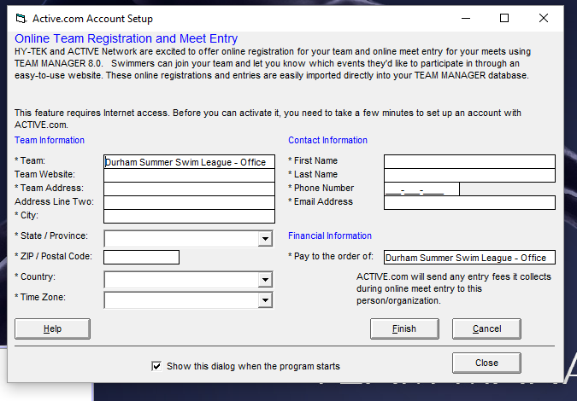

Unclick the Show this dialog, if you do not want to see it each time you open the program.

entering team information
Enter Team information. Go to Teams on the Main Menu, click Add, and enter your team’s information.

entering athlete information
Enter Athlete information. Go to Athletes on the Main Menu, click Add, Edit or Delete to update this year’s team roster.

printing team roster
Print the team roster to make sure you have everyone entered correctly. In the Main Menu, click on Reports, Administrative, Athletes to print your team roster.
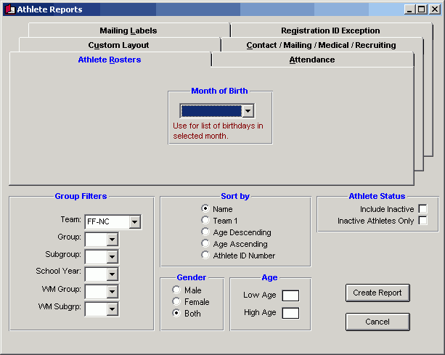

entering meet information
Enter Meet information. Go to Meets on the Main Menu, click on Add, and enter your meet information, including name (follow meet name conventions - YOUR TEAM vs. OPPOSING TEAM), date (start & end), Course YO, and age update (June of the current year – for example in Summer 2021 it would be 06/01/2021).
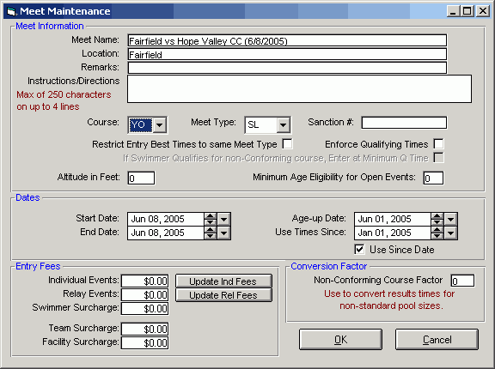

entering events
Enter events by highlighting a 2021 meet, clicking Events, and adding events from the list in Section 4 in Instructions for DSSL Team Statisticians. If you have meet information from two years ago, highlight a 2019 meet, click Events and then Copy Events From and pick a past meet from the drop down list.

DSSL Statistician Procedures Before and After Meet

BEFORE THE MEET
- Set up the meet by giving it a unique name and date.
Always name your team first: (e.g., BHR vs TREY 6/3/21)
- Give to Coach 2 days before the meet:
A blank team roster sheet for meet entries. Get it back the day before meet.
- Enter team entries into computer for the meet.
- Perform a backup and copy the backup file to a USB Flash Drive. From the main screen select File->Backup
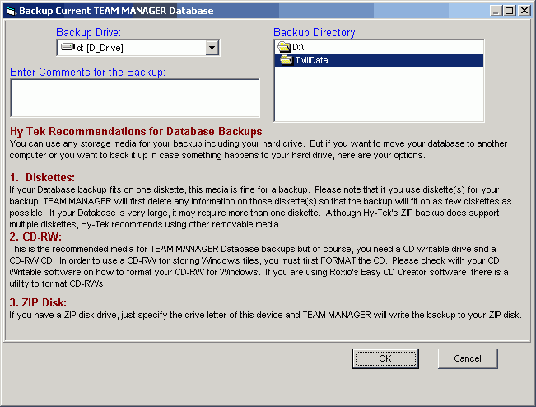
- Give to Coach morning of the meet:
Deck labels with team entries on them. Use Avery Dennison labels #5160. Go to Labels on the main menu, then click on entry labels.

After the Meet
- Either you or the Parent Rep should collect Time Sheet from Scorer’s table. Collect time cards (pink & blue).
- Enter meet result times into computer.
- Make 2 copies of the Time Sheet for you and the coaches.
- E-mail the Meet Results file to the League Statistician (Jennifer Johnson dsslstats@yahoo.com). To do this, click on file, export results, choose the meet and a file will be created and saved to your TM File. It should be a zip file (.zip). Open email and send that file as an attachment. To make a meet results report for your coaches, click on Reports on the main menu, then click on Performance, then click on Meet results and follow directions. Meet results must be submitted within 48 hours of the meet or it is considered a forfeit.
- Bring original Time Sheet to League Statistician (Jennifer Johnson) and roster changes to the seed meeting or DSSL Champs Meet. If there are any additions to the original roster, Team Manager will automatically include them. If there are any deletions or spelling changes, note them in writing, because these changes must be made by hand.
- Once again, create a backup.

Reporting Duties for Team Statisticians
PLEASE BRING ALL TEAM ROSTERS AND MEET RESULT INFORMATION TO THE DSSL League Statistician AT THE SEED MEETING
DSSL League Statistician: Jennifer Johnson
252-430-7403
dsslstats@yahoo.com

MEET SET UP
Set up each of your team’s meets with a unique name. Put your team’s name first:
YOUR TEAM vs. OPPOSING TEAM, and include the scheduled date of the meet. (e.g., CROAS vs GF 6/3/21)

REPORTING MEET RESULTS
After each meet every team must send to the League Statistician (Jennifer Johnson) within 2 days after the completion of the meet: (Due to the high cost of postage, you can save and bring to the seed meeting, if need be.)
- Email an electronic file containing the Meet Results from the meet. Note the file name (ending with .zip extension) in the e-mail and the name and date of the meet as you entered it on your computer. (Send the meet results file to Jennifer Johnson.)
- The initial roster after the first meet, and any additions, deletions, or spelling
changes that effect subsequent meets. Remember, the roster should be submitted both in hard copy only.
At the seed meeting or CHAMPS each team must bring:
- The original copy of the hand written Time Record Sheet for each meet. (Make your copies before submitting it to Jennifer Johnson)

DSSL LISTING OF EVENTS

Event 1 6 & under Girls 25 yd. Freestyle
Event 2 6 & under Boys 25 yd. Freestyle

Event 3 7-8 Girls 25 yd. Freestyle

Event 4 7-8 Boys 25 yd. Freestyle

Event 5 9-10 Girls 50 yd. Freestyle

Event 6 9-10 Boys 50 yd. Freestyle
Event 7 11-12 Girls 50 yd. Freestyle
Event 8 11-12 Boys 50 yd. Freestyle

Event 9 13-14 Girls 50 yd. Freestyle
Event 10 13-14 Boys 50 yd. Freestyle
Event 11 15-18 Girls 100 yd. Freestyle
Event 12 15-18 Boys 100 yd. Freestyle
Event 13 6 & under Girls 25 yd. Breast
Event 14 6 & under Boys 25 yd. Breast

Event 15 7-8 Girls 25 yd. Breast
Event 16 7-8 Boys 25 yd. Breast
Event 17 9-10 Girls 50 yd. Breast
Event 18 9-10 Boys 50 yd. Breast
Event 19 11-12 Girls 50 yd. Breast
Event 20 11-12 Boys 50 yd. Breast
Event 21 13-14 Girls 50 yd. Breast
Event 22 13-14 Boys 50 yd. Breast

Event 23 15-18 Girls 50 yd. Breast
Event 24 15-18 Boys 50 yd. Breast
Event 25 6 & under Girls 25 yd. Back
Event 26 6 & under Boys 25 yd. Back

Event 27 7-8 Girls 25 yd. Back
Event 28 7-8 Boys 25 yd. Back
Event 29 9-10 Girls 50 yd. Back
Event 30 9-10 Boys 50 yd. Back
Event 31 11-12 Girls 50 yd. Back
Event 32 11-12 Boys 50 yd. Back
Event 33 13-14 Girls 50 yd. Back
Event 34 13-14 Boys 50 yd. Back

Event 35 15-18 Girls 50 yd. Back
Event 36 15-18 Boys 50 yd. Back
Event 37 6 & under Girls 25 yd. Fly
Event 38 6 & under Boys 25 yd. Fly

Event 39 7-8 Girls 25 yd. Fly
Event 40 7-8 Boys 25 yd. Fly
Event 41 9-10 Girls 50 yd. Fly
Event 42 9-10 Boys 50 yd. Fly
Event 43 11-12 Girls 50 yd. Fly
Event 44 11-12 Boys 50 yd. Fly
Event 45 13-14 Girls 50 yd. Fly
Event 46 13-14 Boys 50 yd. Fly

Event 47 15-18 Girls 50 yd. Fly
Event 48 15-18 Boys 50 yd. Fly
Event 49 Girls Freestyle Relay
Event 50 Boys Freestyle Relay

