Farmington Glen Swim Team – 2022 Season
Coaching Staff
Head Coach - Drew Hansz, glengator@gmail.com, 248-914-0048
Assistant Coach & Group Lesson Director – Molly Tyler, tylermol21@gmail.com, 313-348-5044
Assistant Coaches
- Gloria Martinez Perez
- Katie Tyler
- Katie Goncalves

Swim Team Chair -Sara Stilwill and Inga Cho, glengatorbooster@gmail.com, 734-716-0625 (Sara)
Coach bios are available on the team website.

Totem
Our official mascot is the Gator. However, each year, Drew selects a new totem for the season. The totem is featured on the team t-shirt. Drew will announce this year’s totem at the Kick-off meeting!

Team Website (www.glenswimteam.com)
The swim team website is available through the “Swim” link on the Farmington Glen site (farmingtonglen.org). Most of the information in this document is on the website. Additionally, you’ll need to register through this website, and sign up/off for meet and volunteer roles.

Team Fees
The fee to be on the team is $145. Families with three or more swimmers on the team will receive a $20 discount for each child after the second. This fee includes one latex swim cap, and a team t-shirt. Swimmers need to be registered by Monday, May 16th to receive a t-shirt. Swim fees will not be prorated.

Team Calendar
The Team Calendar is managed through Google Calendar. You can view it on the “Calendar” tab of the team website. A printout, subject to change, is included at the end of this handout.

Practice Expectations and Schedule
There is no practice attendance requirement for the swim team. Swimmers are encouraged, however, to attend as many practices as possible. Regular attendance is essential to improvement!
Summer Practice Schedule
(6/20 – 7/29)
Age Group | Mon – Sat
13 & Up | 7:00 – 9:00 am
11 & 12 | 9:00 – 10:30 am
9 & 10 | 9:00 – 10:30 am
8 & Under | 10:30 – 11:00 am
Swimmers who cannot attended their scheduled practice must talk to Drew or Molly about attending a different session.
Spring Practice Schedule
(5/16 – 6/18)
Age Group | Mon – Fri | Sat
13 & Up | 3:00 – 4:30 pm | 7:00 – 9:00 am
8 & Under | 4:30 – 5:00 pm | 10:30 – 11:00 am
9 & 10 | 5:00 – 6:00 pm | 9:00 – 10:30 am
11 & 12 | 6:00 – 7:00 pm | 9:00 – 10:30 am
 | (Friday 5:00 - 6:00 pm)

Team Requirements
Swim team membership is open to any Glen member who is 18 years of age or younger and meets the following requirements
- Able to jump into the pool independently,
- Put their faces in the water and blow bubbles
- Propel themselves from the wall to the backstroke flags
New swimmers will be assessed during their first practice. If you are unsure of your child’s ability to meet these requirements, please wait to register until after their assessment. Swimmers who haven’t accomplished these skills yet should sign up for group lessons. Group Lesson Information can be found on the team website and at the end of this packet.

Volunteer Obligation
Each swim team family is expected to provide at least 5 hours of volunteer service. Families who do not fulfill this obligation will be assessed a $75 fee. If you are not able to volunteer during swim meets, please talk to Sara Stilwill or Inga Cho about behind-the-scenes opportunities to help the team.
Volunteer opportunities are available at each meet and team event. Signup for each event is listed on the event page on the team website (see last page of this handout). Available positions will be posted by the first day of practice.
Committee Chairs
The team’s volunteer efforts are organized by committees. If you’re interested in chairing or helping with a committee, please contact Sara Stilwill or Inga Cho.
Concessions – Heather Morden
Concessions Committee:

Timing – Chris DeMartini
Scoring – Eric Golicz
Announcer- Dana Visser
Marshalling – Taryn Skubic and Katie Rusak
Awards – Ami Kipf.
Check-In – Kellie Yost & Katie Golicz
Memorial Day Parade – CHAIR NEEDED
Coordinate team’s participation in the Farmington Memorial Day Parade
Social Events – CHAIR NEEDED
Plan various social events throughout the season, including the team overnight
Senior Night –
Plans senior recognition night and helps with senior gifts.

Spirit Breakfast – Bridget Millar
Plan the team spirit breakfast during the week before B Finals.
Spirit Bags –
Plans and preps spirit bags for swimmers at Finals

Team Banquet –
Organize food and decorations for the end of the year banquet at the Glen

Scoreboard Maintenance – Mike McEvilly
Golf Outing Committee –
B Finals – CHAIR NEEDED
Coordinator team site at B finals, including tent and refreshments for swimmers
A Finals Site Prep – Matt Kipf/Bob Greaves
A Finals Food Coordinator –

Fundraising
As with most youth sports’ programs, we do some fundraising to support the team. All funds raised are also used to purchase new training equipment as needed.
We will be holding out 2nd annual Golf outing and silent auction again this year. We need families to find golfers, businesses for sponsorships, and donations for our auction and raffle. We would like each family to support this outing with at least a sponsorship, twosome or item for the auction/raffle.
This money will be used towards updates and a new location for the scoreboard.

Registration
All registrations must be completed online. Swimmers must be registered by Monday, May 21 to receive a team t-shirt.
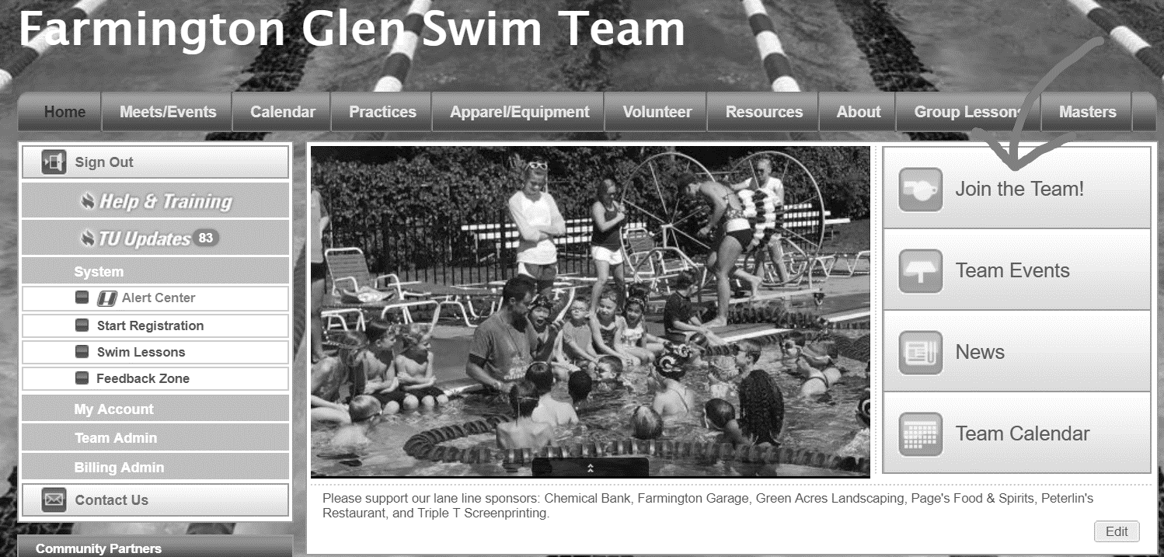
- Go to farmingtonglen.org and click on “Swim”. You will be redirected to the team website.
- Click on “Join the Team!”
- You will be prompted to log in to your account, or create a new one. If your family is new to the team, you’ll have to create a new account.
- Navigate through the registration process.
- After you’ve successfully registered, please mail your check payable to the Farmington Glen Swim Team to Farmington Glen Swim Team 21653 Heatheridge Lane, Northville, MI. This information will appear onscreen when you complete the registration process.
- Payments need to be turned in by the first Friday of practice.

Swim Meets
There are several types of meets in our season. Some of these meets require swimmers to sign UP in order to participate, and some require swimmers to sign OFF to let our coaches know they will NOT be attending.
Swimmers do not have to compete in meets to be on the team. They must, however, compete in at least two dual meets to be eligible to compete at finals.
Dual Meets
- Dual meets are competitions between two teams. We have 6 dual meets each season; 3 at home, and 3 away. These meets are held on weeknights.
- Home meets require a lot of volunteer effort to run. We must provide timers, scorers, marshallers, concessions, awards, and hospitality. Please be sure to sign up for a volunteer role!
- In general, swimmers need to report to the pool for warm-up between 3:30 and 4:30 pm. The meets usually begin at 5:30 or 6:00 pm. Specific information will be sent out as it is confirmed with both clubs. Meets typically last several hours.
- Swimmers need to SIGN-OFF for dual meets by the registration deadline if they will NOT be attending. Swimmers who do not sign-off will be entered in the meet.
- Please let our coaching staff know if your swimmer needs to arrive late or leave early.
- Our coaching staff will choose swimmers’ events for dual meets.
Mini Meets
- Mini-meets are age-specific meets, generally held on Saturday mornings. All teams from the league participate in these meets.
- Swimmers can choose their own events for these meets.
- Swimmers must SIGN UP for this meet if they will be attending. Swimmers who do not sign up by the registration deadline will not be entered in the meet.
9/10 Mini Meet
- The meet will be held at the Glen this year – we’ll need lots of volunteer help for this meet!
A & B Finals
- Finals meets are end-of-season championship meets.
- Swimmers will be notified whether they will be attending A or B finals after the last dual meet of the season.
- Swimmers who cannot attend either A or B finals should let our coaching staff know as soon as possible.

Team Suits, Apparel and Equipment
This year we will be pairing with Sun and Snow for team suits. Try-on and order information will be coming soon.
Each registered swimmer will receive one latex swim cap with the Glen logo. You will have to option of ordering personalized or plain silicone caps as well.
Each registered swimmer will also receive one team t-shirt. Be sure to indicate t-shirt size during the registration process. Parent t-shirts can also be ordered through the link on the website. Shirts will only be ordered for swimmers who are registered by May 16.
Additional apparel can be ordered from the team’s My Locker website: http://www.mylocker.net/michigan/farmington/gators/index.html

Social Activities
We plan several social activities during the season, including the Memorial Day parade, an overnight at the pool, spirit breakfast, spirit sign-making, and the end-of-season banquet.

Meet Sign-Up/Off & Volunteer Sign-Up
