Please see our website for the latest team information: www.teambenningtonwhales.com

May/June 2022
Sun. | Mon. | Tues. | Wed. | Thurs. | Fri. | Sat.
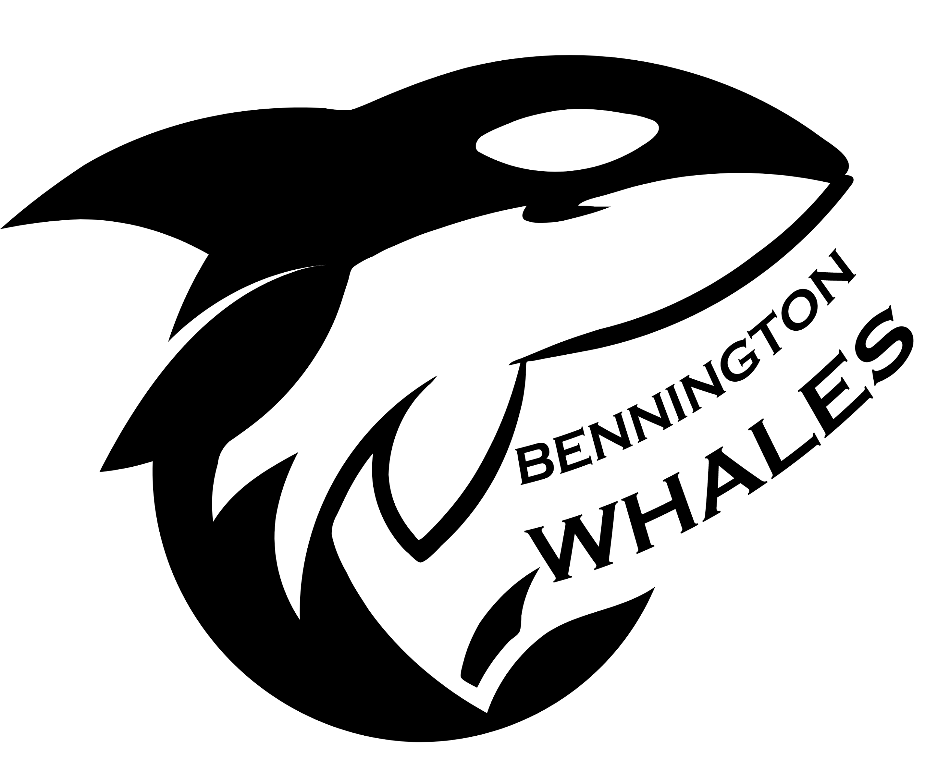 | 30 | 31  Practice | 1  Practice | 2  Practice | 3  Practice | 4
5 | 6  Practice | 7  Practice | 8  Practice | 9  Practice | 10  Practice | 11
12 | 13  Practice | 14  Practice | 15  Practice | 16  Practice | 17  Practice | 18  Home v. Northlake
19 | 20  Practice | 21  Practice | 22  Away @ Aurora Hills | 23  Practice | 24  Practice | 25  Home v. Hadley Farms
26 | 27  Practice | 28  Practice | 29  Home v. Stratford Knolls | 30  Practice

July 2022
Sun. | Mon. | Tues. | Wed. | Thurs. | Fri. | Sat.
 |  |  |  |  | 1 | 2  NO MEET
3 | 4 | 5  Practice | 6  Practice | 7  Practice | 8  Practice | 9  Away @ WSAP
10 | 11  Mini Meet @ Northlake | 12  Practice | 13  Home v. MPEV | 14  Practice | 15  Practice | 16  Away @ CVS
17 | 18  Practice- swimmers going to invitationals | 19  Practice- swimmers going to invitationals | 20  Meet Make Up Day | 21  Practice- swimmers going to invitationals | 22  Practice- swimmers going to invitationals | 23  Invitationals @ CVS  End of Season Party
24  End of Season Party Rain Date | 25 | 26 | 27 | 28 | 29 | 30
Practice Schedule:
Practices are Mon-Fri beginning the day after Memorial Day unless otherwise noted
5:30 - 6:15 pm  5-10 year olds  (parents must be present) | 6:30 - 7:45 pm  11-18 year olds  (parents are welcome)

Meets:
Saturday Mornings  8:00 am - arrive at 7:15 am | Wednesday Evenings  6:30 pm - arrive at 5:45 pm

Contacts:
Co-Coach Elena  elenanewman01@gmail.com | Co-Coach Naomi  nrcocker10@gmail.com
Assistant Coach TBD | Parent Reps Stephanie and Shelley  teambenningtonwhales@gmail.com

Pool Addresses:
Arora Hills  23230 Arora Hills Dr.  Clarksburg, MD 20871 | Churchill Village South (CVS)  13601 Wanegarden Dr.  Germantown, MD 20874
Hadley Farms  7420 Hadley Farms Dr.  Gaithersburg, MD 20879 | Montgomery Place (MPEV)  8825 Centerway Rd.  Montgomery Village, MD 20879
Northlake  12700 Partridge Wood Dr.  Germantown, MD 20874 | Stratford Knolls  11531 Doxdam Terrace  Germantown, MD 20876
Williamsburg Square/Ashton Place (WSAP)  18274 Smokehouse Court  Germantown, MD 20874 | We must follow the parking rules of all respective communities when participating in meets, including our own. Specific parking information is included on the team website (www.teambenningtonwhales.com).

