- Open your browser and go to cedarmillpool.org
- When the page loads, click the Start Registration link (highlighted in red below).

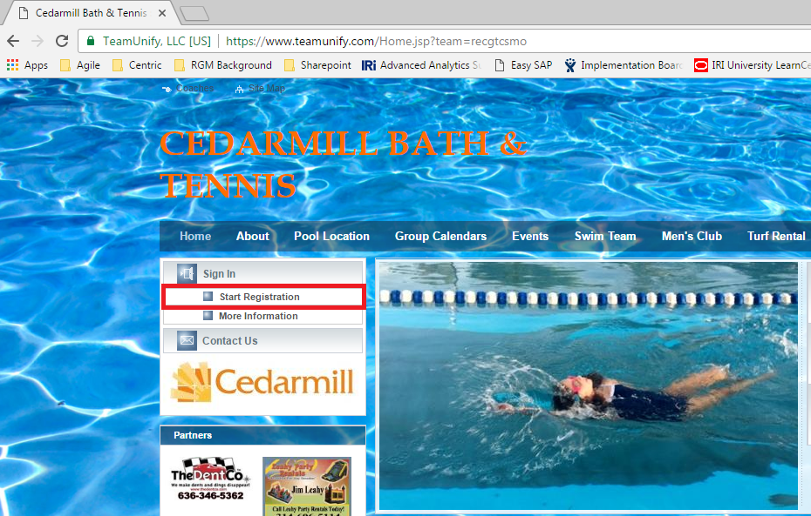

- The initial registration page will load and displays a title [Current Year] Registration. For example, this year’s page title reads “2017 Registration”.
- Scroll down to the bottom of the page and click on the “Continue or Check Status” button.
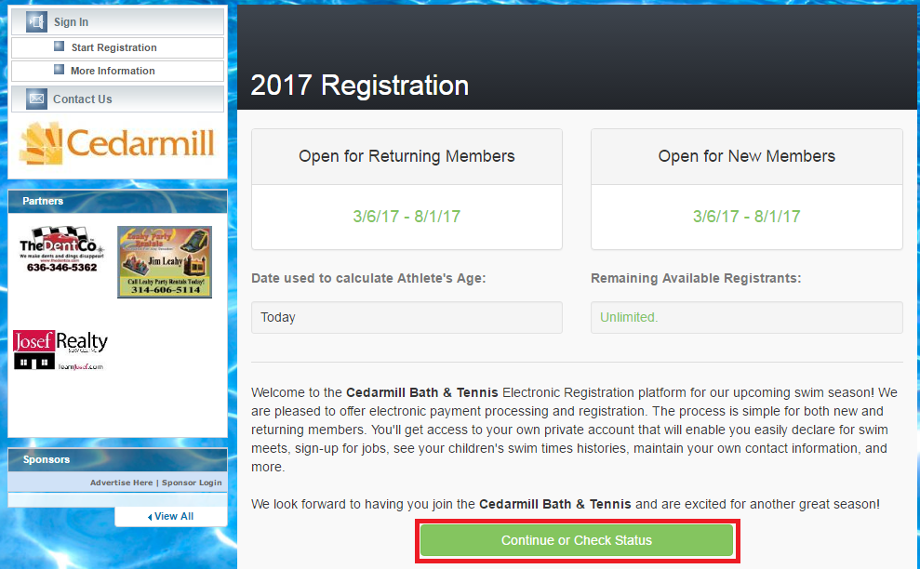
- The 2017 Registration logon page appears.
  - Enter the e-mail address you provided when you created your Cedarmill Bath and Tennis club account. If you don’t know that e-mail address, contact a board member.
  - Enter the password associated with that e-mail address. If you don’t know the password, click the Forgot Password link. Go to step 6.
  - Once you have entered the e-mail (user ID) and password, click Continue. Go to step 7.
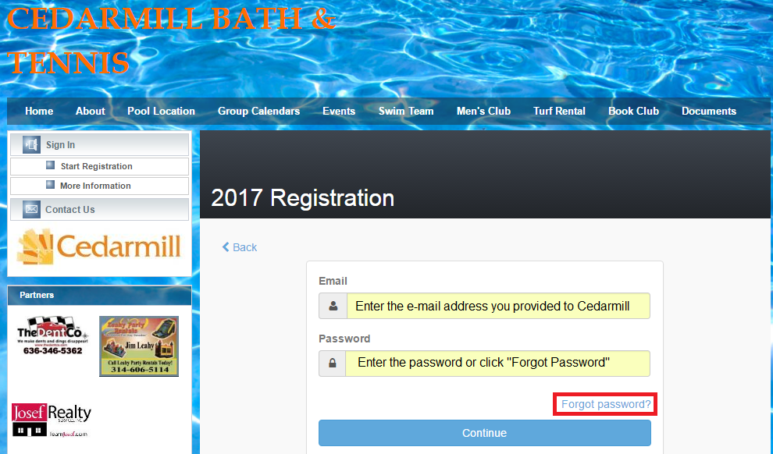
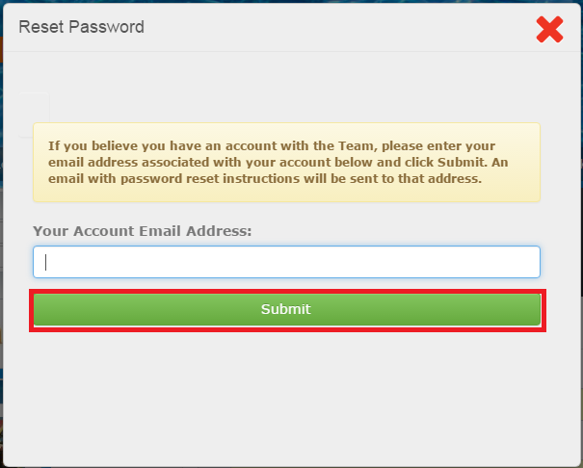
- If you clicked the Forgot Password link, the following screen appears.
  - Enter the e-mail address you provided to Cedarmill and click Continue.
  - An e-mail will be sent to the address you specified with instructions to reset your password.
  - Follow those instructions to reset your password, then return to the 2017 Registration logon page.

- When you successfully login, the Account Info page displays.
  - If you are returning member:
    - Verify the information on this page.
    - Click Continue (button located at the bottom of this page).
  - If you are new member:
    - Fill out the required fields on this page (designated with an asterisk).
    - Click Continue (button located at the bottom of this page).

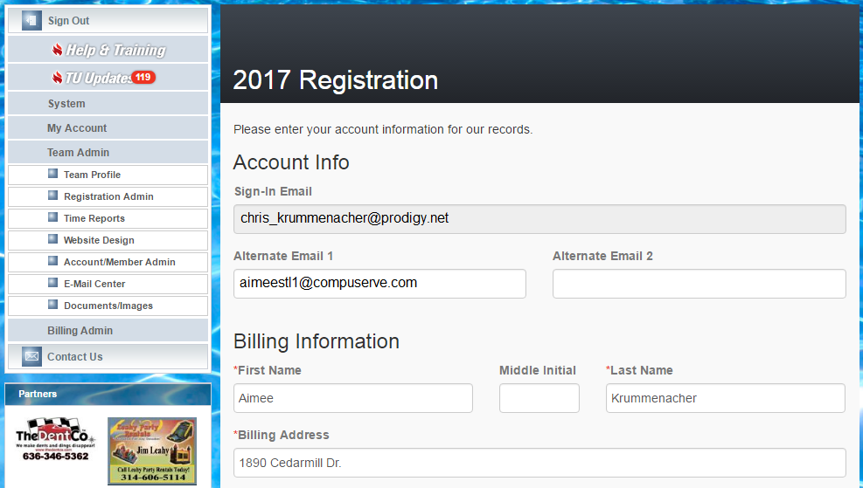

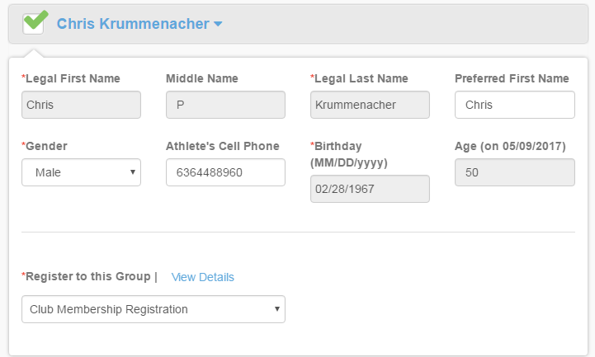
- On the next page, you will select each family member you want to activate for your account.
  - Click the drop-down next to the name and information for that member is displayed.
  - In the “Register to this Group” field, select the appropriate group membership for the member.
    - If you have questions about which option to select, click the View Details link.
  - Click the checkbox to select that person for activation.

- Scroll down on this same page to agree to the medical release and liability waivers.
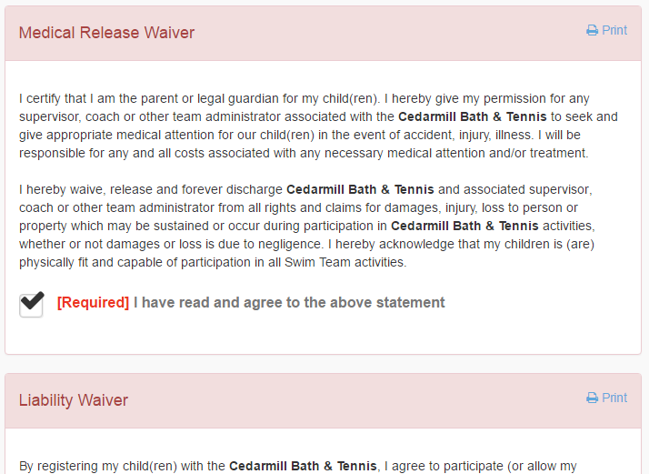
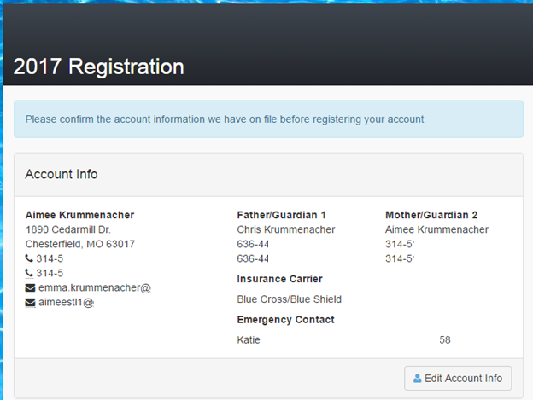
- When this page is filled out, click Continue.
- When the confirmation page displays, verify the information in the Account Info section.
  - If you need to make changes, click the Edit Account Info button.
- Scroll down to the Registration Fees section to review the membership fee and member information
- Select a payment method and then click the Proceed To Checkout button (see next page).
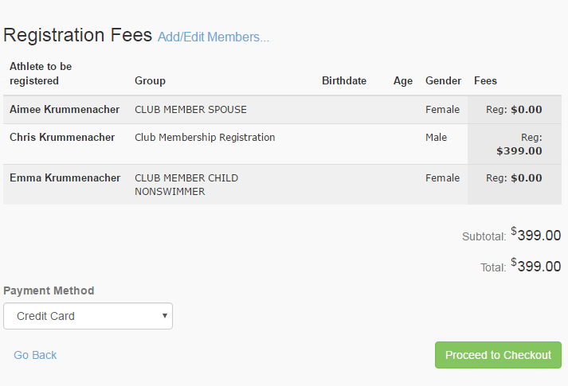
- On the Checkout page, specify your payment information.
  - For example, if you selected a Payment Method of Credit Card, you will enter a credit card number, expiration date, billing address, and CVV.
NOTE!

Work Commitment checks for the pool and/or swim team must be mailed to the address listed below or provided to a board member or swim team parent rep.
Cedarmill Bath and Tennis
PO BOX 226
Chesterfield, MO 63006

  - You can then process the payment and the registration is complete!

robersonw@charter.net

